ACTIVITY REPORT

Activity Name: Poster Competition on Information Technology (IT)
Class: FYBBA
Date: 16/09/2025
Activity Co-ordinator: Prof. S. P. Borhade
The Poster Competition on the theme of Information Technology (IT) was successfully organized on 16th September 2025 for the students of FYBBA with the aim of enhancing their creativity, awareness, and understanding of modern technological developments. The event was conducted under the guidance of the Activity Co-ordinator, Prof. S. P. Borhade, whose efforts ensured the smooth planning and execution of the competition. The primary objective of organizing this activity was to provide a platform for students to express their ideas related to information technology through creative and visual means, while also encouraging them to explore current trends and innovations in the digital world. In today’s rapidly evolving environment, IT plays a crucial role in shaping business operations, communication systems, education, and everyday life, and this competition helped students recognize its growing importance.
Before the competition, students were informed about the theme, rules, and evaluation criteria. They were encouraged to select relevant topics such as artificial intelligence, cybersecurity, digital payment systems, cloud computing, e-commerce, and the role of IT in business and society. Students actively participated with great enthusiasm and prepared their posters using innovative ideas, attractive designs, and meaningful content. The preparation process involved research, planning, and creative thinking, which helped students gain deeper insights into various IT concepts. The competition witnessed active and energetic participation from FYBBA students, reflecting their interest in both creative expression and technological awareness.
On the day of the event, participants displayed their posters in an organized manner and presented their ideas with confidence. Each poster was unique in its design and message, covering different aspects of information technology. Some posters highlighted the benefits of digital transformation in businesses, while others focused on challenges such as cybercrime, data privacy, and the ethical use of technology. A few students also presented futuristic ideas related to automation, robotics, and the integration of IT in various industries. The posters were visually appealing and informative, demonstrating students’ creativity, knowledge, and effort. The presentation of posters also helped students improve their communication skills and boosted their confidence.
The evaluation of the posters was carried out based on criteria such as originality, creativity, relevance to the theme, clarity of message, and overall presentation. The judges carefully reviewed each entry and appreciated the efforts of the participants in presenting complex IT concepts in a simple and engaging manner. The competition not only helped students develop artistic skills but also encouraged analytical thinking and practical understanding of technological advancements. It provided an opportunity for students to learn beyond textbooks and apply their knowledge in a creative format.
The activity also promoted peer learning and interaction among students, as they observed and gained ideas from each other’s work. It created a healthy competitive environment that motivated students to perform better and think innovatively. Such co-curricular activities are essential for the overall development of students, as they help in building confidence, enhancing creativity, and improving problem-solving abilities. The Poster Competition served as an effective medium to bridge the gap between theoretical knowledge and practical application.
At the conclusion of the event, the best posters were selected and awarded based on their performance. Certificates were distributed to the winners and participants to appreciate their hard work and encourage them for future participation. Prof. S. P. Borhade addressed the students and emphasized the importance of staying updated with the latest developments in information technology. He motivated students to actively engage in such activities, which contribute significantly to their academic and personal growth.
Overall, the Poster Competition on Information Technology (IT) was a successful and enriching activity that achieved its objectives effectively. It provided students with a valuable opportunity to showcase their creativity, enhance their knowledge, and develop essential skills required in today’s digital era. The enthusiastic participation of students and the efficient coordination of the event made it a memorable and impactful experience for all.

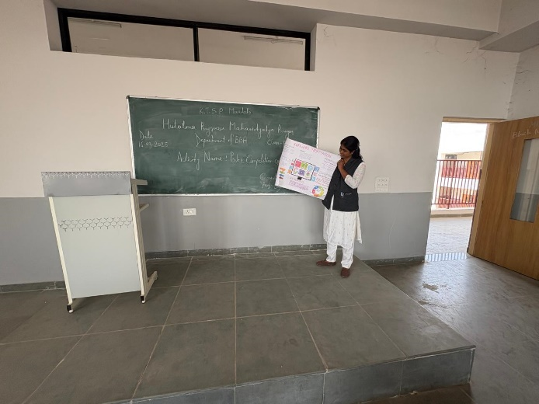
Photographs of Property
