ACTIVITY REPORT
Activity Name :- ERP (Enterprise Resource Planning)

The activity on ERP (Enterprise Resource Planning) was successfully conducted for the students of TYBBA on 5th November 2025 under the guidance and coordination of Prof. T. P. Bhalshinge. A total of 46 students actively participated in this academic session, which aimed to provide practical and theoretical insights into modern business management systems. The session was organized with the objective of enhancing students’ understanding of ERP concepts, their applications in business operations, and their importance in today’s digital business environment.
The program commenced with a brief introduction to the concept of ERP, where students were introduced to the meaning, evolution, and significance of Enterprise Resource Planning systems. The coordinator explained how ERP integrates various business functions such as finance, human resources, production, supply chain, and customer relationship management into a unified system. The session highlighted how organizations use ERP software to improve efficiency, accuracy, and decision-making by providing real-time data and streamlined processes. Students were also made aware of popular ERP software used in industries, which helped them relate theoretical knowledge to real-world applications.
During the activity, emphasis was placed on the importance of ERP in enhancing productivity and reducing operational costs. The coordinator explained how ERP systems help in eliminating data duplication, improving communication across departments, and ensuring better resource utilization. The students were engaged through interactive discussions, examples, and case-based explanations, which made the session more interesting and informative. The practical aspects of ERP implementation, such as planning, customization, training, and maintenance, were also discussed in detail, giving students a comprehensive understanding of the subject.
Furthermore, the session covered the advantages and challenges of ERP systems. Students learned that while ERP offers numerous benefits such as improved efficiency, better reporting, and enhanced customer service, it also involves high implementation costs, complexity, and the need for proper training. These discussions helped students develop a balanced perspective and critical thinking regarding the adoption of ERP systems in organizations. Real-life examples of companies using ERP successfully were also shared to make the learning more relatable and effective.
The activity also encouraged student participation through questions and discussions, where students shared their views and clarified their doubts regarding ERP systems. This interactive approach helped in improving their communication skills and boosted their confidence. The coordinator ensured that all students were actively involved and gained maximum knowledge from the session. The students showed keen interest throughout the activity and appreciated the practical relevance of the topic in their academic and professional careers.
In conclusion, the ERP activity proved to be highly beneficial and informative for the TYBBA students. It successfully enhanced their understanding of enterprise systems and their role in modern business management. The session not only provided theoretical knowledge but also practical insights, preparing students for future challenges in the corporate world. The efforts of Prof. T. P. Bhalshinge in organizing and conducting this activity were commendable, and the participation of 46 students made the event a great success. Overall, the activity achieved its objectives and contributed significantly to the academic development of the students.

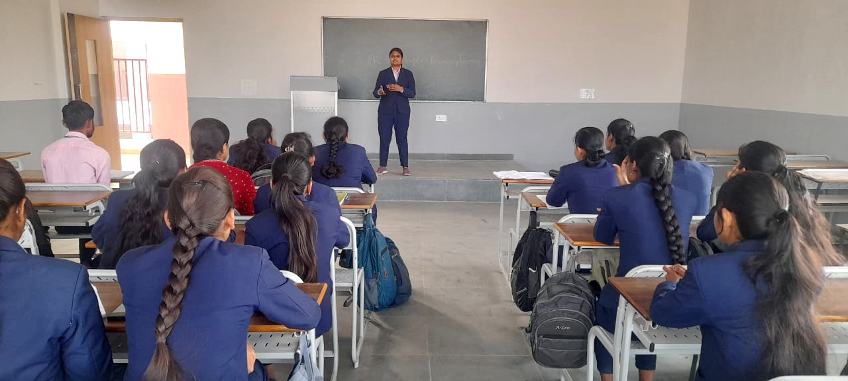
Photographs
