**K.T.S.P.MANDAL’S**

**HUTATMA RAJGURU MAHAVIDYALAYA**

RAJGURUNAGAR, TAL-KHED, DIST-PUNE 410501

**DEPARTMENT OF BBA**

A log sheet with the following details of program

|  |  |  |
| --- | --- | --- |
| Sr. No | Item | Particulars |
| 1 | Date | 25th October, 2024 |
| 2 | Name of Event | Freshers Party |
| 3 | Venue | College Auditorium |
| 4 | Time | 8.00 am to 2.00 pm |
| 5 | Duration of the program | 1 Day |
| 6 | Expense | 29,000/- |
| 7 | Source of Financial Assistance | Staff & Students |
| 8 | Names of resource persons | Dr.P.P.Oswal,  FACULTY MEMBERS |
| 9 | Name of coordinator | Dr.P.P.Oswal |
| 10 | Number of participants | 102 students |
| 11 | Copy of the program | - |
| 12 | Curricular/Co-Curricular/Extra-Curricular | Co-Curricular |
| 13 | Activity belongs to Which Criteria of NAAC | - |

Date: -25th October, 2024

**Report**

The BBA Freshers Party held on 25th October, 2024, at Hutatma Rajguru Mahavidyalaya was a grand success. The event was graced by the esteemed presence of Chief Guest, Adv. Devedraji Buttepatil, Chairman of KTSP Mandal’s. Also in attendance were Nanasaheb Takalkar, Vice Chairman of KTSP Mandal’s, all Directors of KTSP Mandal’s, The Principal of Hutatma Rajguru Mahavidyalaya, Dr. S.S.Pingale, BBA faculty, and enthusiastic students.

The event began with a warm welcome extended to the dignitaries and guests. Adv. Devedraji Buttepatil delivered an inspiring address, emphasizing the importance of education and leadership in the field of business administration. His insightful words motivated the students and faculty alike.

Nanasaheb Takalkar, in his role as Vice Chairman of KTSP Mandal, also shared his valuable insights and encouraged the students to excel in their academic journey. The entire gathering had the privilege of hearing from all the directors, who shared their vision for the BBA program. Principal Dr.Shirish Pingale sir give best wishes for all BBA students.

The students were introduced to their faculty members, who were enthusiastic about guiding and nurturing them throughout their BBA journey. It was a wonderful opportunity for students to get to know their mentors and professors.

Cultural performances by the students added an element of entertainment and vibrancy to the event. The Freshers Party served as a platform for students to socialize, make new friends, and feel a sense of belonging to the BBA program. Each student was welcomed with note pad and snacks at the end.

In conclusion, the BBA Freshers Party held on 25th October, 2024, was a memorable event that marked the beginning of an exciting academic journey for the students. The presence of distinguished guests and inspiring speeches set a positive tone for the upcoming academic year, and it left everyone looking forward to the promising future of the BBA program at Hutatma Rajguru Mahavidyalaya.

Dr.P.P.Oswal

HOD - BBA

**Attendance of student:-**

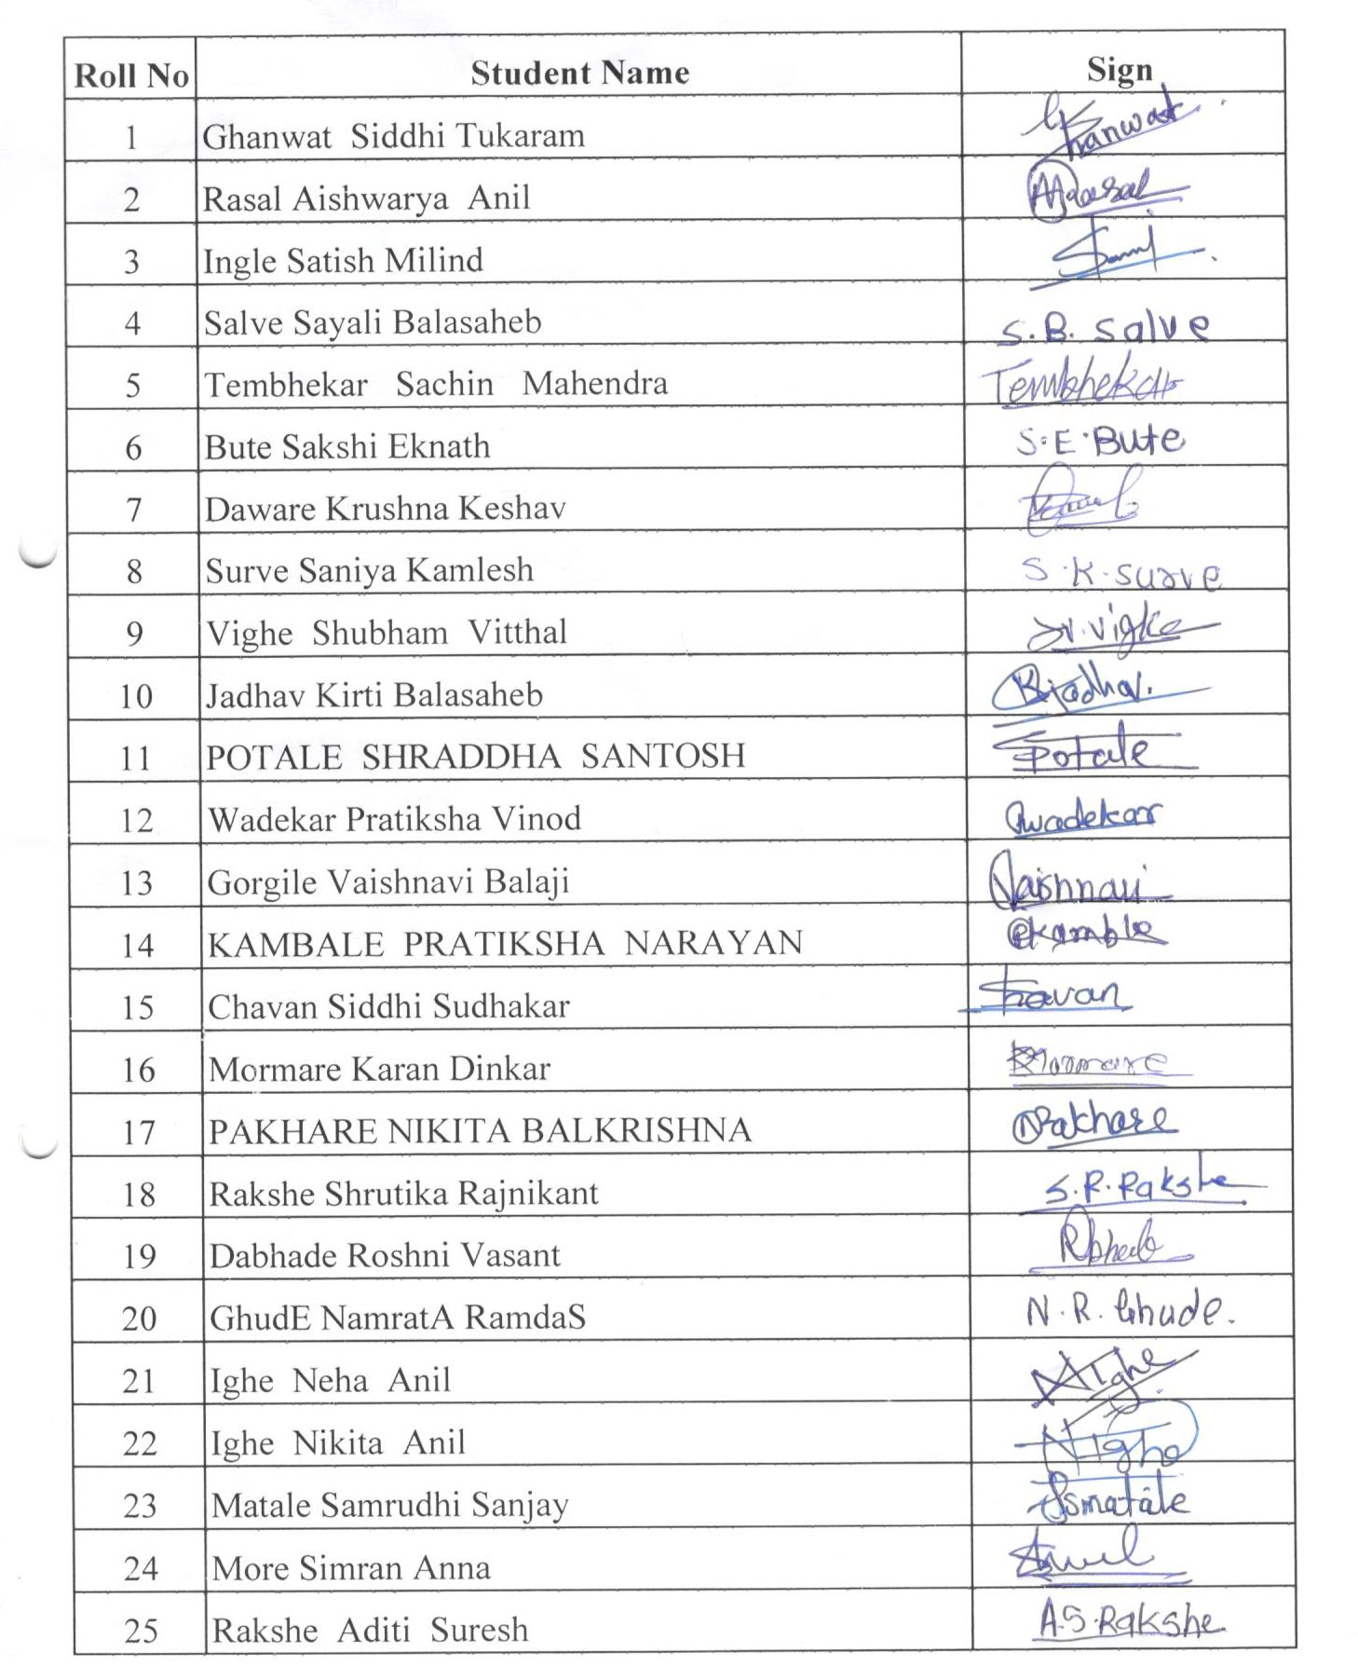

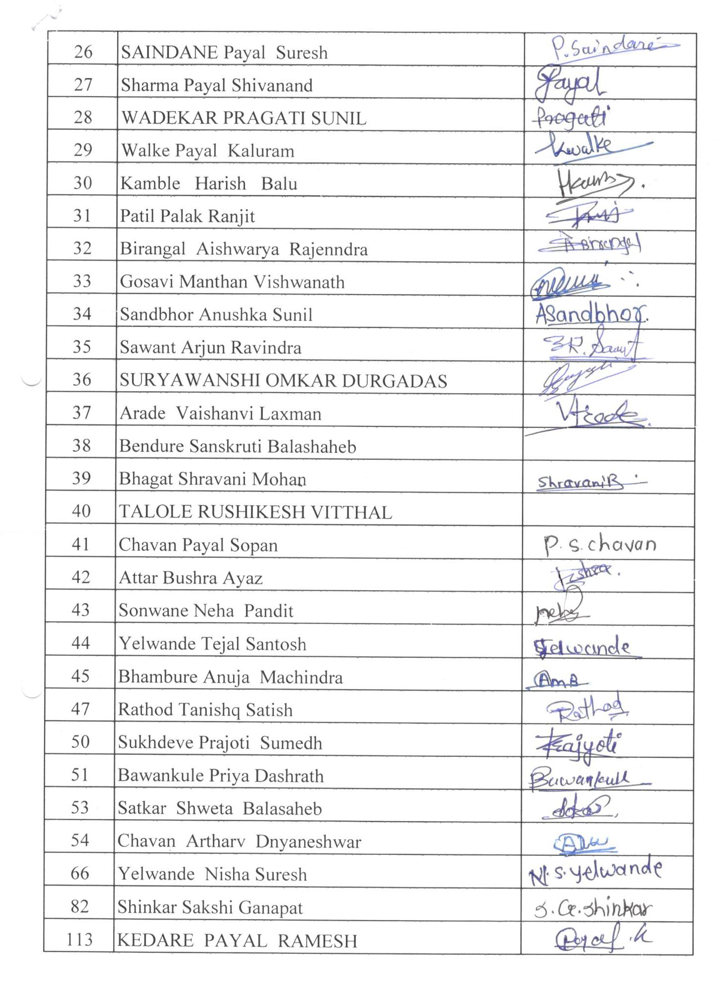

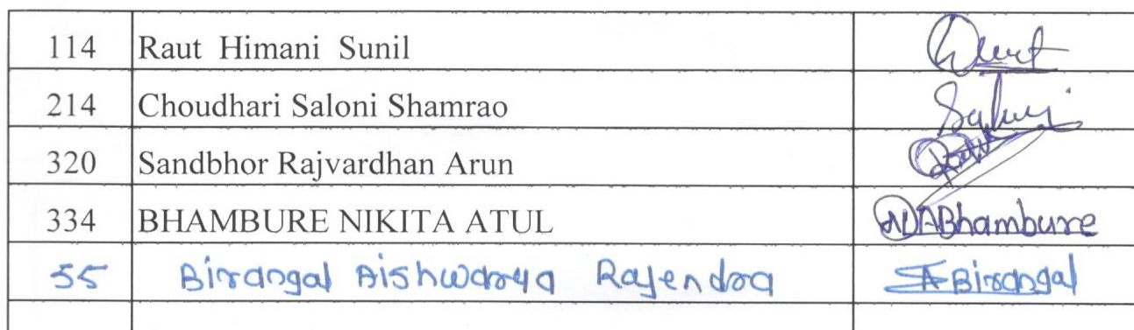

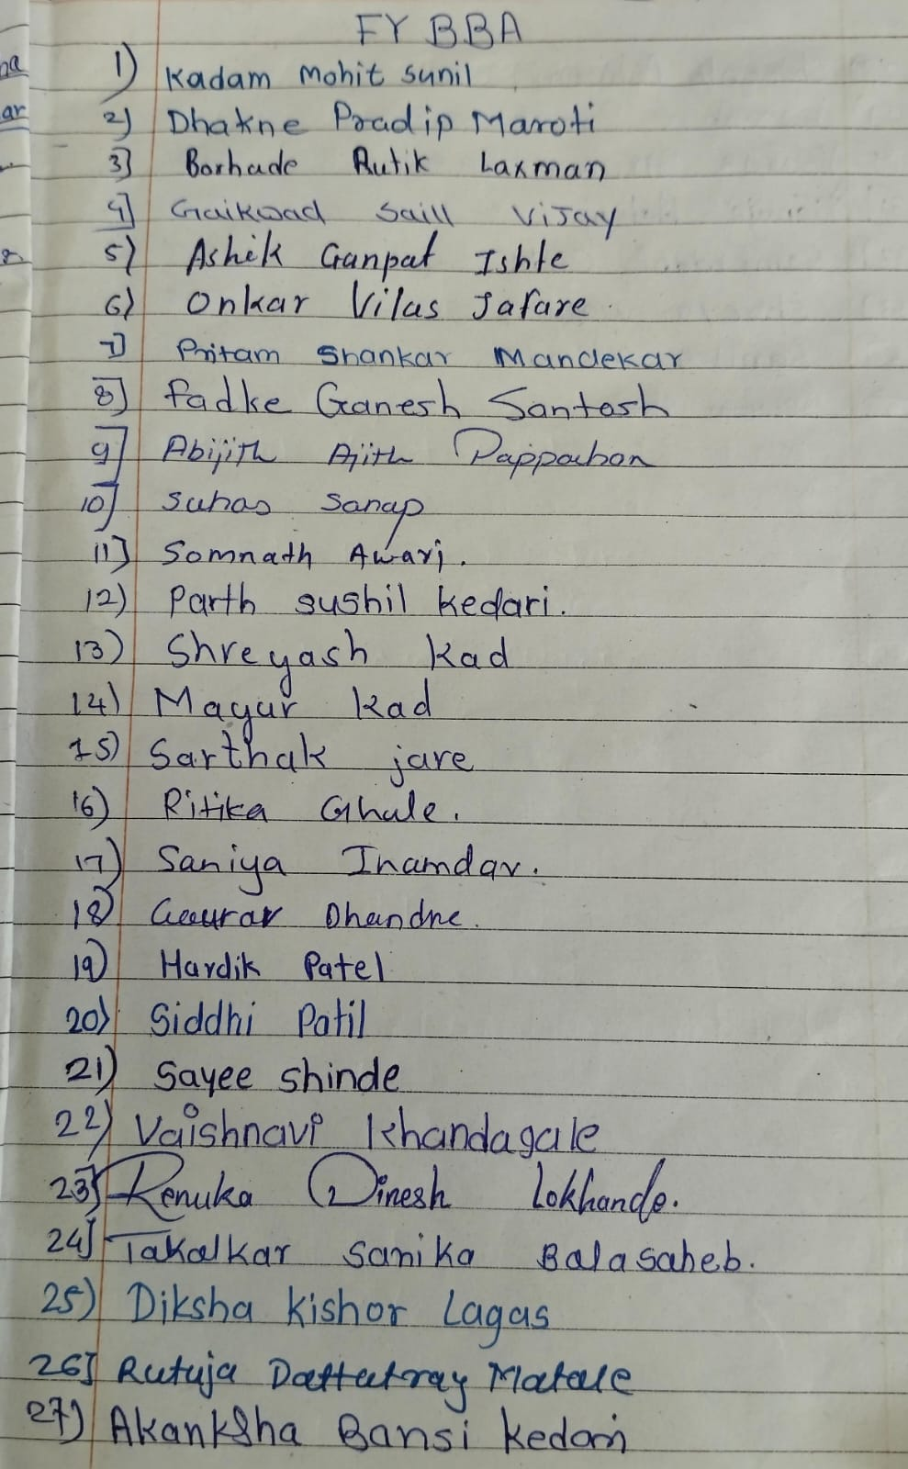

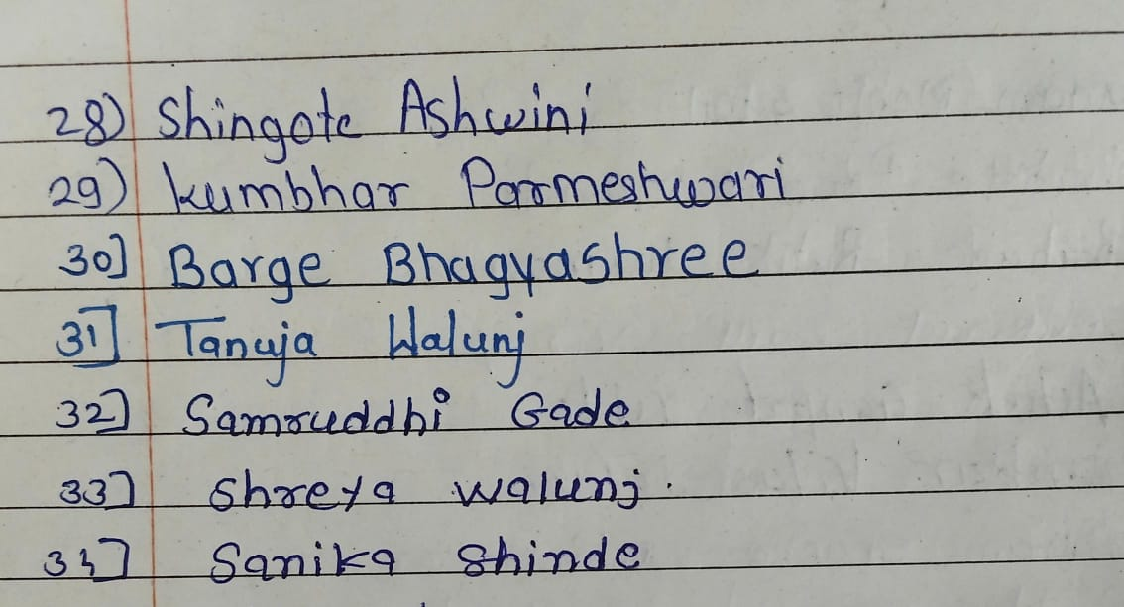

Dr.P.P.Oswal

HOD - BBA

Photos:-

