K.T.S.P.MANDAL’S
HUTATMA RAJGURU MAHAVIDYALAYA
RAJGURUNAGAR, TAL-KHED, DIST-PUNE 410501
BBA DEPARTMENT (2024-25)

A log sheet with the following details of program
Sr. No | Item | Particulars
1 | Date | 10th July
2 | Name of Event | Guru Purnima Celebration
3 | Venue | CLASSROOM
4 | Time | Class timings
5 | Duration of the program | 1 Day
6 | Expense | -
7 | Source of Financial Assistance | -
8 | Names of resource persons | -
9 | Name of coordinator | Dr. P.P.Oswal
10 | Number of participants | T.Y.BBA
11 | Copy of the program | -
12 | Curricular/Co-Curricular/Extra-Curricular | Extra-Curricular
13 | Activity belongs to Which Criteria of NAAC | -

Date: - 10 July, 2024
Report
Guru Purnima, the festival dedicated to spiritual and academic teacher was celebrated in BBA department on 10/07/2024. The event was organized by TYBBA students. It was a memorable event that showcased the deep reverence and gratitude of the students towards their teachers and the event was anchored by students. The function began with lightening the lamp of Goddess Sarasvati by Dr. P.P. Oswal and teachers followed the felicitation of teachers by the students. They each student presented a beautiful bouquet of flowers and Diary to their respective teachers as a token of appreciation for their guidance and support. Following the felicitation, several students were given the opportunity to deliver speeches and Poems. The Student of TYBBA Ms. Sakshi Bute hosted the event with great enthusiasm followed by poem on teacher’s worth it students life by Ms. Roshni Dabhade. They shared their thoughts and experience, expressing their gratitude towards the teachers who had played a significant role in shaping their lives and academic journeys. Students have arranged funny games for teachers in this programed.
Dr.P.P.Oswal HOD of BBA department acknowledges the importance of Guru Purnima and emphasized about their first Gurus at college, their parents and their elders. As the program drew to a close, a vote of thanks was extended by student of TYBBA Ms. Anushka Bomble to all the attendance.
The event was concluded with a formal vote of thanks.

DR. P.P.OSWAL
HOD-BBA

Photos:-

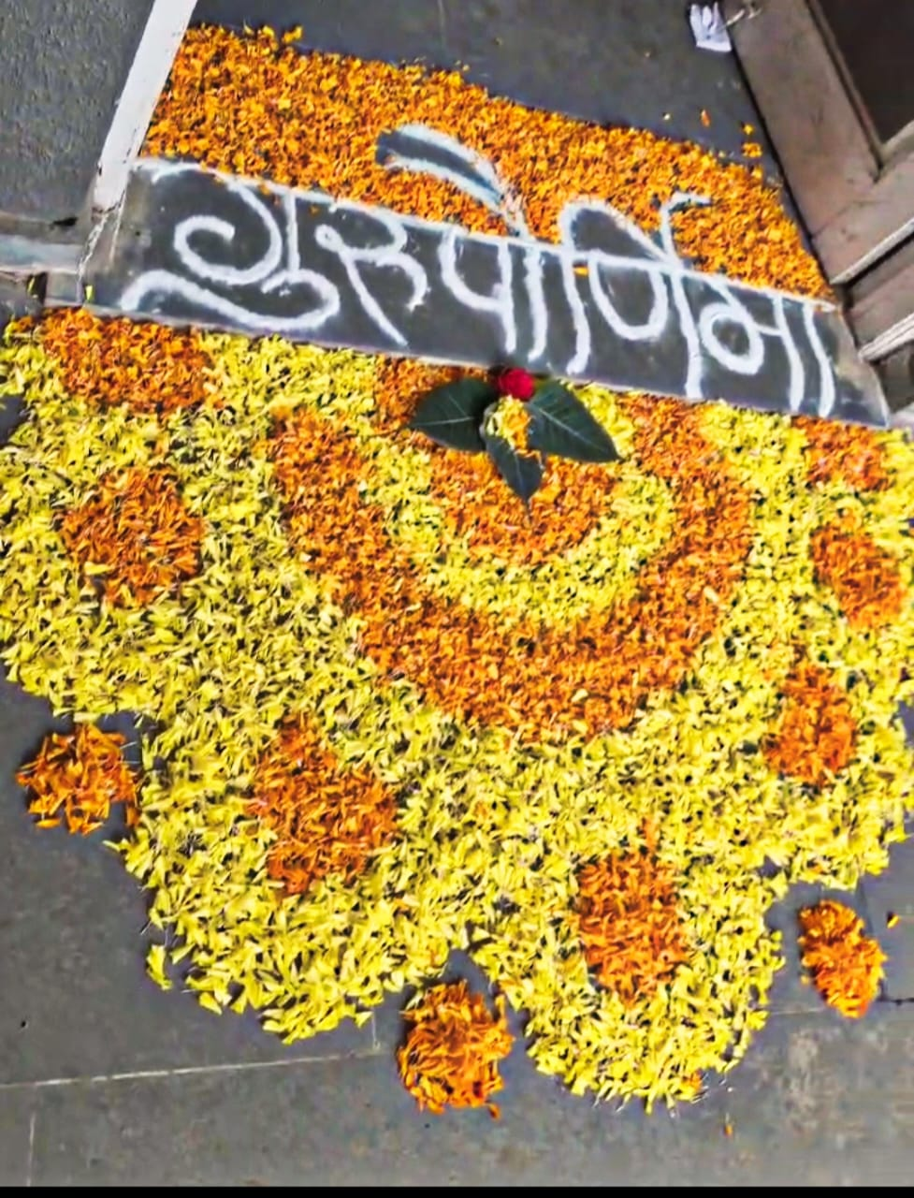

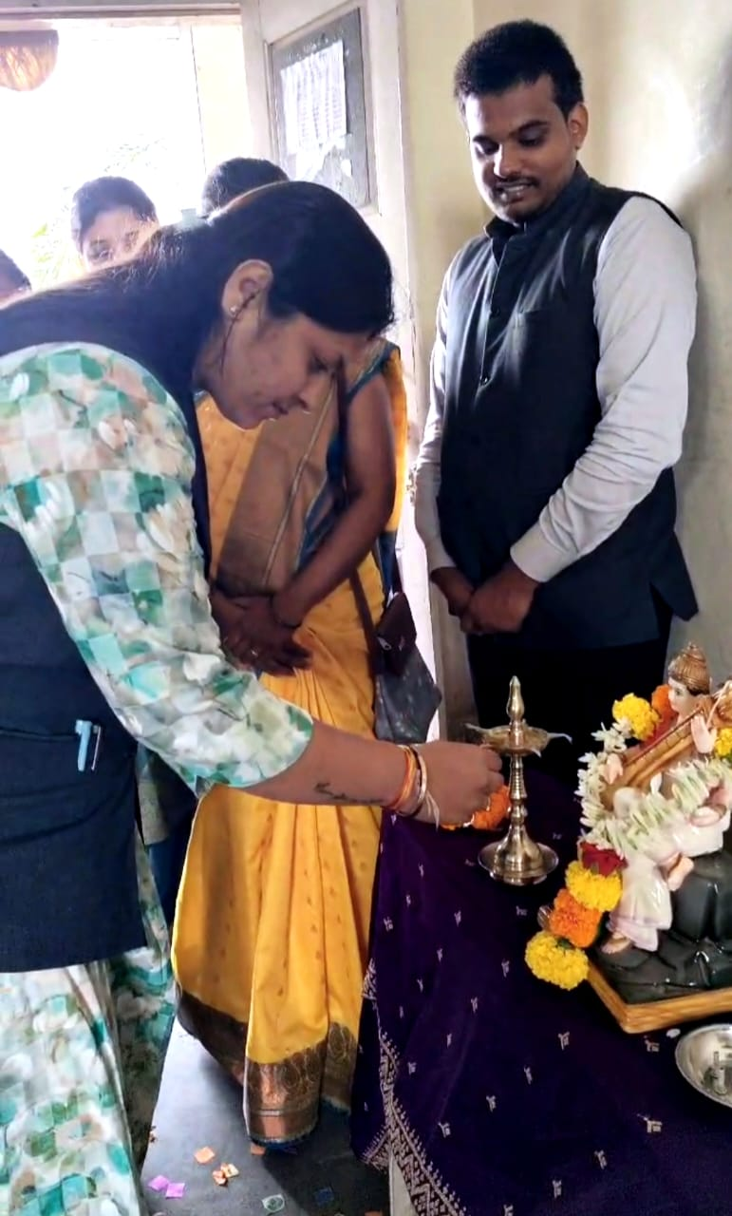
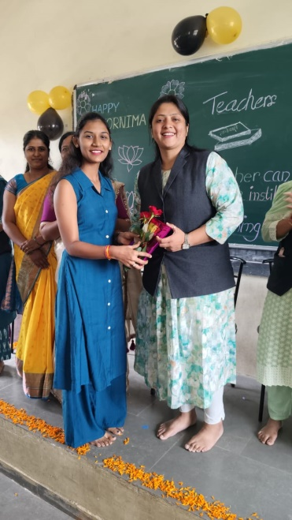

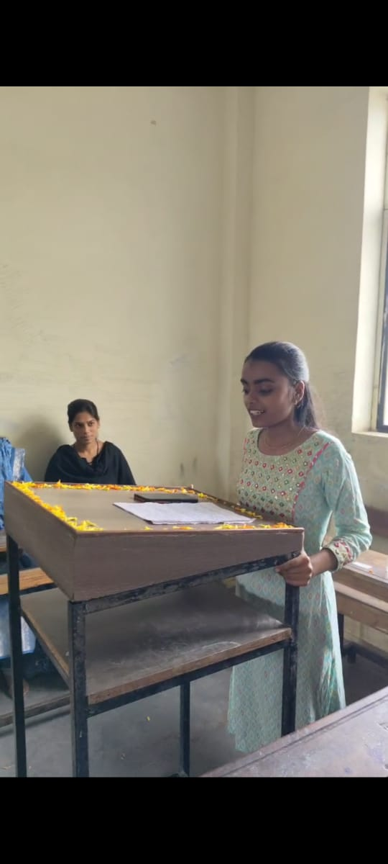

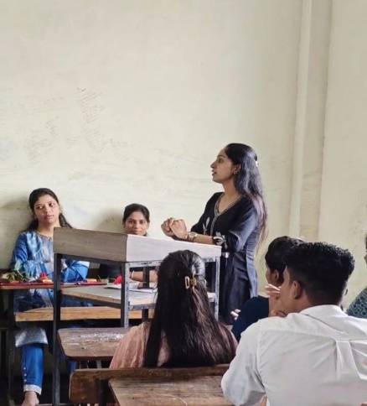

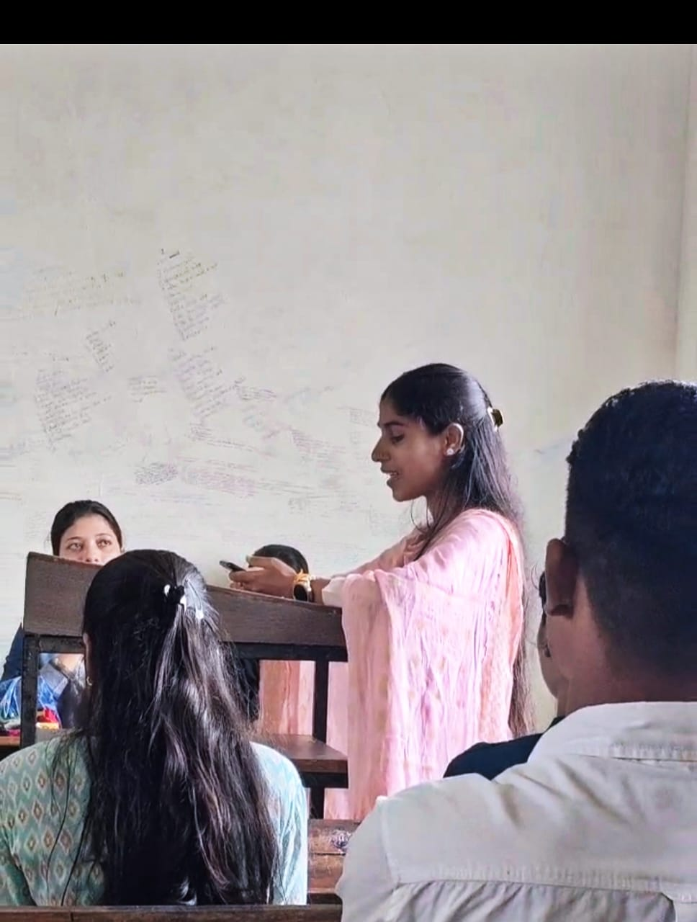

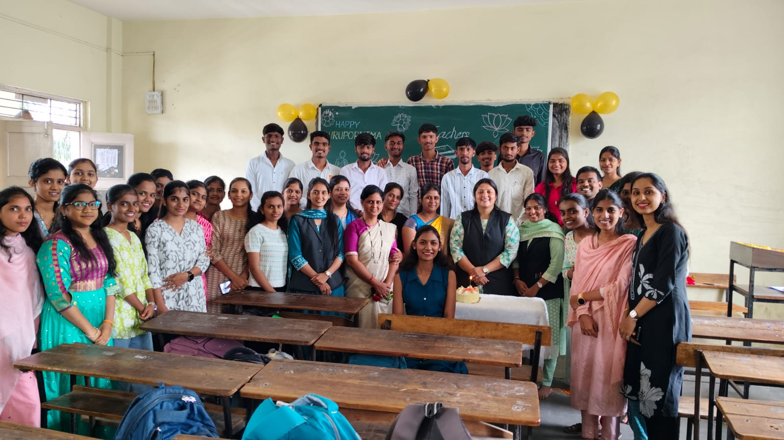

Attendance of student:-
Roll No. | Student Name | P/A
1 | Bute Sakshi Eknath | P
2 | Sawant Arjun Ravindra | P
3 | Jadhav Kirti Balasaheb | P
4 | Ingle Satish Milind | P
5 | Malande Hanuman Dhondiba | P
6 | Sukhdeve Prajoti Sumedh | P
7 | Wadekar Pragati Sunil | A
8 | Choudhari Saloni Shamrao | A
9 | Ghude Namrata Ramdas | P
10 | Kudale Prerana Rajendra | A
11 | Arade Vaishanvi Laxman | P
12 | Pawar Priyanka Arun | A
13 | Chavan Payal Sopan | P
14 | Saindane Payal Suresh | A
15 | Rasal Aishwarya Anil | P
16 | Sandbhor Anushka Sunil | P
17 | Pakhare Nikita Balkrishna | P
18 | Tembhekar Sachin Mahendra | P
19 | Kad Pranali Ashok | A
20 | Khandagale Prachi Mahendra | A
21 | Rathod Tanishq Satish | A
22 | Bomble Anushka Harishchandra | P
23 | Ghanwat Siddhi Tukaram | A
24 | Rakshe Shrutika Rajnikant | A
25 | Satkar Shweta Balasaheb | A
26 | Suryawanshi Omkar Durgadas | A
27 | Shinkar Sakshi Ganapat | P
28 | Ighe Nikita Anil | A
29 | Dabhade Roshni Vasant | P
30 | Mormare Karan Dinkar | P
31 | Surve Saniya Kamlesh | A
32 | Pachade Harshal Jagdish | P
33 | Sonwane Neha Pandit | P
34 | Chavan Siddhi Sudhakar | P
35 | Gaikwad Shruti Sunil | A
36 | Siddhi Dhamale | P
37 | Kamble Pratiksha Narayan | P
38 | Kamble Harish Balu | P
39 | Attar Bushra Ayaz | A
40 | Madage Ajay Khandu | P
41 | Matale Samrudhi Sanjay | A
42 | Sandbhor Rajvardhan Arun | A
43 | Talole Rushikesh Vitthal | A
44 | Walke Payal Kaluram | A
45 | Kedare Payal Ramesh | A
46 | Chakankar Mahesh Ajit | A
47 | Gorgile Vaishnavi Balaji | P
48 | Bhambure Nikita Atul | A
49 | More Simran Anna | A
50 | Sharma Payal Shivanand | A
51 | Gunjal Ashish Kisan | A
52 | Potale Shraddha Santosh | A
53 | Bawankule Priya Dashrath | P
54 | Vighe Shubham Vitthal | P
55 | Yelwande Nisha Suresh | A
56 | Yelwande Tejal Santosh | A
57 | Chavan Atharva Dyaneshwar | A
58 | Rakshe Aditi Suresh | A
59 | Pande Nishant Arun | P
60 | Patil Palak Ranjit | A
61 | Wadekar Pratiksha Vinod | P
62 | Salve Sayali Balasaheb | A

Dr.P.P.Oswal
HOD -BBA

