**K.T.S.P.MANDAL’S**

**HUTATMA RAJGURU MAHAVIDYALAYA**

RAJGURUNAGAR, TAL-KHED, DIST-PUNE 410501

**BBA DEPARTMENT (2024-25)**

A log sheet with the following details of program

|  |  |  |
| --- | --- | --- |
| Sr. No | Item | Particulars |
| 1 | Date | 17th Oct 2024 |
| 2 | Name of Field Visit | **Rajgurunagar Sahakari Bank Field Visit** |
| 3 | Venue | Rajgurunagar |
| 4 | Time | 12.30 pm to 2.30 pm |
| 5 | Duration of the program | 1 Day |
| 6 | Expense | - |
| 7 | Source of Financial Assistance | - |
| 8 | Names of resource persons | - |
| 9 | Name of coordinator | Prof. S.P.Borhade |
| 10 | Number of participants | 23 Students |
| 11 | Copy of the program | - |
| 12 | Curricular/Co-Curricular/Extra-Curricular | Extra-Curricular |
| 13 | Activity belongs to Which Criteria of NAAC | - |

Date: - 17th Oct , 2024

**Report**

**Objectives:**

Students of S.Y.BBA learnt about How to open a bank account.

Banking: Types of Accounts Basic knowledge of cheque banking:With New Technology.  
  
**Start time**: 12.30 pm to 2.30 pm had introduced a subject Financial Education for students. Before few years, this has been developed by adopting a functional approach. The need of financial education is to improve understanding of basic financial concepts and using them in our daily life. To know about various financial products and to become more aware of financial risks and opportunities to enable each one of us to make informed choices, and in return we can improve our financial well-being. The vision of financial education is that it could enable students, at their level of need, to understand the role of money in their life, the need and use of savings, the advantages of using the formal financial sector and various options to convert their savings into investments, protection through insurance and a realistic recognition of the attributes of these options. The objective of this activity was to create awareness and educate students on access to financial services (banking), availability of various types of services and their features and to make students understand their rights and responsibilities as customers of financial services.

**Introduction:** Bank Manager Mr. Sandbhor and their staff gave a warm welcome. The session was conducted by Mr. Rasakar, who gave a brief introduction on banking and he explained the visit to a bank is always informative.  
Working of the bank: The working of the bank is divided into many different departments which collectively handle the affairs of the bank. These departments have been provided with specific counters or windows where the customers have to stand in queue and wait for their turn. There are seats put up for the people who visit the bank for work. There are cabins provided for the managers and general manager of the bank. Mr. Rasakar made sure students have understood what is banking and how it is useful to individuals and businesses. Then Mr. Rasakar explained various counters/sections which are there in the bank.

At lasts the field visit ended by vote of thanks to all members of bank for supporting and coordinating with students.

After the field visit the students were given refreshments and informal banking discussion was carry forward between teacher & students. 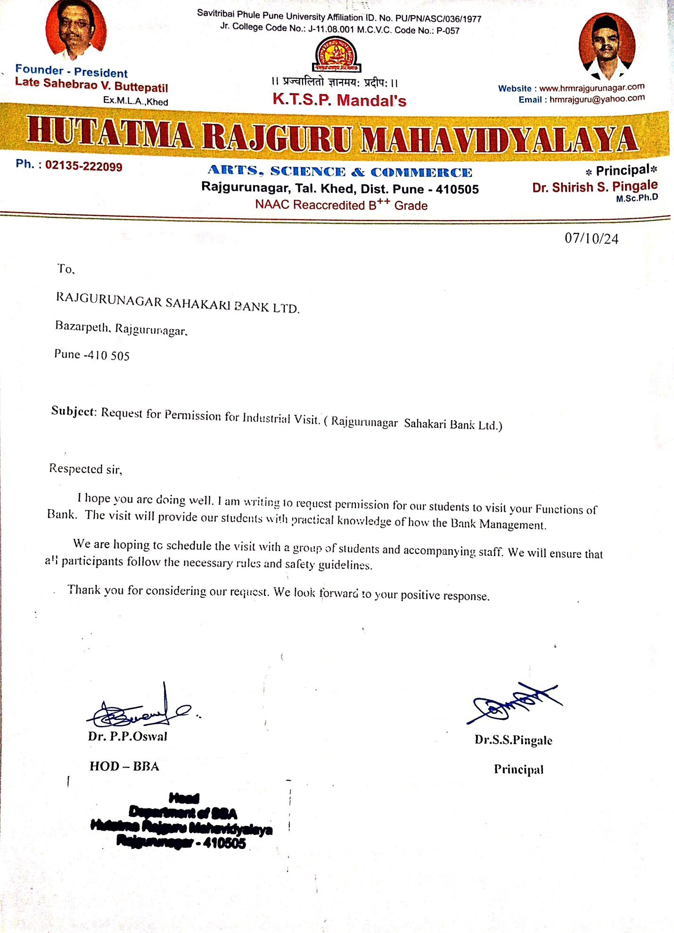

**Photos:-**

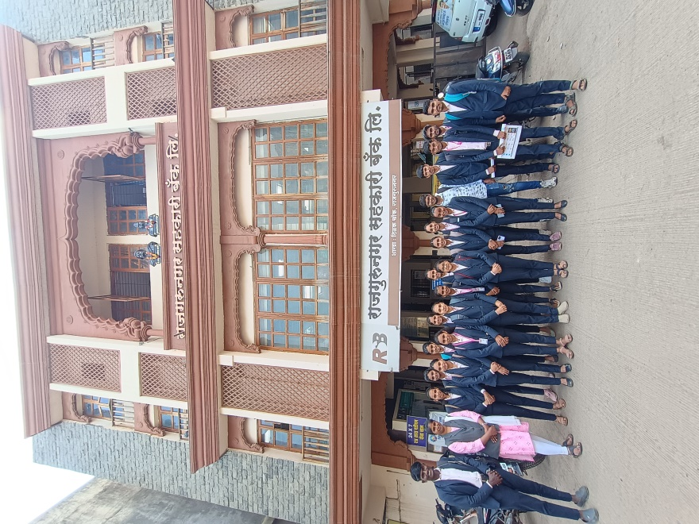

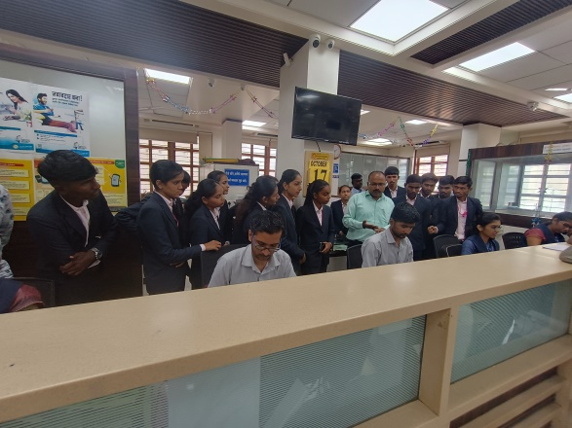

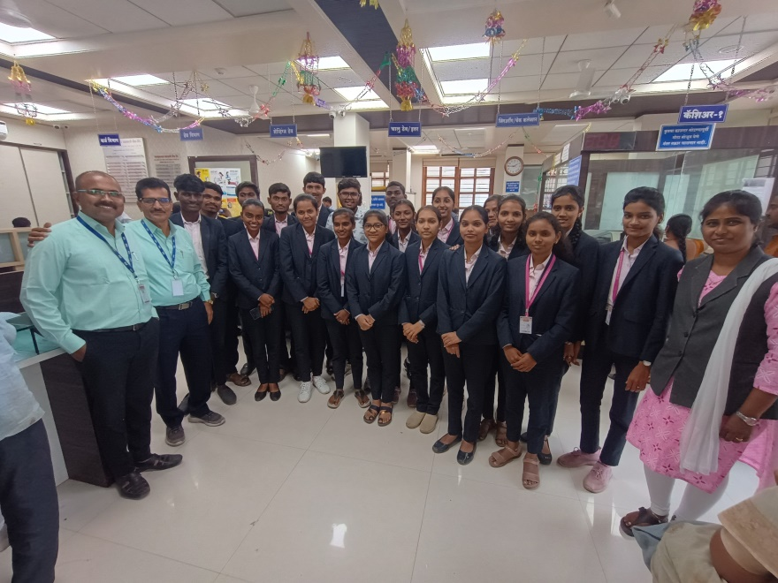

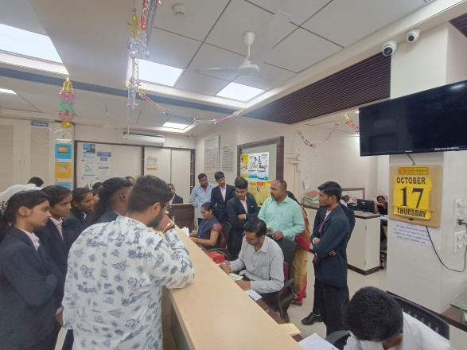

**Present Sheet –** 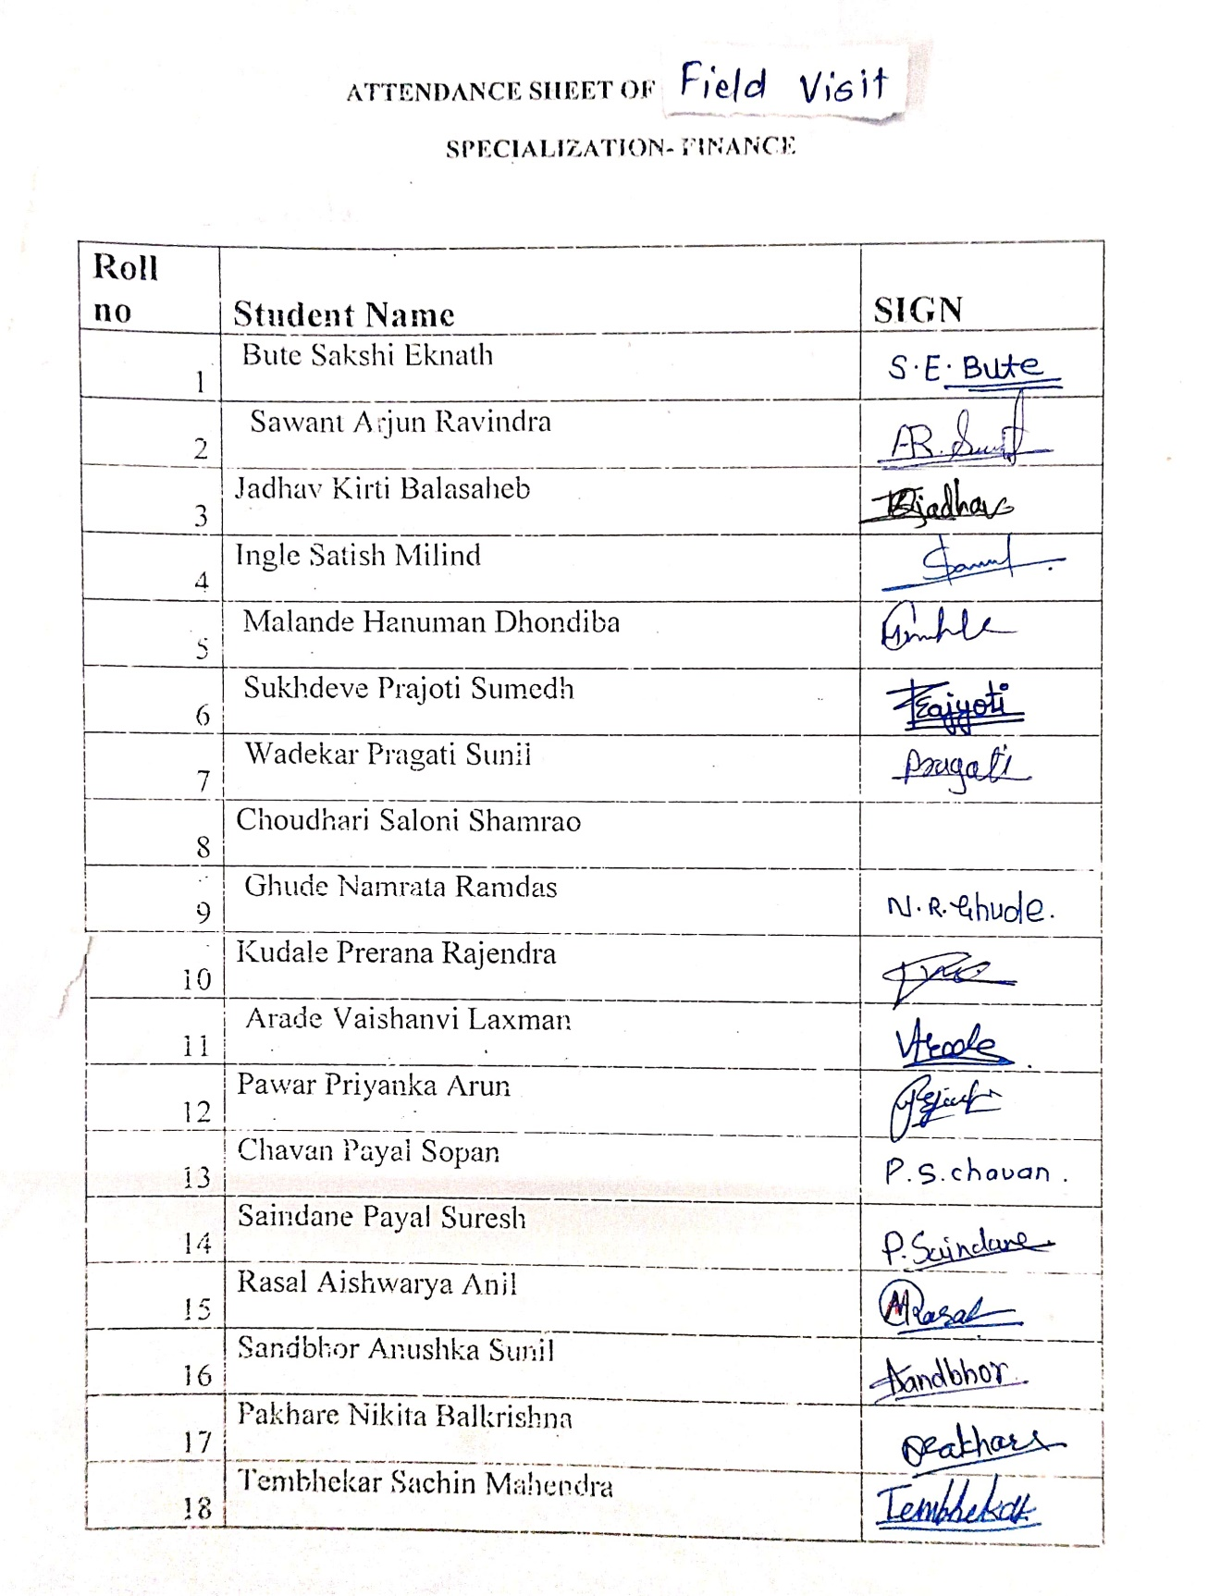

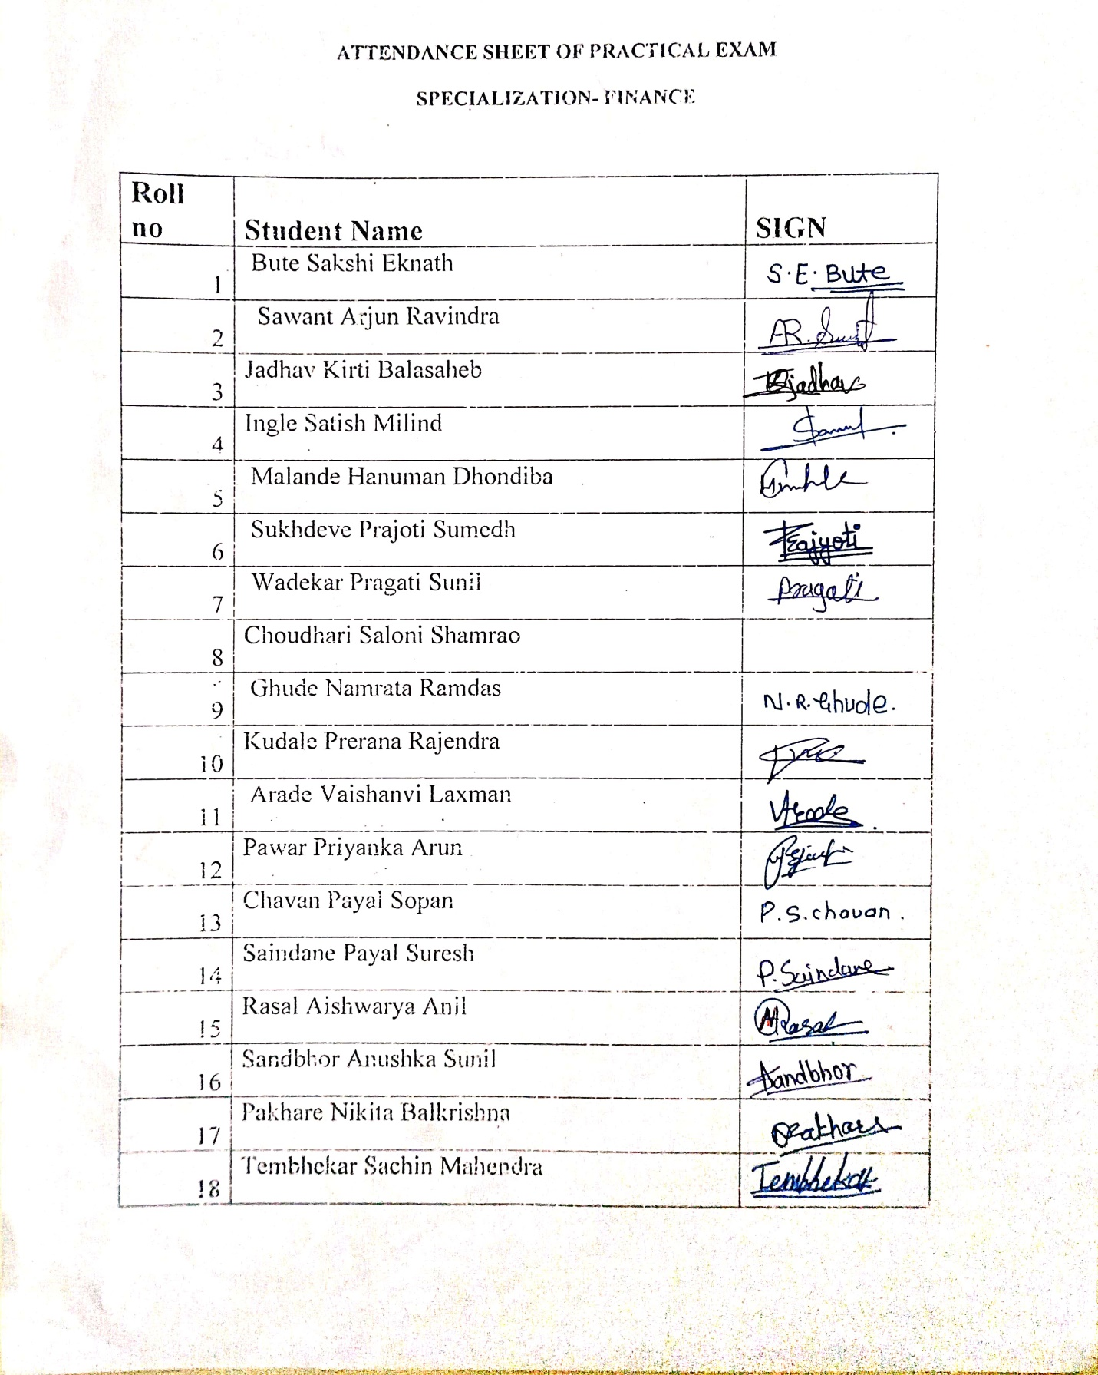

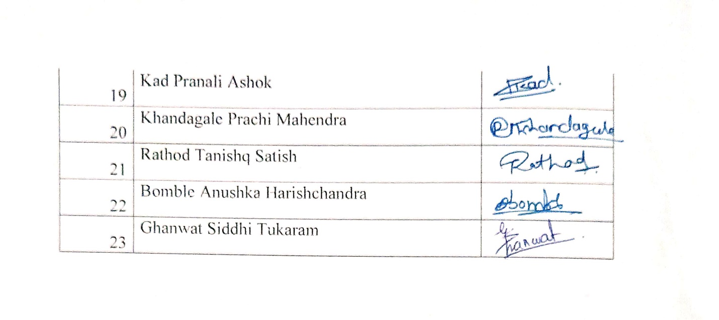

Dr.P.P.Oswal

HOD-BBA