ACTIVITY REPORT
Activity Name :- Resume Writing
The “Resume Writing” activity was conducted for the students of FYBBA on 06/01/2026 between 10:10 AM and 11:00 AM under the guidance of Prof. M.S. Bhogade. A total of 48 students actively participated in the session. The primary objective of this activity was to develop students’ understanding of how to prepare an effective and professional resume, which is an essential tool for career development and job applications. The session began with an introduction to the importance of resume writing in the professional world, highlighting how a well-structured resume can create a strong first impression on employers. Prof. Bhogade explained the key components of a resume, including personal details, career objectives, educational qualifications, skills, achievements, and extracurricular activities. Emphasis was placed on clarity, accuracy, and proper formatting while presenting information.
The students were guided on different types of resume formats and were made aware of common mistakes to avoid, such as including irrelevant information, grammatical errors, and poor layout. Practical tips were shared to make resumes more attractive and impactful, such as using concise language, proper headings, and highlighting key strengths. The session was interactive, with students asking questions and clarifying their doubts regarding resume preparation. They were also encouraged to begin drafting their own resumes using the guidelines provided during the session. Overall, the activity proved to be highly informative and beneficial, as it enhanced the students’ confidence and equipped them with the necessary skills to prepare professional resumes. The session successfully achieved its objectives and contributed positively to the students’ academic and career readiness.

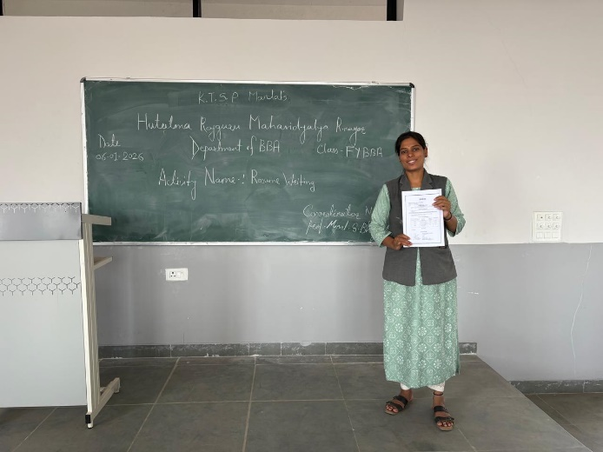
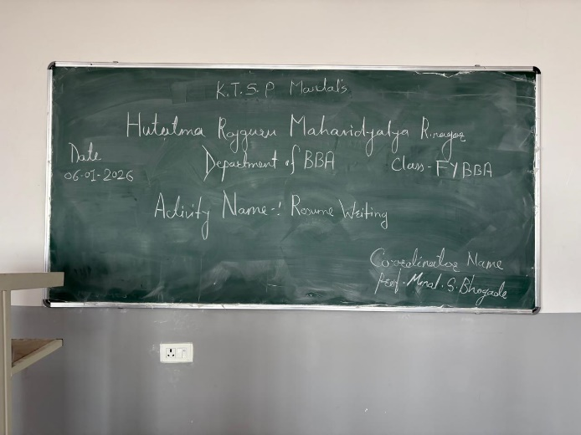
Photographs of Property

