ACTIVITY REPORT
Activity Name :- Tree Plantation
The activity on “Tree Plantation” was successfully organized for the students of FYBBA on 20th February 2026 under the guidance and coordination of Prof. L. S. Salunke and Prof. S. P. Borhade. A total of 68 students actively participated in this environmental initiative, which aimed to promote awareness about the importance of trees and environmental conservation. The primary objective of this activity was to instill a sense of responsibility among students towards nature and encourage them to contribute positively to the environment.
The program commenced with a brief introduction highlighting the importance of tree plantation in maintaining ecological balance. The coordinators explained how trees play a vital role in sustaining life by providing oxygen, improving air quality, conserving water, preserving soil, and supporting wildlife. Students were made aware of the growing environmental challenges such as deforestation, global warming, and climate change, and how tree plantation can be an effective solution to these problems. The session created awareness among students about the need to protect and nurture the environment for future generations.
Following the introduction, the plantation activity was carried out in the college campus and surrounding areas. Students, along with the coordinators, actively participated in planting various types of saplings. The activity was conducted in an organized manner where students were divided into groups, and each group was assigned specific areas for plantation. Necessary tools and materials such as saplings, water, and soil were arranged in advance to ensure smooth execution of the activity. The students worked enthusiastically, showing great teamwork and cooperation throughout the process.
During the activity, the coordinators provided guidance on proper planting techniques, including how to prepare the soil, place the sapling, and ensure adequate watering. Students were also educated about the importance of taking care of the plants after plantation, including regular watering, protection from damage, and monitoring growth. This practical exposure helped students understand that tree plantation is not just about planting trees but also about nurturing them for long-term environmental benefits.
The activity also emphasized the social and environmental benefits of tree plantation. Students learned that trees help in reducing pollution, controlling temperature, preventing soil erosion, and enhancing biodiversity. The coordinators highlighted how such initiatives contribute to creating a greener and healthier environment. Students were encouraged to take similar initiatives in their communities and spread awareness about environmental conservation among others.
The event witnessed enthusiastic participation from all 68 students, who showed great interest and dedication throughout the activity. The atmosphere was filled with energy and positivity as students actively engaged in the plantation work. The coordinators appreciated the efforts of the students and motivated them to continue contributing towards environmental sustainability. The activity also helped in developing a sense of unity, responsibility, and environmental consciousness among the participants.
In conclusion, the “Tree Plantation” activity proved to be a meaningful and impactful initiative for the FYBBA students. It successfully achieved its objective of creating awareness about environmental conservation and encouraging active participation in eco-friendly practices. The guidance and support of Prof. L. S. Salunke and Prof. S. P. Borhade played a crucial role in the successful execution of the activity. The participation of 68 students made the event a grand success. Overall, the activity not only enhanced students’ understanding of environmental issues but also inspired them to take responsibility for protecting and preserving nature for a better future.

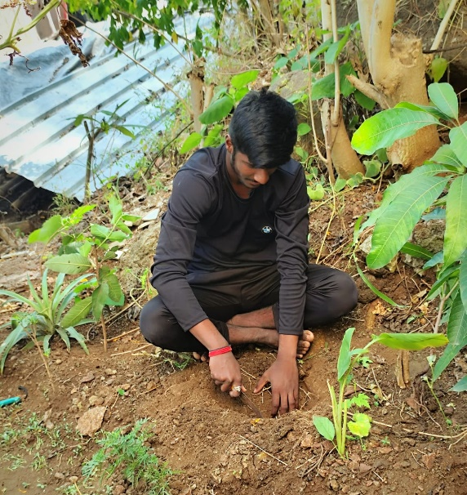
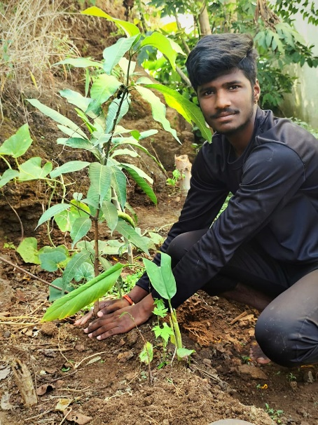
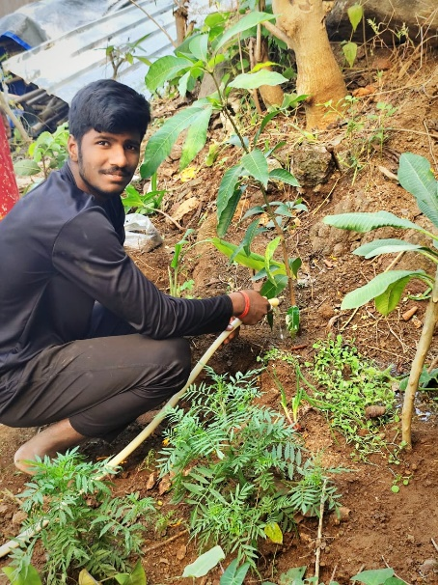
Photographs
