**K.T.S.P.MANDAL’S**

**HUTATMA RAJGURU MAHAVIDYALAYA**

RAJGURUNAGAR, TAL-KHED, DIST-PUNE 410501

**BBA DEPARTMENT (2024-25)**

A log sheet with the following details of program

|  |  |  |
| --- | --- | --- |
| Sr. No | Item | Particulars |
| 1 | Date | 10th January , 2025 |
| 2 | Name of Event | **“Industrial Exhibition ”** |
| 3 | Venue | Hutatma Rajguru Mahavidyalaya |
| 4 | Time | 09.30 AM to 1.30 P.M. |
| 5 | Duration of the program | 1 Day |
| 6 | Expense | - |
| 7 | Source of Financial Assistance | STUDENTS & BBA DEPARTMENT |
| 8 | Names of resource persons | Y.P.OSWAL |
| 9 | Name of coordinator | DR. P.P.OSWAL |
| 10 | Number of participants | All FY & SYBBA Students |
| 11 | Copy of the programme | - |
| 12 | Curricular/Co-Curricular/Extra-Curricular | Extra-Curricular |
| 13 | Activity belongs to Which Criteria of NAAC | - |

Date:- 10th January ,2025

**Report**

The BBA Exhibition held on January 10, 2025, at Hutatma Rajguru Mahavidyalaya was a grand success. The event was graced by the esteemed presence of Chief Guest Mr.Ravindra Jagdale, Mr. Nilesh Pawale and Miss Utkarsha Wakode, executive and manager of Spark Minda Company, Adv. Devedraji Buttepatil, the Chairman of KTSP Mandal’s and Nanasaheb Takalkar, Vice Chairman of KTSP Mandal’s, The Principal of Hutatma Rajguru Mahavidyalaya, Dr. S.S.Pingale, BBA faculty, and enthusiastic students.

The event began with a warm welcome extended to the dignitaries and guests. Adv. Devedraji Buttepatil delivered an inspiring address, emphasizing the importance of education and leadership in the field of business administration. His insightful words motivated the students and faculty alike.

Nanasaheb Takalkar, in his role as Vice Chairman of KTSP Mandal, also shared his valuable insights and encouraged the students to excel in their academic journey. The entire gathering had the privilege of hearing from all the directors, who shared their vision for the BBA program. Principal Dr.Shirish Pingale sir give best wishes for all BBA students.

Dr P.P.OSWAL also extended a warm welcome to all present and stressed on the importance of learning management skills and developing a futuristic orientation. Special guest were invited Mr.Ravindra Jagdale, Mr. Nilesh Pawale and Miss Utkarsha Wakode, executive and manager of Spark Minda company. All three of them gave career guidance to the students about the growth in positions.

After high school, moving to college is the most anticipated phase in the life of a student. One prominent point of comparison between college life & school life that everyone would agree with is; college gives a sense of freedom to students. In school, students follow the instruction of teachers & parents, but, in college, one likes to take charge of his/her life. Well, with freedom comes responsibility. This is the one life lesson that colleges aim to inculcate in students apart from course work. Through various training & programs, the college administration indirectly teaches students to become responsible for their life. However, the first step that a college takes towards this is through the induction program. Yes, the day that most students believe makes no sense. Well, it does. It is so important that the education ministry of India has made it mandatory. In this report, we will tell you all the reasons why it holds a lot of importance for a fresher.

1. Life Lessons For The Future: Induction programs usually have a session from experts who can impart life lessons. Listening to someone with experience of life can fill students with enthusiasm & energy to take-on this new step of life.

2. Add-On Information: Colleges offer a variety of additional courses that are mentioned in the brochure, but, are generally ignored by the students. During an induction program, the faculty introduces these add-on programs that students can join.

3. Familiarization with Department: As a student, you will spend 2-4 years of your life as part of a specific department in the college. Getting acquainted with department heads in advance can be very vital for students. Getting to know who the professors are, where will classes be held, at what timings, and where the laboratories are can ensure that you do not enter college at day one with a blank mind!

4. Meet Your Mates: To enter a class with friends on day one of college can be a blissful feeling. An induction program can help you meet & interact with all your batch mates and make friends

The success and smooth conduct of program is an evidence of the management skills and initiative taking abilities of our SYBBA Batch 2024-25 and taking inspiration by FYBBA batch 2024-25

DR .P.P.OSWAL

HOD of BBA

Topics of project were:

|  |
| --- |
| Group 1- Bank |
| 1. Rakshe Shrutika Rajnikant |
| 1. Salve Sayali Balasaheb |
| 1. Bute Sakshi Eknath |
| 1. Gorgile Vaishnavi Balaji |
| 1. Sawant Arjun Ravindra |

|  |
| --- |
| Group 7- Agricultural Traditional Vs Modern |
| 1. Sukhdeve Prajoti Sumedh |
| 1. Suryawanshi Omkar Durgadas |
| 1. More Simran Anna |
| 1. Bawankule Priya Dashrath |
| 1. Rasal Aishwarya Anil |

|  |
| --- |
| Group 2 - Urban Vs Rural |
| 1. Jadhav Kirti Balasaheb |
| 1. Dabhade Roshni Vasant |
| 1. Vighe Shubham Vitthal |
| 1. Tembhekar Sachin Mahendra |
| 1. Potale Shraddha Santosh |

|  |
| --- |
| Group 8- Share Market |
| 1. Wadekar Pragati Sunil |
| 1. Chavan Siddhi Sudhakar |
| 1. Kamble Harish Balu |
| 1. Kedare Payal Ramesh |
| 1. Choudhari Saloni Shamrao |

|  |
| --- |
| Group 3- Small Scale Industries |
| 1. Yelwande Tejal Santosh |
| 1. Bhambure Nikita Atul |
| 1. Chavan Payal Sopan |
| 1. Pachade Harshal Jagdish |
| 1. Sonwane Neha Pandit |

|  |
| --- |
| Group 9- Pollution Control |
| 1. Rathod Tanishq Satish |
| 1. Ghude Namrata Ramdas |
| 1. Ighe Nikita Anil |
| 1. Rakshe Aditi Suresh |
| 1. Pakhare Nikita Balkrishna |

|  |
| --- |
| Group 4- Evaluation Of Coins & Notes |
| 1. Ingle Satish Milind |
| 1. Surve Saniya Kamlesh |
| 1. Sharma Payal Shivanand |
| 1. Chakankar Mahesh Ajit |
| 1. Shinkar Sakshi Ganapat |

|  |
| --- |
| Group 10- Ai Robotics |
| 1. Gosavi Manthan Vishwanath |
| 1. Bomble Anushka Harishchandra |
| 1. Kad Pranali Ashok |
| 1. Yelwande Nisha Suresh |
| 1. Saindane Payal Suresh |
| 1. Gunjal Ashish Kisan |

|  |
| --- |
| Group 5- Ecofriendly Sources Of Energy |
| 1. Malande Hanuman Dhondiba |
| 1. Khandagale Prachi Mahendra |
| 1. Gaikwad Shruti Sunil |
| 1. Patil Palak Ranjit |
| 1. Walke Payal Kaluram |

|  |
| --- |
| Group 11- Supermarket Working |
| 1. Kudale Prerana Rajendra |
| 1. Madage Ajay Khandu |
| 1. Sandbhor Anushka Sunil |
| 1. Pawar Priyanka Arun |
| 1. Shinde Mansing Hiraman |

|  |
| --- |
| Group 12- Waste Management |
| 1. Satkar Shweta Balasaheb |
| 1. Sandbhor Rajvardhan Arun |
| 1. Matale Samrudhi Sanjay |
| 1. Attar Bushra Ayaz |
| 1. Pande Nishant Arun |

**Photos:-**

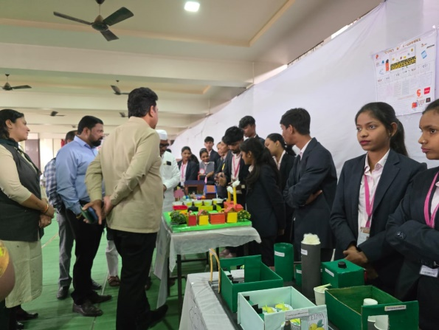

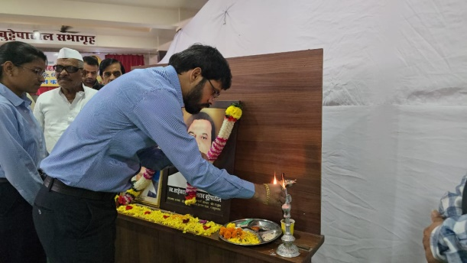

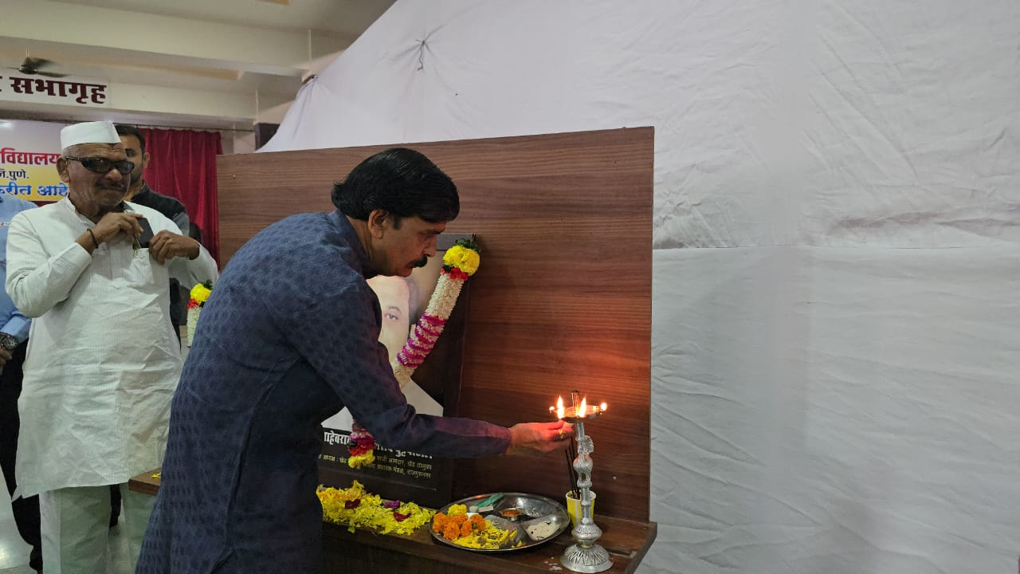

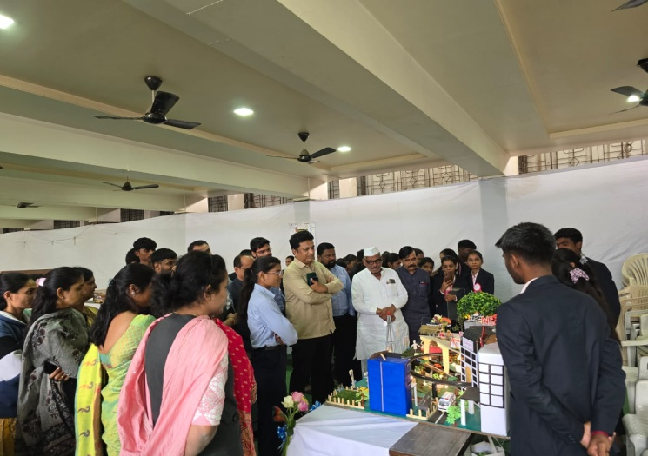

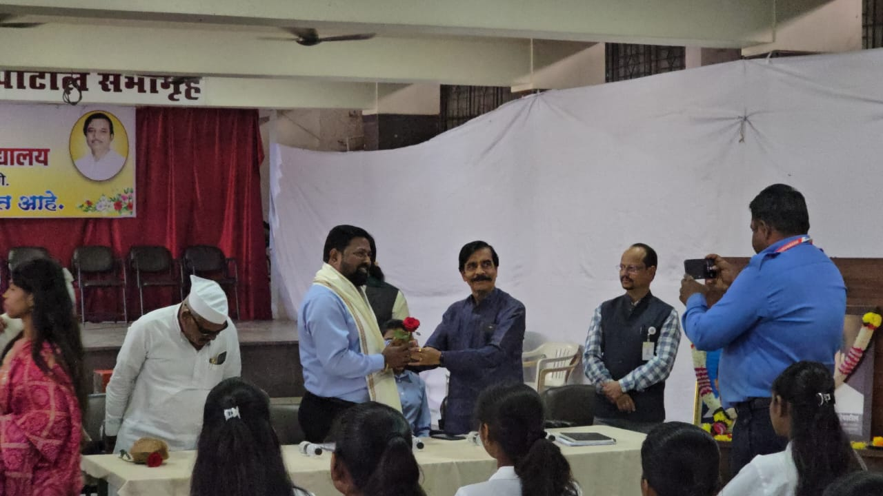

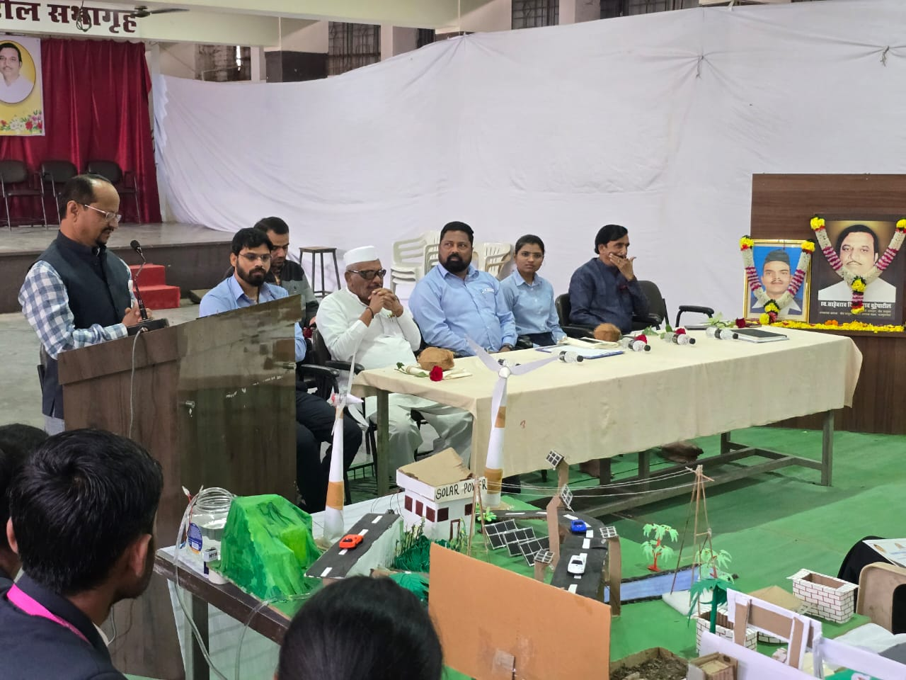

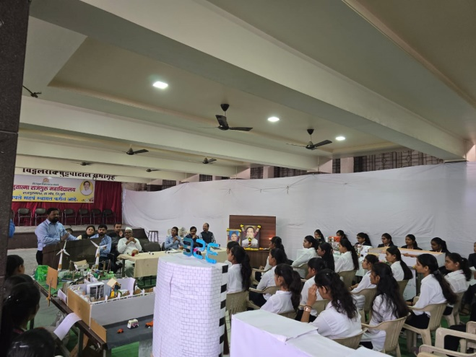

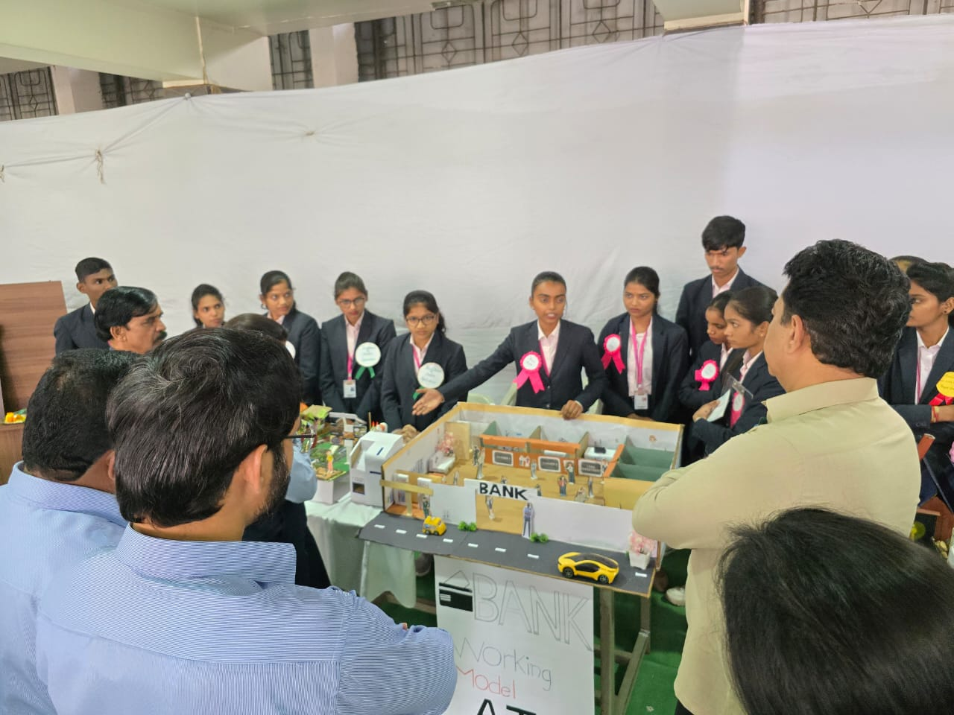

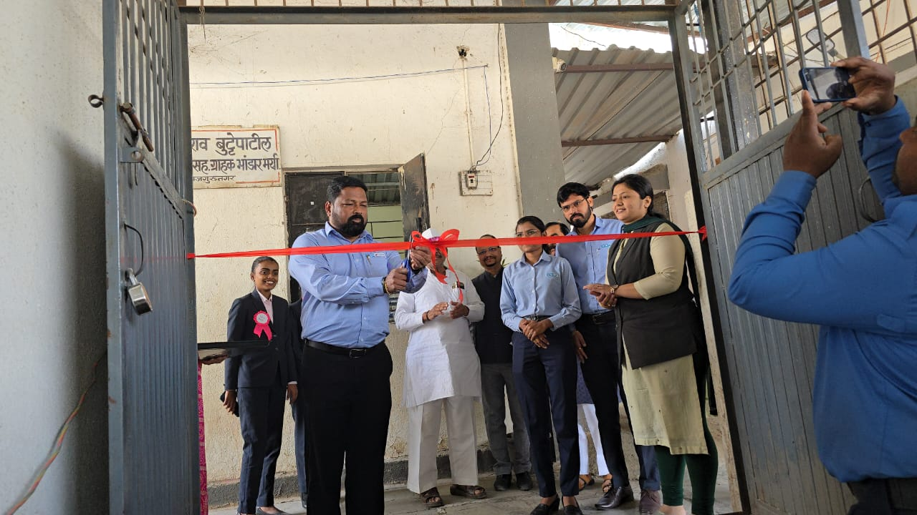

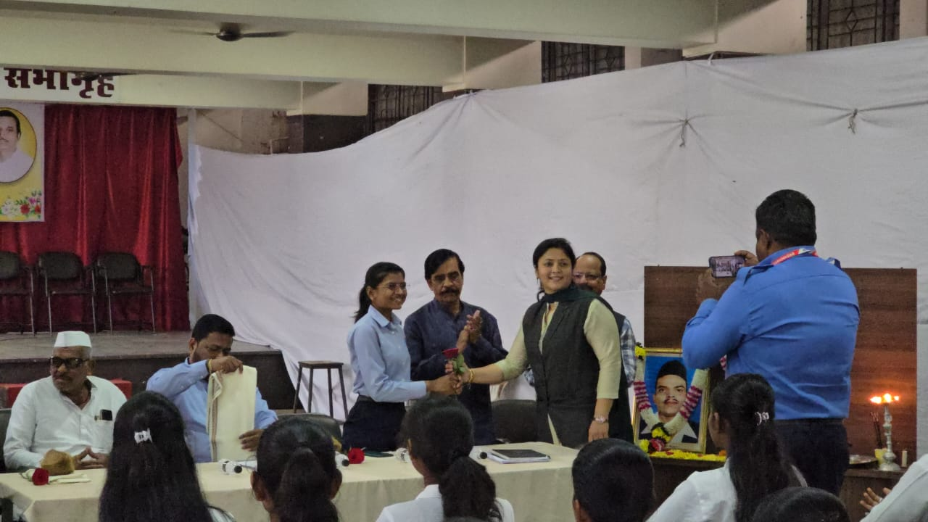

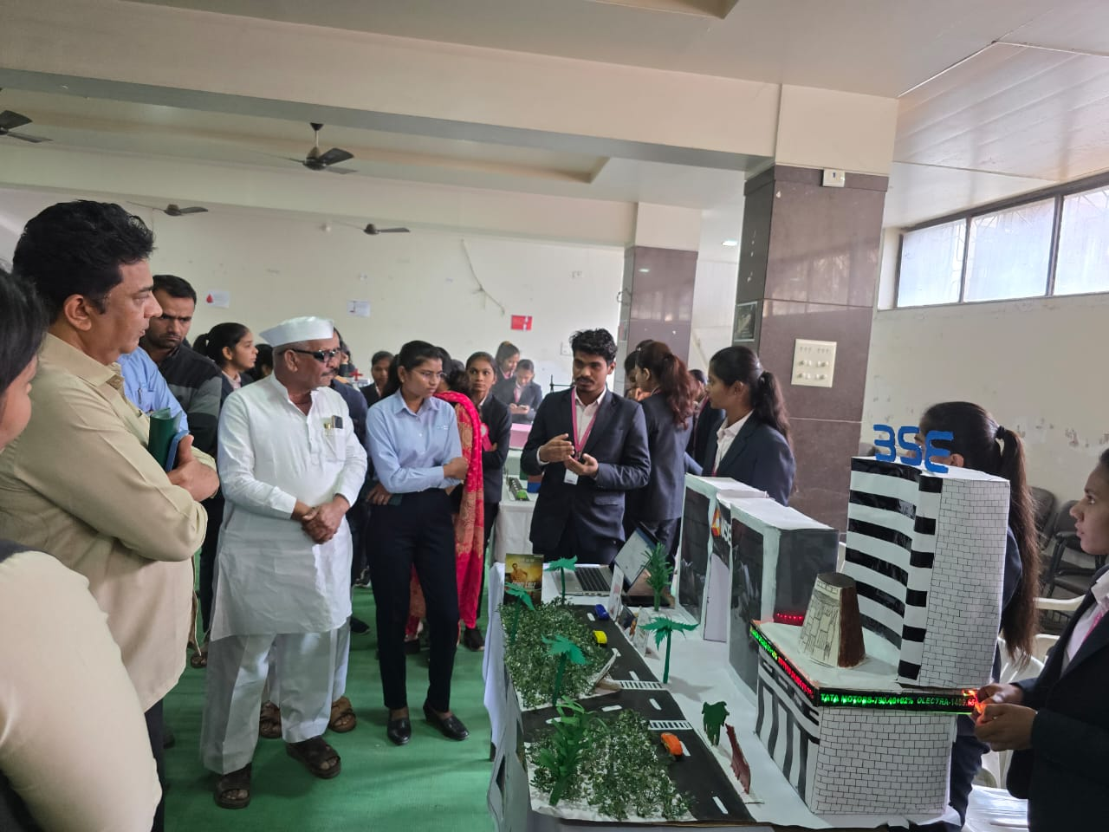



**Attendance of student:-**

|  |  |  |
| --- | --- | --- |
| **Roll no** | **Student Name** |  |
| 1 | Bute Sakshi Eknath | P |
| 2 | Sawant Arjun Ravindra | P |
| 3 | Jadhav Kirti Balasaheb | P |
| 4 | Ingle Satish Milind | P |
| 5 | Malande Hanuman Dhondiba | P |
| 6 | Sukhdeve Prajoti Sumedh | P |
| 7 | Wadekar Pragati Sunil | P |
| 8 | Choudhari Saloni Shamrao | P |
| 9 | Ghude Namrata Ramdas | P |
| 10 | Kudale Prerana Rajendra | P |
| 11 | Arade Vaishanvi Laxman | P |
| 12 | Pawar Priyanka Arun | P |
| 13 | Chavan Payal Sopan | P |
| 14 | Saindane Payal Suresh | P |
| 15 | Rasal Aishwarya Anil | P |
| 16 | Sandbhor Anushka Sunil | P |
| 17 | Pakhare Nikita Balkrishna | P |
| 18 | Tembhekar Sachin Mahendra | P |
| 19 | Kad Pranali Ashok | P |
| 20 | Khandagale Prachi Mahendra | P |
| 21 | Rathod Tanishq Satish | P |
| 22 | Bomble Anushka Harishchandra | P |
| 23 | Ghanwat Siddhi Tukaram | P |
| 24 | Rakshe Shrutika Rajnikant | P |
| 25 | Satkar Shweta Balasaheb | P |
| 26 | Suryawanshi Omkar Durgadas | P |
| 27 | Shinkar Sakshi Ganapat | P |
| 28 | Ighe Nikita Anil | P |
| 29 | Dabhade Roshni Vasant | P |
| 30 | Mormare Karan Dinkar | P |
| 31 | Surve Saniya Kamlesh | P |
| 32 | Pachade Harshal Jagdish | P |
| 33 | Shinde Mansing Hiraman | P |
| 34 | Sonwane Neha Pandit | P |
| 35 | Chavan Siddhi Sudhakar | P |
| 36 | Gaikwad Shruti Sunil | P |
| 37 | Gosavi Manthan Vishwanath | P |
| 38 | Kambale Pratiksha Narayan | P |
| 39 | Kamble Harish Balu | P |
| 40 | Attar Bushra Ayaz | P |
| 41 | Madage Ajay Khandu | P |
| 42 | Matale Samrudhi Sanjay | P |
| 43 | Sandbhor Rajvardhan Arun | P |
| 44 | Talole Rushikesh Vitthal | P |
| 45 | Walke Payal Kaluram | P |
| 46 | Kedare Payal Ramesh | P |
| 47 | Chakankar Mahesh Ajit | P |
| 48 | Gorgile Vaishnavi Balaji | P |
| 49 | Bhambure Nikita Atul | P |
| 50 | More Simran Anna | P |
| 51 | Sharma Payal Shivanand | P |
| 52 | Gunjal Ashish Kisan | P |
| 53 | Potale Shraddha Santosh | P |
| 54 | Bawankule Priya Dashrath | P |
| 55 | Vighe Shubham Vitthal | P |
| 56 | Yelwande Nisha Suresh | P |
| 57 | Yelwande Tejal Santosh | P |
| 58 | Chavan Atharva Dyaneshwar | P |
| 59 | Rakshe Aditi Suresh | P |
| 60 | Pande Nishant Arun | P |
| 61 | Patil Palak Ranjit | P |
| 62 | Wadekar Pratiksha Vinod | P |
| 63 | Salve Sayali Balasaheb | P |

|  |  |  |
| --- | --- | --- |
|  | Dhandre Dnyaneshwar Gaurav | P |
|  | Patel Hardik Vasant | P |
|  | Matale Rutuja Dattatray | P |
|  | Patil Siddhi Manohar | P |
|  | Bhalerao Rahul Bharat | P |
|  | Walunj Tanuja Rohidas | P |
|  | Barge Bhagyashree Pravin | P |
|  | Gaikwad Saill Vijay | P |
|  | Shinde Sayee Pandurang | P |
|  | Kedari Parth Sushil | P |
|  | Ishte Ashik Ganpat | P |
|  | Kad Mayor Anil | P |
|  | Khumbhar Parmeshwari Laxam | P |
|  | Shinde Sanika Sambhudev | P |
|  | Dhakne Pradip Maroti | P |
|  | Takalkar Sanika Balasaheb | P |
|  | Shingote Ashwini Ganpat | P |
|  | Walunj Shreya Dilip | P |
|  | Kedari Akanksha Bansi | P |
|  | Lokhande Renuka Dinesh | P |
|  | Aadil Sahir Sikilgar | P |
|  | Jafare Onkar Vilas | P |
|  | Borhade Rutik Laxman | P |
|  | Gade Samruddhi Suresh | P |
|  | Sanap Suhas Shahadev | P |
|  | Awari Somnath Ananda | P |
|  | Jare Sarthak Balasaheb | P |
|  | Kadam Mohit Sunil | P |
|  | Kad Shreyash Dilip | P |
|  | Fadke Ganesh Santosh | P |
|  | Ghule Ritika Mahendra | P |
|  | Mandekar Pritam Shankar | P |
|  | Inamdar Saniya Shakil | P |
|  | Abijith Ajith Pappachan | P |
|  | Diksha Kishor Lagas | P |
|  | Rakshe Siddhi Santosh | P |
|  | Paswan Tamannakunari Rampreet | P |
|  | Khandagale Vaishnavi Kumar | P |
|  | Bandwane Shweta Santosh | P |
|  | Diksha Kishor Lagas | p |

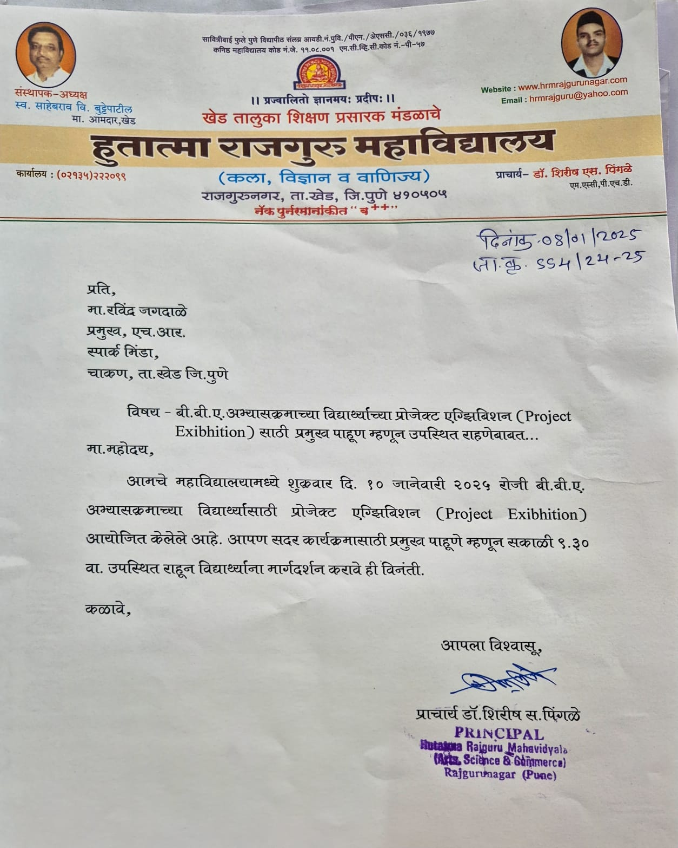

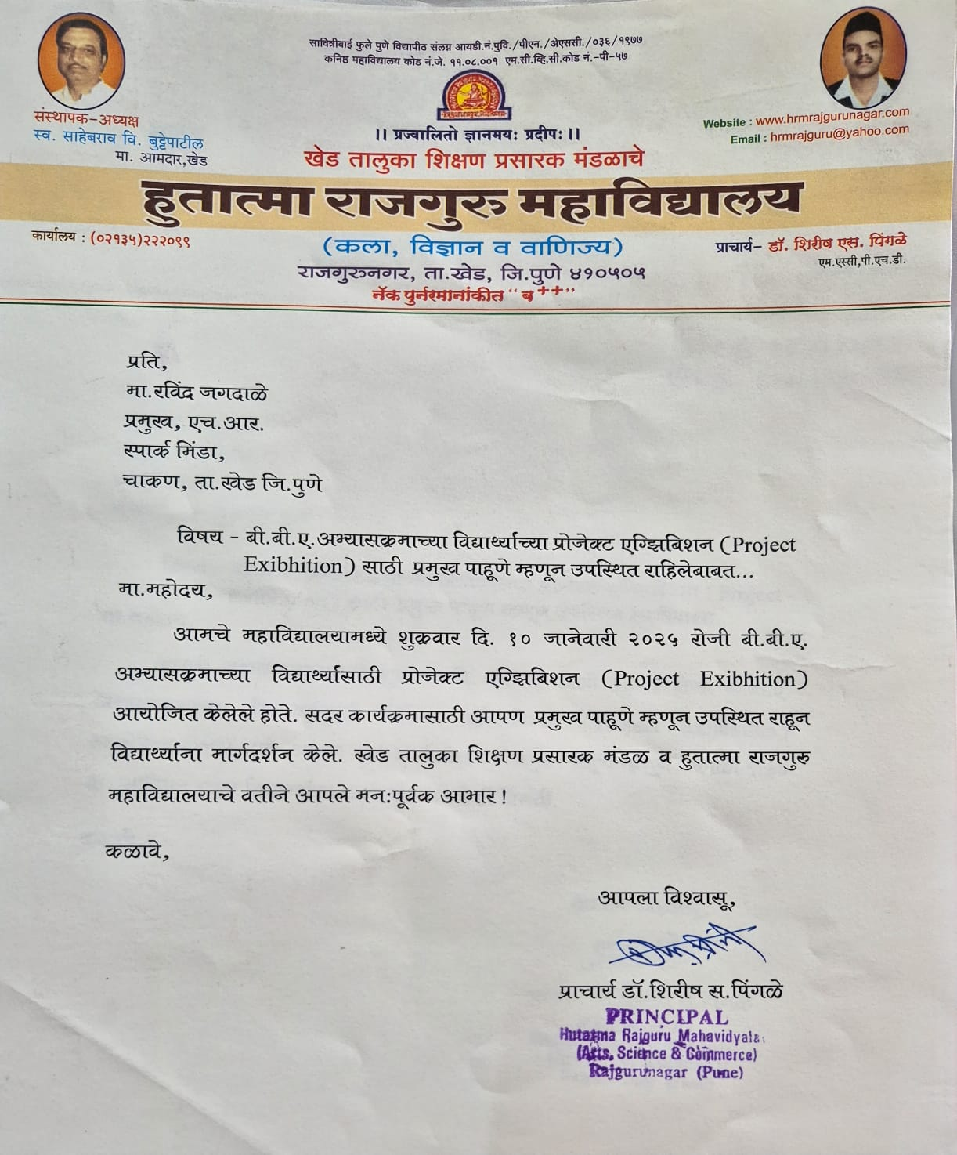

Dr.P.P.Oswal

Head of Department