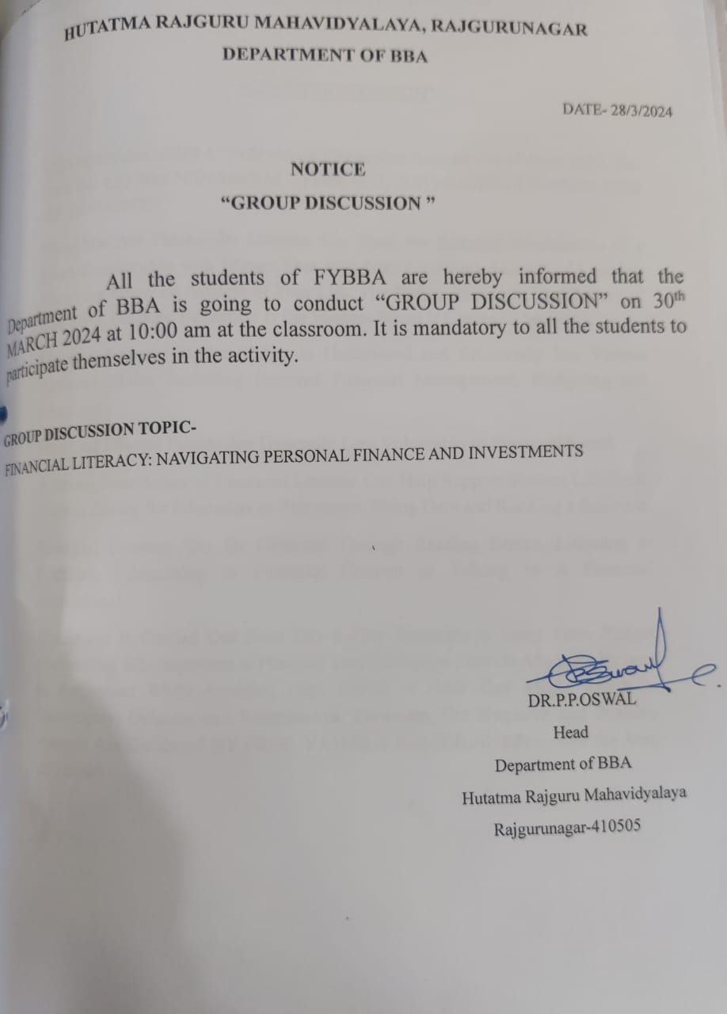

**GROUP DISCUSSION**

**THE GROUP DISCUSSION COMPETITION WAS PROPOSED UNDER THE THEME OF “ FINANCIAL LITERACY, NAVIGATING PERSONAL FINANCE AND INVESTMENTS”, ORGANIZED BY THE DEPARTMENT OF BBA ON 30TH MARCH 2024 AT 10.00 AM IN CLASSROOM.**

**THE MAIN OBJECTIVES OF THE STUDY WAS 1. TO STUDY THE IMPACT OF DIFFERENT DEMOGRAPHIC FACTORS ON FINANCIAL LITERACY. 2. TO STUDY THE VARIATION BETWEEN PERSONAL INVESTMENT DECISION OF THE INVESTORS OF DIFFERENT FINANCIAL LITERACY LEVEL WITH RESPECT TO SHORT, MEDIUM AND LONG TERM. 3. TO STUDY THE RELATIONSHIP BETWEEN FINANCIAL LITERACY AND PERSONAL INVESTMENT DECISIONS.**

**THE STUDY WAS UNDERTAKEN TO ACCESS THE LEVEL OF FINANCIAL LITERACY AMONG THE STUDENTS, TO STUDY THE IMPACT OF**

**DIFFERENT DEMOGRAPHIC FACTORS ON FINANCIAL LITERACY AND TO STUDY THE VARIATION BETWEEN PERSONAL INVESTMENT**

**DECISION OF DIFFERENT FINANCIAL LITERACY LEVEL WITH RESPECT TO SHORT, MEDIUM AND LONG TERM. MANY TYPES OF PERSONAL INVESTMENT AND THEIR WORKING WAS DISCUSSED INVESTING IN**

* **STOCKS.**
* **CERTIFICATE OF DEPOSIT.**
* **BONDS.**
* **INVESTING IN REAL ESTATE.**
* **FIXED DEPOSITS.**
* **MUTUAL FUNDS.**
* **PPF (PUBLIC PROVIDENT FUND)**
* **(NPS) NATIONAL PENSION SYSTEM.**

**THIS GROUP DISCUSSION WAS COMPLETEED UNDER THE GUDANCE OF HEAD OF DEPARTMENT DR PROF.P.P.OSWAL, AND WAS CONDUCTED BY PROF. Y.R.SEMLANI. AT THE LAST STUDENTS WERE ENCOURAGED TO DO PERSONAL INVESTMENT.**

