K.T.S.P.Mandal’s
HutatmaRajguruMahavidyalaya,Rajgurunagar
NationalServiceScheme

Notice

Date: 19/06/2026

We are delighted to announce that NSS unit of Hutatma Rajguru Mahavidyalaya will be organizing a specialevent to celebrate InternationalYoga Day. The event will take place on Saturday, 20th June, and aimsto promotethe practice ofyoga forphysical and mental well-being. We encourage all students to actively participate in this event and experience the transformative power of yoga.
EventDetails:
- Date:Saturday,20th June 2026
- Time:at 8.15 am
- Venue: Sabhagruh New Building

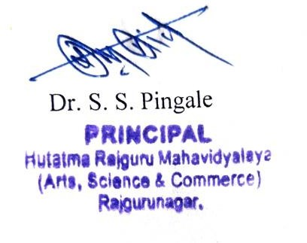
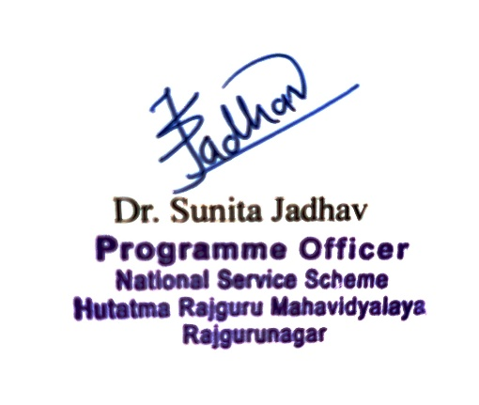


K.T.S.P.MANDAL’S
HUTATMA RAJGURU MAHAVIDYALAYA RAJGURUNAGAR,TAL-KHED,DIST-PUNE410501
National Service Scheme

Sr. No | Item | Particulars
1 | Date | 20stJune2026
2 | NameofEvent | InternationalYogaDay
3 | Venue | HutatmaRajguru  Mahavidyalaya,Rajgurunagar
4 | Time | 8.15a.m.
5 | Durationoftheprogramme | Oneday
6 | Expense
7 | SourceofFinancialAssistance | NSS
8 | Namesofresourcepersons | -
9 | Nameofcoordinator | NSSProgramofficer
10 | Numberofparticipants | 76
11 | Curricular/Co-Curricular/Extra-  Curricular | Extra-Curricular
12 | ActivitybelongstoWhichCriteriaof  NAAC | III

Report
On Saturday, 20st June, the yoga demonstration was organized in accordance with the significance of International Yoga Day. Yoga holds great importance for individuals of all ages as it promotes knowledge and good health. By practicing yoga asanas, everyone can maintain their mental and physicalwell-being, and it has proven to be effective against various disorders and helps in controlling the mind, leading to a happier and healthier life. Therefore, it was emphasized that everyone should practice yoga. OntheoccasionofInternationalYoga Day, on21st June, all the professors, staff members, NSS, NCC, and sports department students participated in the Common Yoga Protocol, following the prescribed yoga asanas. During this time Mr. Saurabh Botra provided information about the asanas, and demonstrated the asanas by online.
The program was attended by the Principal Dr. Shirish Pingale, Dr. Sanjay Shinde, all professors, staff members, NSS, NCC,andsportsdepartment students. Dr.Sunita Jadhav , Prof. S.R. Thorat , Prof. M.L.Muluk Dr.Y.S.Walunj initiated and introduced the program, while Prof. Pratima Lonari expressed the gratitude.

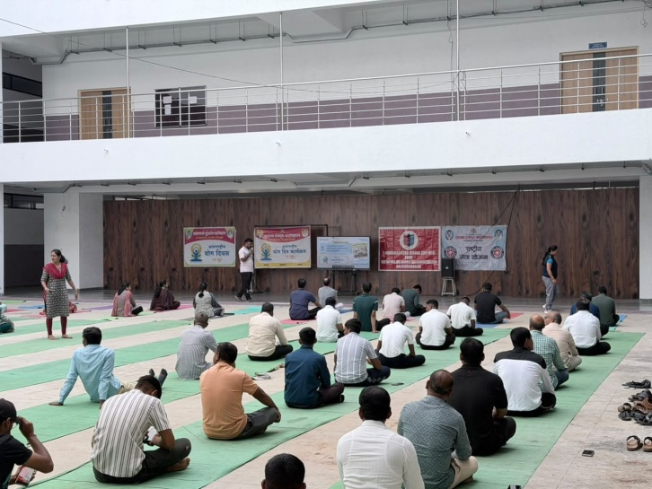

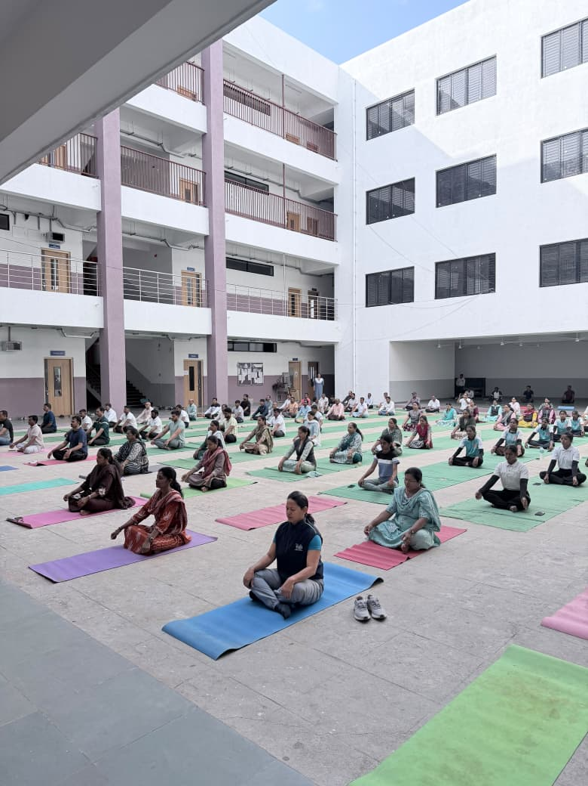

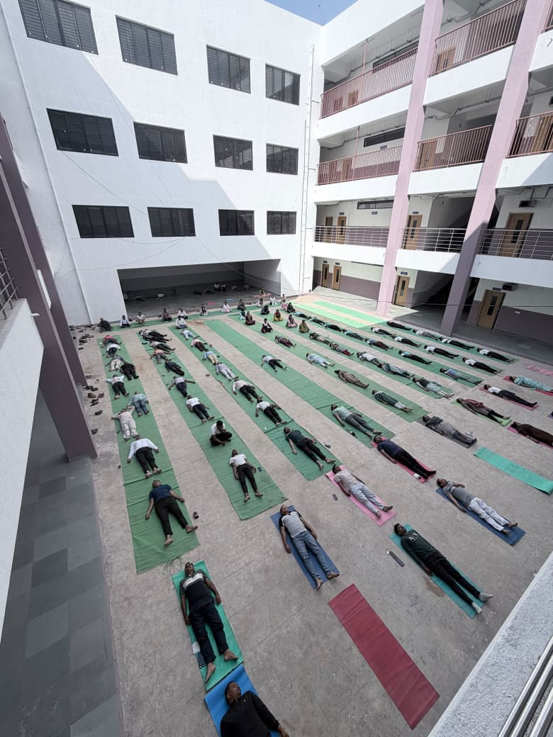

StaffandNSSvolunteerswhileperformingyoga
