KTSP Mandal’s
HutatmaRajguruMahavidyalaya,Rajgurunagar

NationalServiceScheme

NOTICE
Date:30thAugust2025

All the NSS volunteers are here by informed that,cleanliness drive and awareness activities have been scheduled as part of the regular NSS program on 01/09/2024 in college campus at 8.00 a.m. Attendance is mandatory for all NSS volunteers.
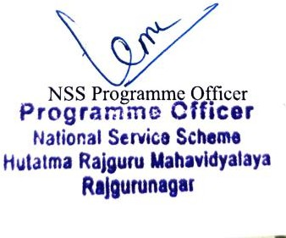

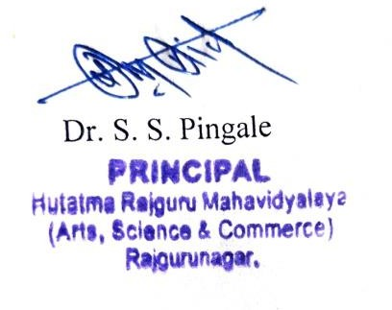
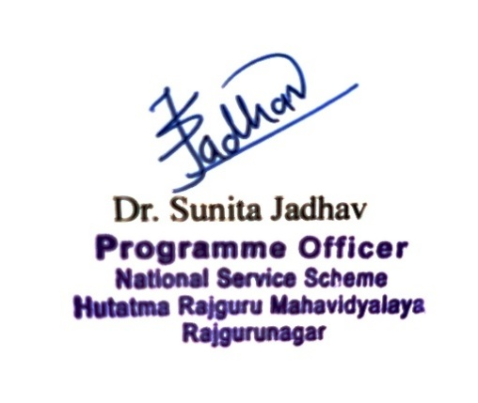

K.T.S.P.MANDAL’S
HUTATMA RAJGURU MAHAVIDYALAYA RAJGURUNAGAR,TAL-KHED,DIST-PUNE410501
NationalServiceScheme

Sr. No | Item | Particulars
1 | Date | 07/09/2025
2 | NameofEvent | Cleanlinessdriveand awareness activity
3 | Venue | CollegeCampus
4 | Time | 8.00a.m.to10.00am
5 | Durationoftheprogramme | OneDay
6 | Expense
7 | SourceofFinancialAssistance | N.S.S.
8 | Namesofresourcepersons | -
9 | Nameof coordinator | N.S.S. ProgramOfficer
10 | Numberofparticipants | 121
11 | Curricular/Co-Curricular/Extra- Curricular | Extra-Curricular
12 | ActivitybelongstoWhichCriteria of NAAC | III

ReportonCleanlinessDriveandAwarenessActivities

The National Service Scheme (NSS) volunteers of Hutatma Rajguru College organized a cleanliness drive on Sunday, 7th September 2025, at 9:00 a.m., as partof the regular NSS activities. The initiative aimed at maintaining cleanliness on the college premises. Additionally, the volunteers prepared for street plays on various important social topics, including: Organ Donation, Cleanliness, Population Control,Gender Equality. Several other activities were also conducted to promote social awareness. The event was graced by the presence of: Principal Dr. Shirish Pingale, NSS Program Officers Dr. Sunita Jadhav ,Prof. Machhindra Muluk and Prof. Sandeep Thorat , Committee membersProf.NileshBarneandProf.V.B.Kathe. The program was a success, reflecting the dedication of the NSS volunteers towards community service and awareness. Such initiatives foster responsibility and civic engagement among students.

