K.T.S.P. Mandal’s
HutatmaRajguruMahavidyalaya,Rajgurunagar

NationalServiceScheme

NOTICE
All NSS volunteers are hereby informed that a Tree Plantation Drive has been organizedincollaborationwiththeNationalCadetCorps(NCC)on 20thAugust2026 at 9:00 AM at the Shiroli Forest Range, Khed and college ground. All NSS volunteers must participate actively in this initiative and contribute to environmental conservation. Attendance is mandatory.
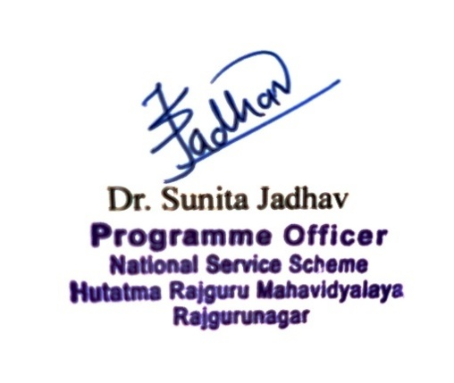



K.T.S.P.MANDAL’S
HUTATMA RAJGURU MAHAVIDYALAYA RAJGURUNAGAR,TAL-KHED,DIST-PUNE410501
NationalServiceScheme

Sr. No | Item | Particulars
1 | Date | 20thAugust2026
2 | NameofEvent | Treeplantation
3 | Venue | Shiroli, College Ground
4 | Time | 9.00a.m.to12.00pm
5 | Durationoftheprogramme | Oneday
6 | Expense
7 | SourceofFinancialAssistance | NSS
8 | Namesofresourcepersons | -
9 | Nameofcoordinator | NSSProgram officer
10 | Numberofparticipants | 72
11 | Curricular/Co-Curricular/Extra- Curricular | Extra-Curricular
12 | ActivitybelongstoWhichCriteria of NAAC | III
13 | Incollaborationwith | Shiroli Forest Office

Report

On August 20, 2026, at 9:00 AM, 238 trees were planted at the Shiroli Forest RangeinKhed through the joint efforts of the National Service Scheme (NSS) and the National Cadet Corps (NCC) of Hutatma Rajguru College. During this event, Forest Range Officer (R.F.O.) Mr. Raundal provided in-depth guidance by sharing detailed information about various types of trees. Additionally, the college principal, Dr. Shirish Pingale, guided the students.

The program was organized by Dr. Sunita Jadhav, Prof. M.L. Muluk, Prof. S.R.Thorat Prof. Nilesh Barne, Dr. Sagar Theurkar, Prof. Jayashree Gogawale, Prof. Vrushali Kathe, and Prof. Rohini Patole.

