K.T.S.P. Mandal’s
Hutatma Rajguru Mahavidyalaya, Rajgurunagar

National Service Scheme

NOTICE
Date: 22/09/2026

This is to inform all NSS volunteers residing in Rajgurunagar and near by areas that a
Nirmalya Collection Program has been organized on 25thSeptember 2026 at 8:00
a.m. in connection with Ganpati Visarjan.Volunteers residing in Rajgurunagar and surrounding areas are requested to gather at the college by 8:00 a.m. for the event. Volunteers who will be attending tomorrow must submit their names to Mr. Aditya Borse at Mob: 90213 30948.

Forfurtherdetailsorinquiries,please contact:

- Prof.S.R.Thorat-Mob:92846 64327
- Prof.M.L.Muluk- Mob:97629 52121

Your participation will be greatly appreciated in this community service initiative.
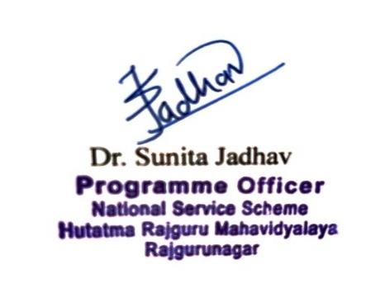
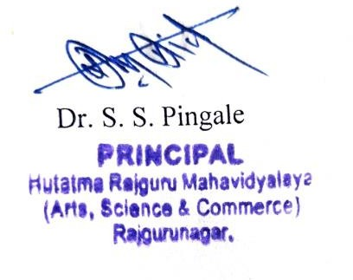


K.T.S.P.MANDAL’S
HUTATMA RAJGURU MAHAVIDYALAYA RAJGURUNAGAR,TAL-KHED,DIST-PUNE410501
NationalServiceScheme

Sr. No | Item | Particulars
1 | Date | 25/09/2026
2 | NameofEvent | NirmalyaCollectionProgram for Ganpati Visarjan
3 | Venue | NearBhimaRiver Khed
4 | Time | 8.00 am
5 | Durationoftheprogramme | Oneday
6 | Expense
7 | SourceofFinancialAssistance | NSS
8 | Namesofresourcepersons | -
9 | Nameof coordinator | NSSProgram officer
10 | Numberofparticipants | 28
11 | Curricular/Co-Curricular/Extra- Curricular | Extra-Curricular
12 | ActivitybelongstoWhichCriteria of NAAC | III
13 | Incollaborationwith | -

REPORT
A Nirmalya Collection Program was organized on 25th September 2026 at 8:00 a.m. under the National Service Scheme (NSS) of Hutatma Rajguru College in connection withGanpatiVisarjan. Theevent aimedtocontributetotheenvironmental cleanliness by collecting the offerings and flowers used during Ganpati Visarjan.The program was attended by: Dr. Shirish Pingale, Principal of the College, Prof. Sandip Thorat, NSS Program Officer, A large number of NSS volunteers. The volunteers actively participated in the initiative, collecting the Nirmalya (offerings) and ensuring that the surroundingareas werekeptcleanpost-Visarjan. Thisinitiativereflected thecollege’s commitment to environmental awareness and community service.
Theparticipationofthevolunteerscontributedtothesuccessoftheprogram,andtheir efforts in maintaining cleanliness were highly appreciated. This activity not only helped in keeping the surroundings clean but also promoted the importance of environmental responsibility among students.

