K.T.S.P.Mandal’s
HUTATMA RAJGURU MAHAVIDYALAYa
RAJGURUNAGAR
A Report
Title | International Yoga Day 2024
Organizer | Department of Physical Education & Sports
Date | 21st June 2024
Venue | Vitthalraoji Buttepatil Sabhagruh
Objective of the programme | Celebrating International Yoga Day
Number of participants | 120
Target Group | College students & Staff
Introduction | Under the guidance of UGC, SPPU University and College Principal Dr. S.S.Pingale, International Yoga Day was organized on 21st June 2024 at 7:30 am in the college Seminar Hall. The program was held in the presence of sports. NCC, NSS, other students, professors and non- teaching staff of the college.
Summary | Under the guidance of UGC, SPPU University and College Principal Dr.S.S.Pingale. International Yoga Day was organized on 21st June 2024 at 7:30 am in the college Seminar Hall The program was held in the presence of a total of 120 people including sports, NCC, NSS, other students, professors and non-teaching staff of the college. Mr. Sagar Gade gave a yoga demonstration & explain the asanas.


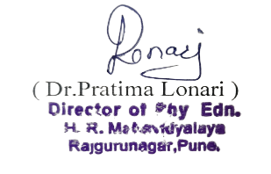
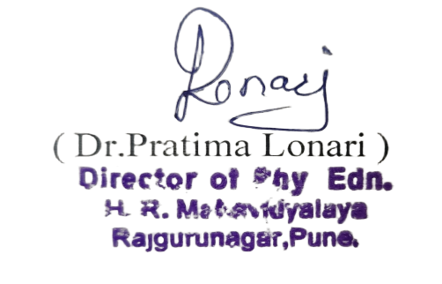
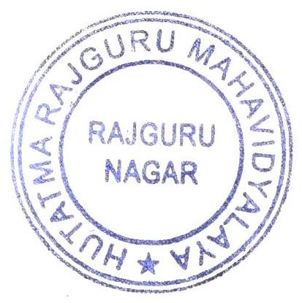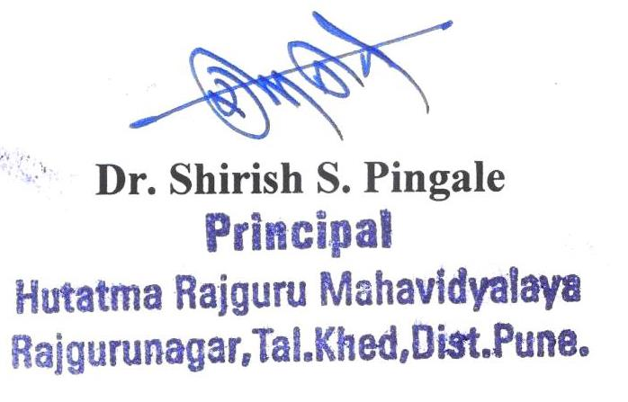
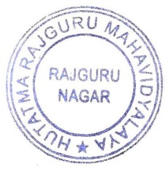
Photos of International Yoga Day 2024

