K.T.S.P.Mandal’s
HUTATMA RAJGURU MAHAVIDYALAla
RAJGURUNAGAR
A Report
Title | Report on the Independence day Celebration 15th Aug 2024
Introduction | The Independence day of India was celebrated on 15th Aug 2024 by all of us. The Main responsibility of program Organizing & Flag Hosting is on the shoulder of Department of Physical Education & Sports. Hon. Adv. Devendraji Buttepatil (Chairman, K.T.S.P.Mandal) was the chief guest of the function.
Organizer | Department of Physical Education & Sports
Date | 15th Aug 2024
Venue | Hutatma Rajguru Mahavidyalaya, Hutatma Rajguru Smarak
Objective of the programme | The Independence day of India Celebration on 15th Aug 2024
Details of participants | 1000 student & staff
Summary | The event was successful due of the proper planning & implementation of task. The Independence day of India was celebrated on 15th Aug 2024 by all of us. The Main responsibility of program Organizing & Flag Hosting is on the shoulder of Department of Physical Education & Sports. Hon. Adv. Devendraji Buttepatil (Chairman, K.T.S.P.Mandal ) was the Chief Guest of the Function.

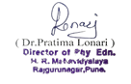
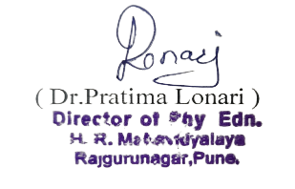
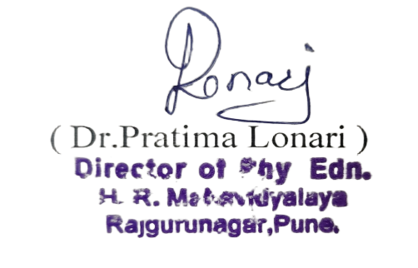
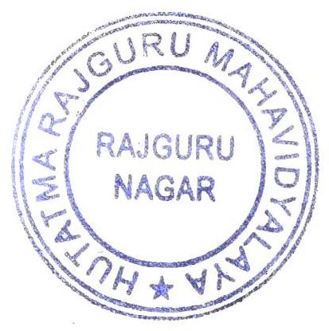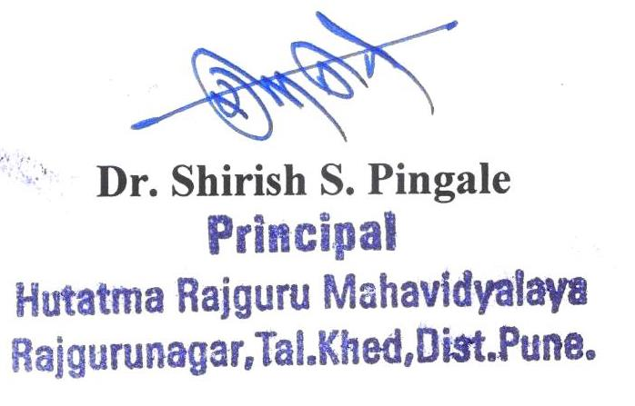
Notice

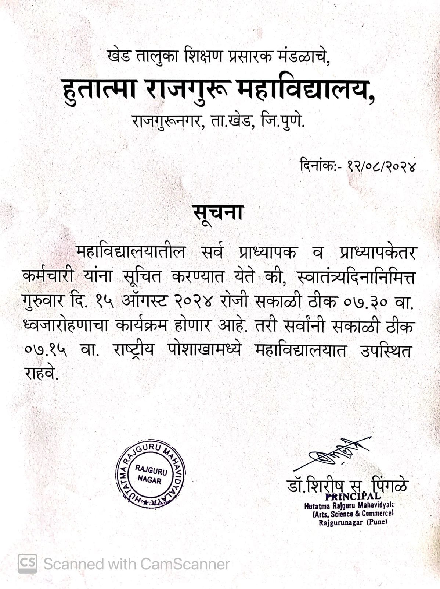

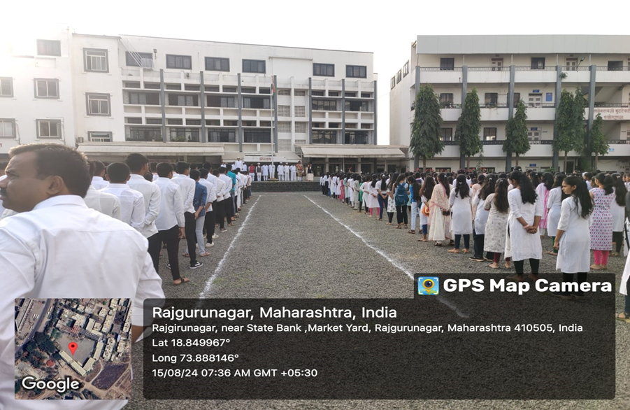
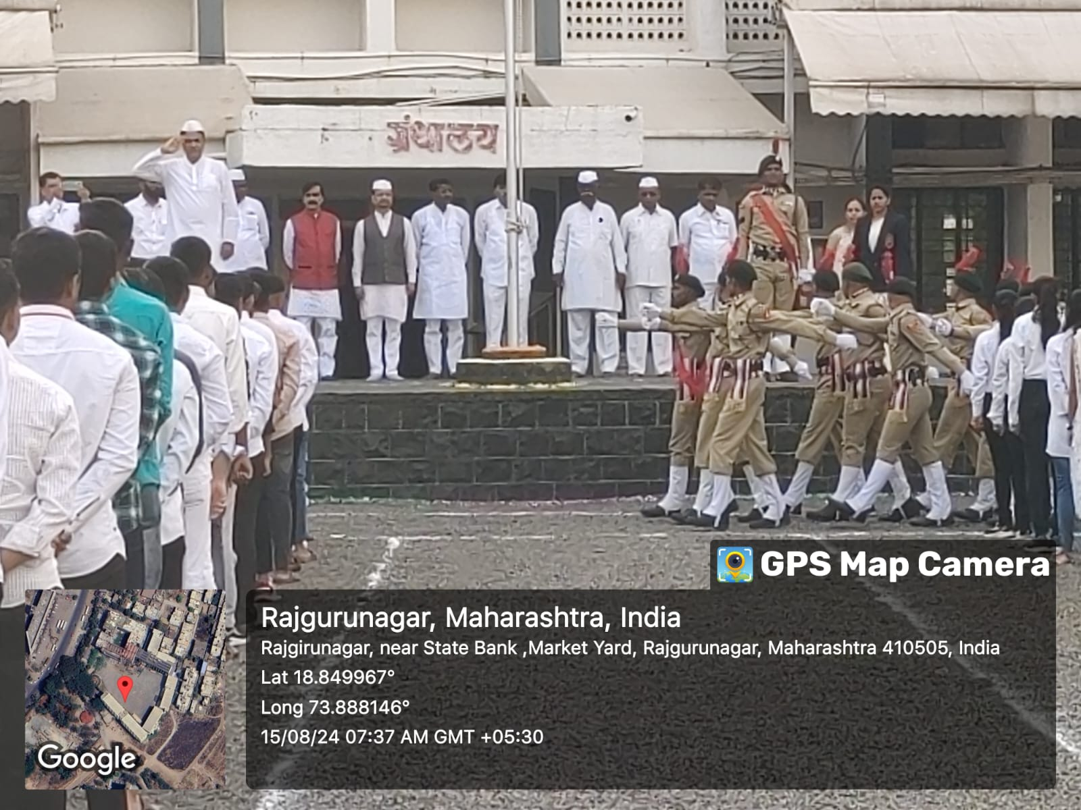

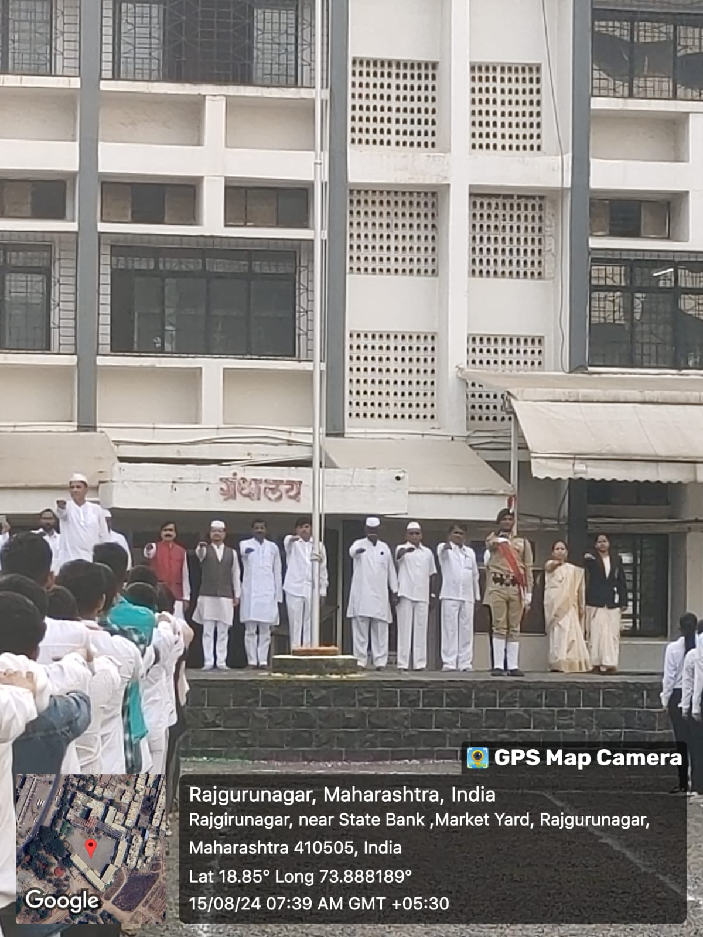

Independence Day Photo on 15th Aug 2024

