K.T.S.P.Mandal’s
HUTATMA RAJGURU MAHAVIDYALAYa
RAJGURUNAGAR
A Report
Title | Report on the Maharashtra Din Celebration on 1st May 2025
Introduction | The Maharashtra Din was celebrated on 1st May 2025 by all of us. The Main responsibility of program Organizing & Flag Hosting is on the shoulder of Department of Physical Education & Sports. Hon. Principal Dr. S.S.Pingale was the chief guest of the function.
Organizer | Department of Physical Education & Sports
Date | 1st May 2025
Venue | Hutatma Rajguru Mahavidyalaya
Objective of the programme | The Maharashtra Din celebration on 1st May 2025
Details of participants | 150 staff
Summary | The event was successful due of the proper planning & implementation of task. The Maharashtra Din was celebrated on 1st May 2025 by all of us. The Main responsibility of program Organizing & Flag Hosting is on the shoulder of Department of Physical Education & Sports. Hon. Principal Dr. S.S.Pingale was the Chief Guest of the Function.

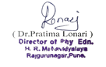
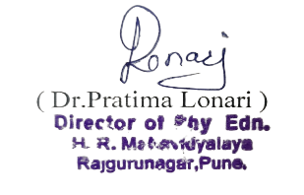
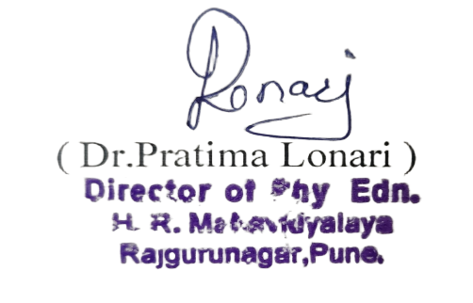
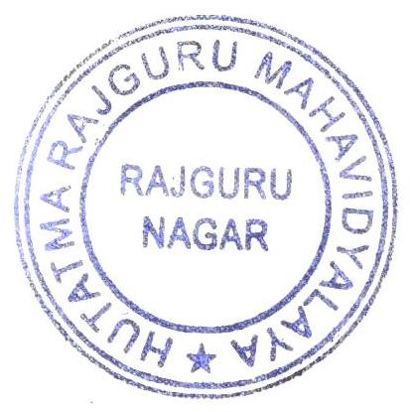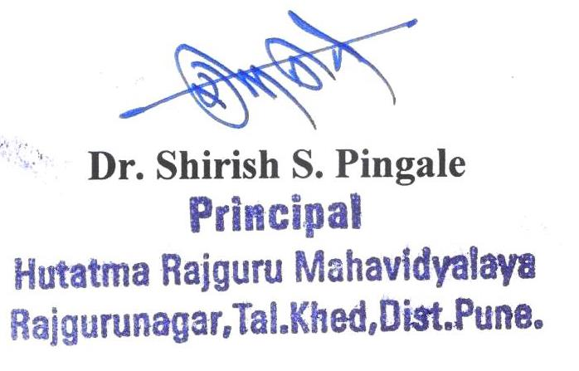

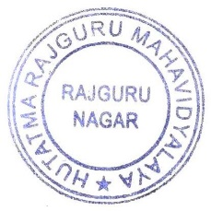

Photo
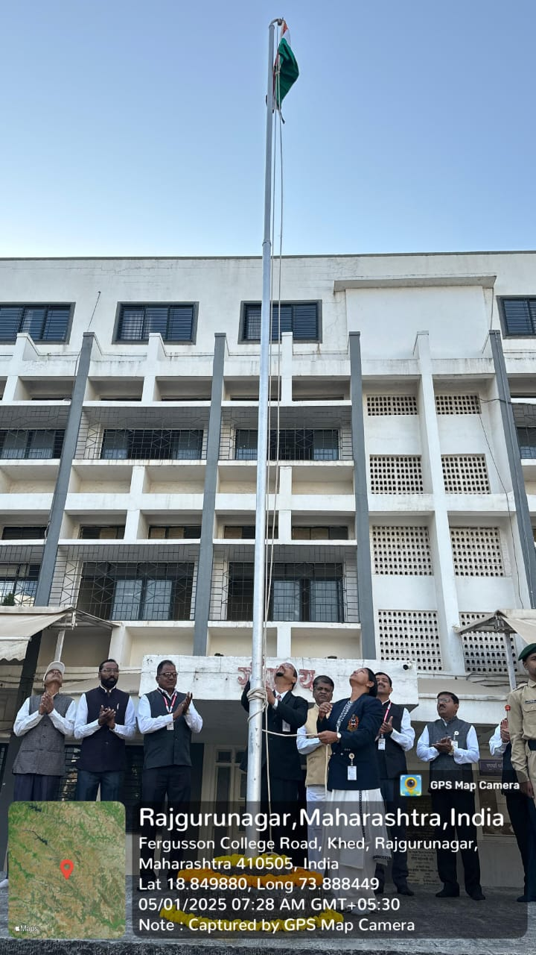

Notice
