K.T.S.P.Mandal’s
Hutatma Rajguru Mahavidyalaya
Rajgurunagar, Tal-Khed, Dist-Pune
2024-25
The title of the event | IC Weight Lifting competition (M & W)
Organizing Department | Department of Physical Education & Sports
The name of the organizer/coordinator | Prof.Pratima Lonari
Dated | 18 October 2024
Venue | College Sabhagruh
Number of participants | 20 Boy’s, 19 Girl’s students
Expenditure of program | 20,000/-
Fund | Pune District Zonal Committee
Target group | Players in various colleges under Pune District Zonal Committee
Introduction | Inter Collegiate Weight Lifting competition was organized under Pune District Zonal Committee on 18th Oct 2024.
The objectives of the program | To select the PDZSC Weight Lifting (M & W) team for the SPPU Inter Zonal Weight Lifting Competition
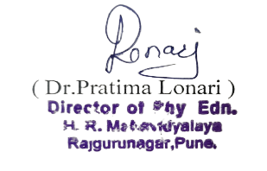
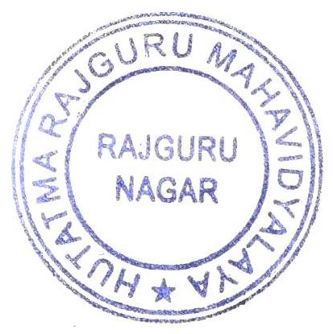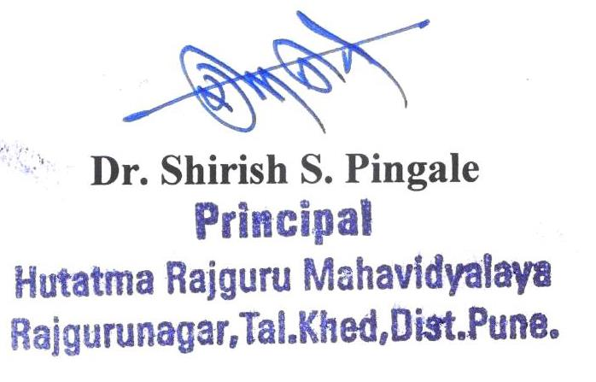

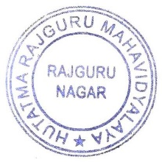
Photos of the Competition
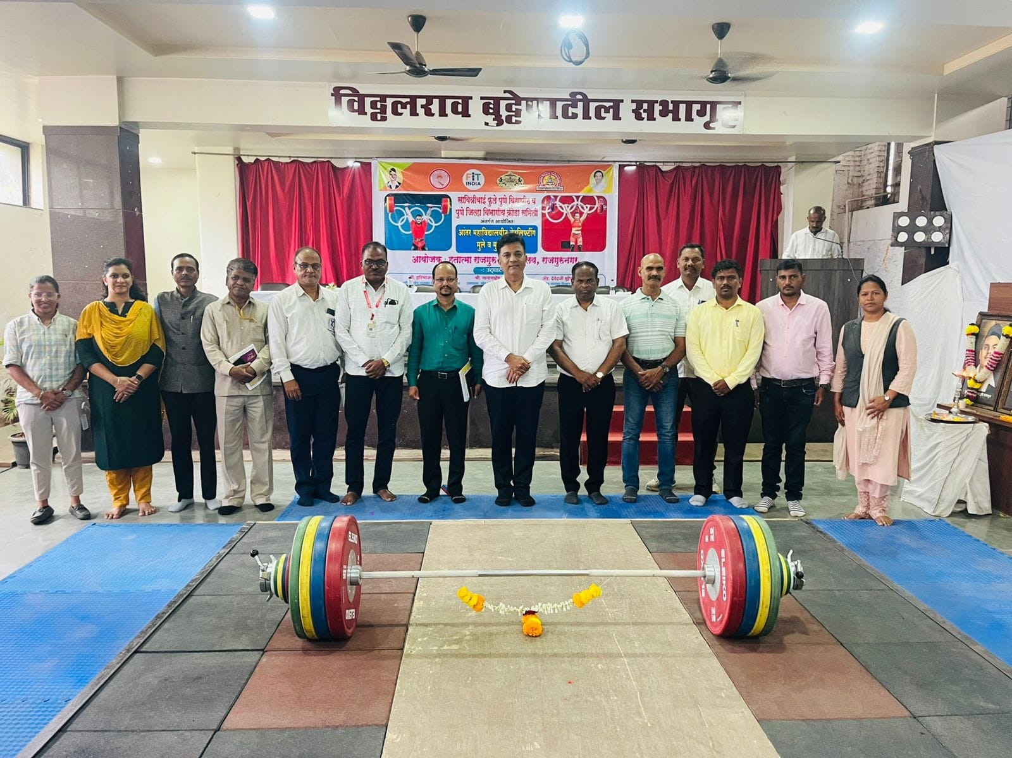Opening Ceremony of Inter Collegiate Weight Lifting Competition

