K.T.S.P.Mandal’s
HUTATMA RAJGURU MAHAVIDYALAYA
Inter Class Competition /Annual Sports 2024-25
Report
The title of the event | Inter Class Competition/ Annual Sports
Organizing Department | Department Of Physical Education & Sports
The name of the organizer/ coordinator | Prof. Pratima Lonari
Dated | 26th Dec 2024 to 7 Jan 2025
Venue | College Ground, Kreeda Sankul
Number of participants | More than 621 students
Target group | College students
Introduction | Inter-class competition / sports festival organized in college from 26th Dec 2024 to 7 Jan 2025. The festival was inaugurated with the game of Chess. At that time,the Principal Dr.S.S.Pingale,Vice Principal, Registrar and teachers were present.
The objectives of the program | To organize competitions for the fitness of the students and for the promotion for the entertainment of the student. Inclination towards sports.

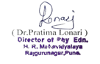
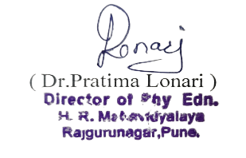
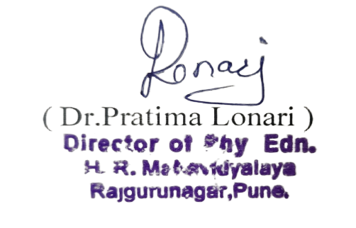
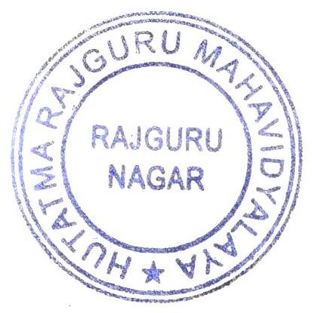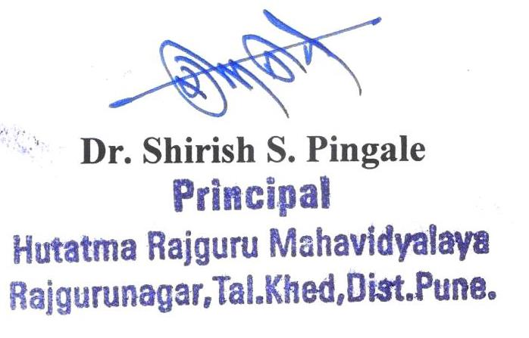

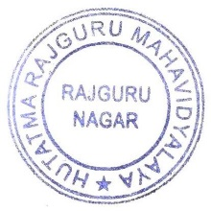
Notice

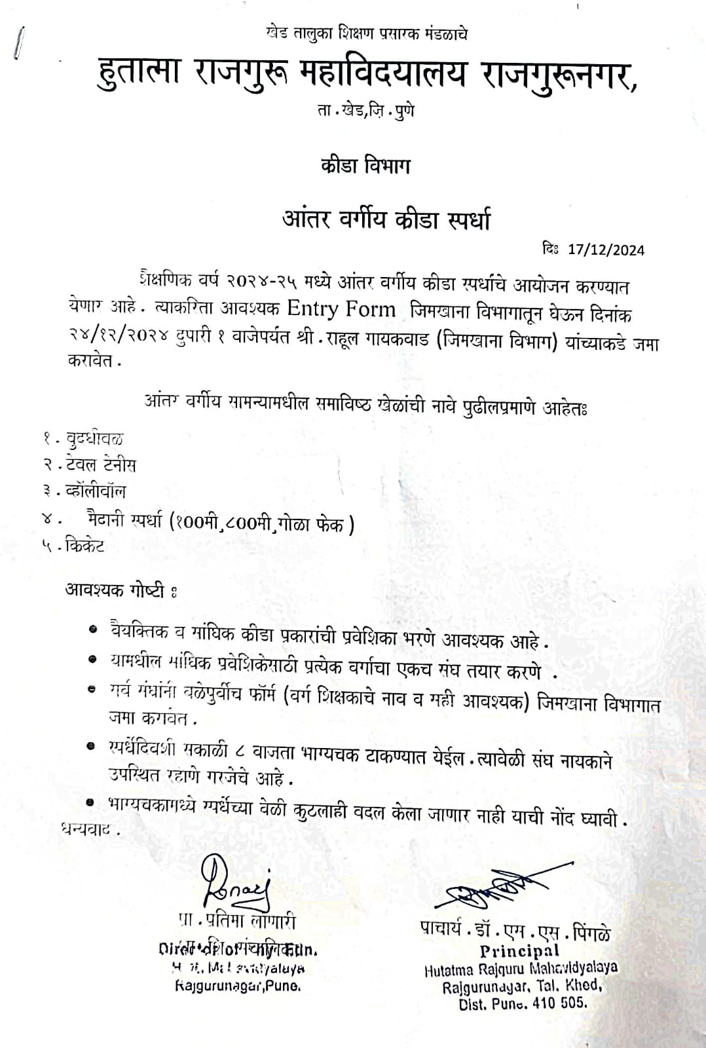

Interclass Competition photos

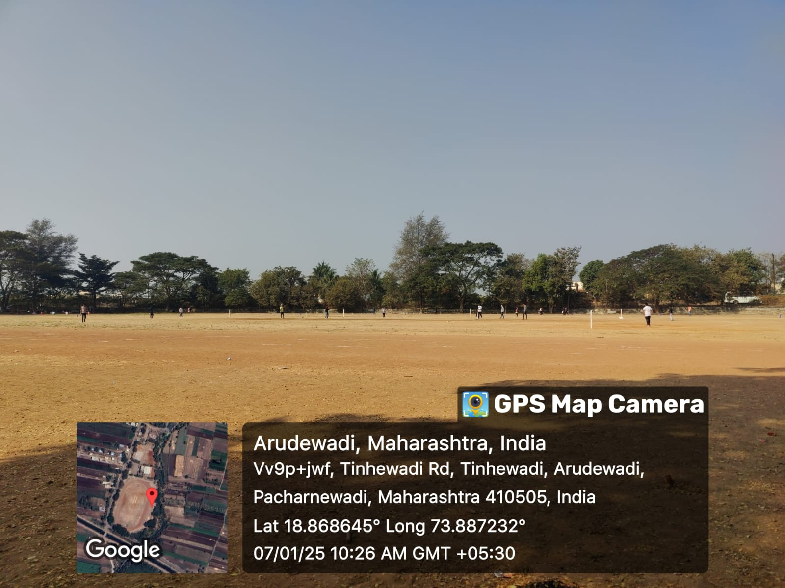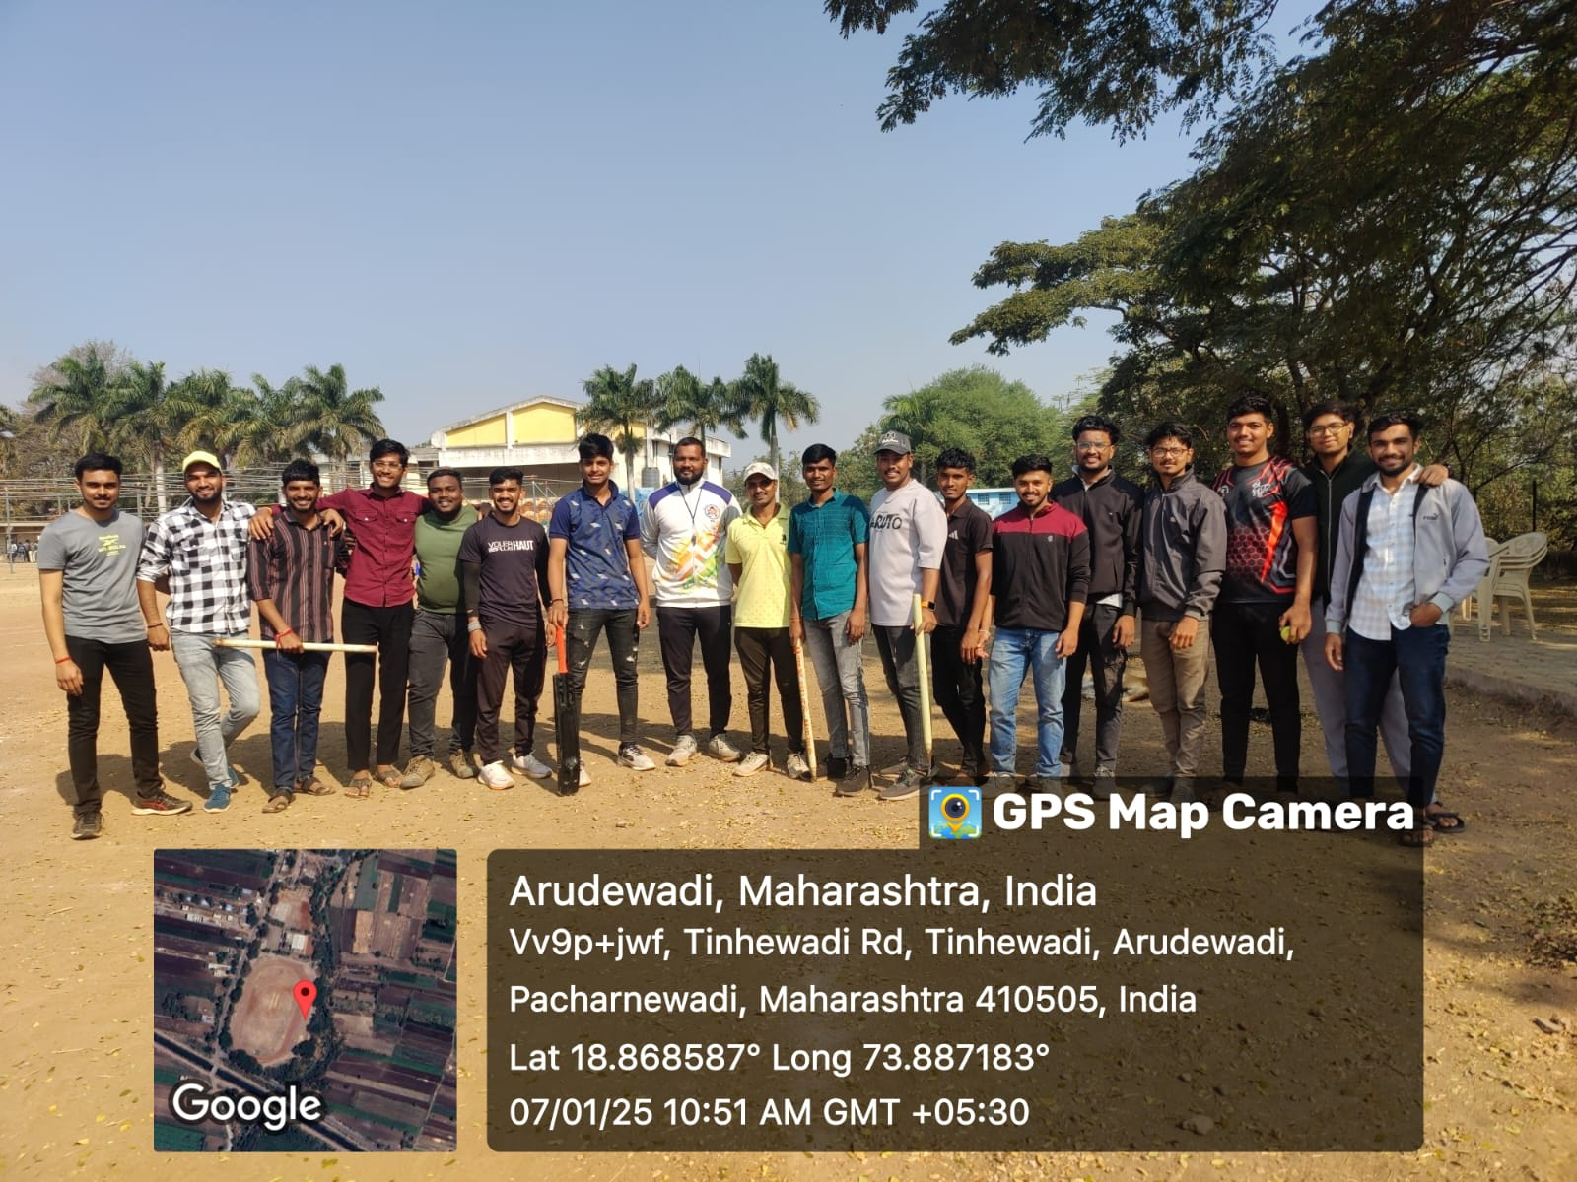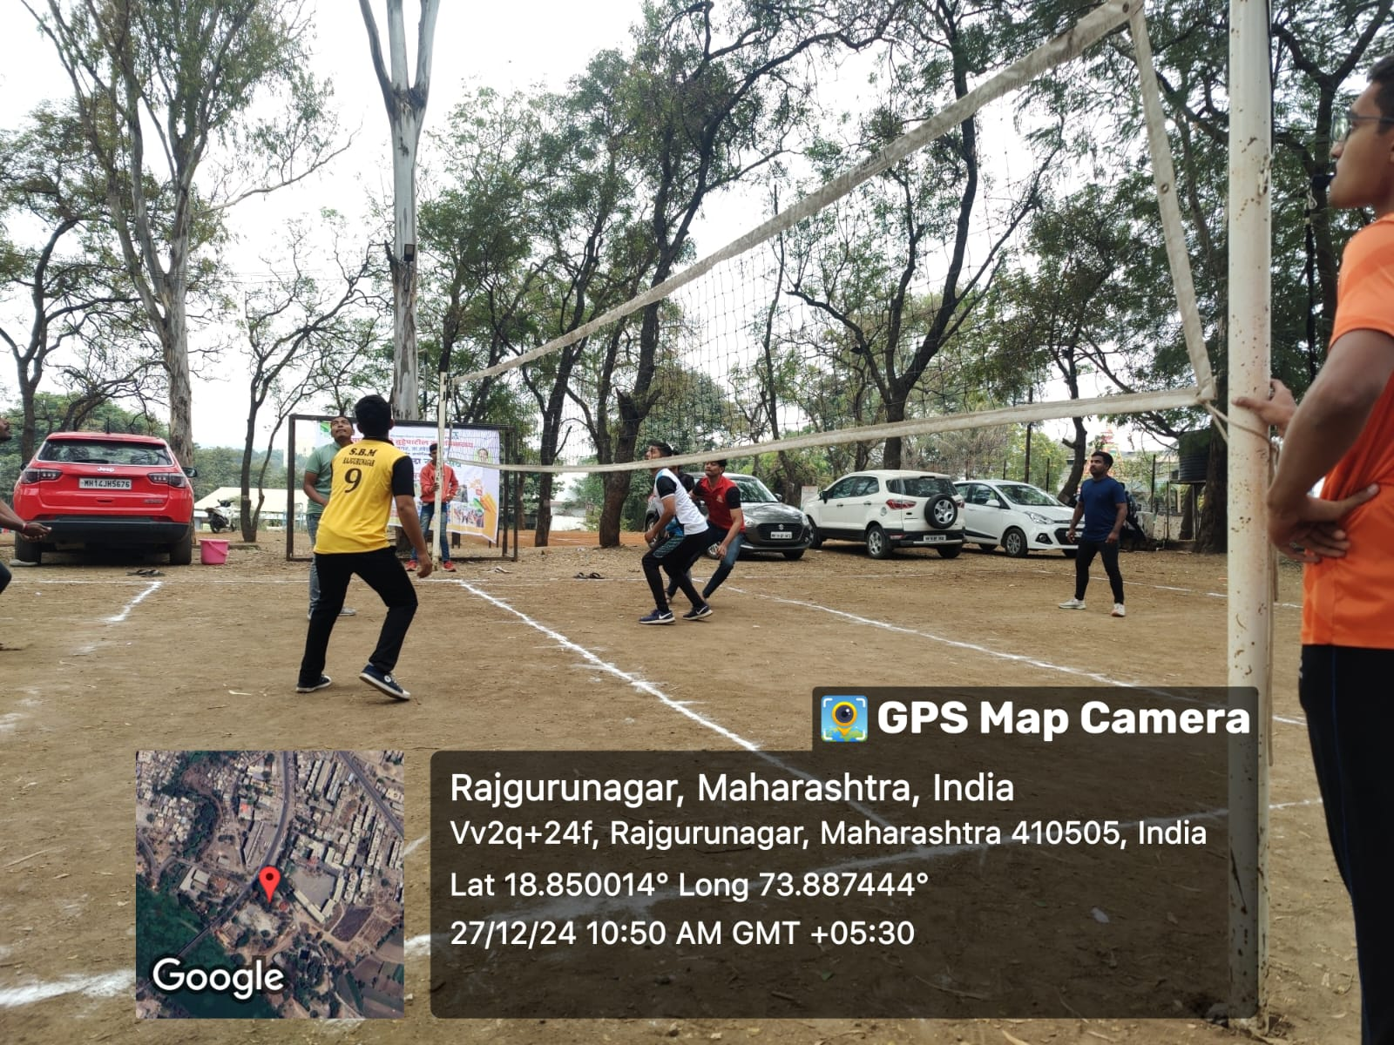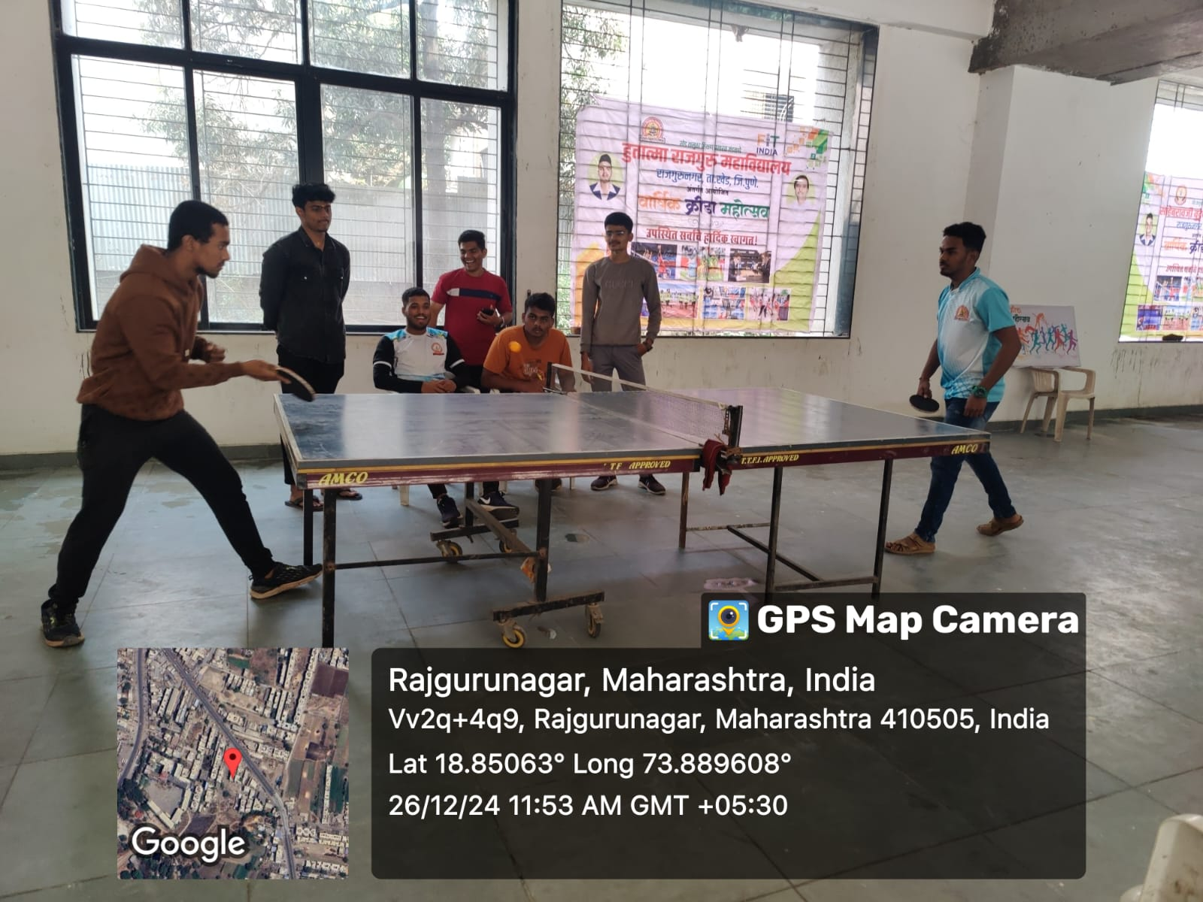

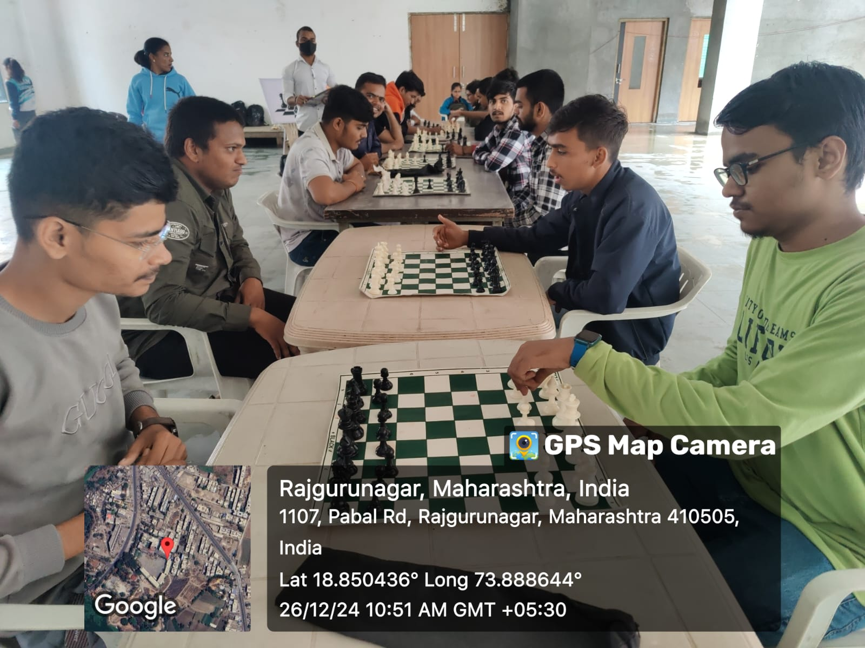

Result of Inter Class competition 24-25
 | Place | Name of the Player | Class
Chess (Boys) | Winner | Anuj Sambhaji Korde | S.Y.BCS
Chess (Boys) | Runner Up | Pramod Sanajay Kondhavale | S.Y.BCOM
Chess (Boys) | Third | Suyash Subhash Pokharkar | T.Y.BBA(CA)
Chess (Girls) | Winner | Siddhi Janardhan Bhadale | F.Y.BCOM
Chess (Girls) | Runner Up | Gangasagar Raoshabe Konale | F.Y.BCS
Table Tennis (Boys) | Winner | Jinesh Ajay Shingvi | S.Y.Bcom
Table Tennis (Boys) | Runner Up | Raj Babaji Ghanwat | T.Y.BBA(CA)
Table Tennis (Boys) | Third | Atharva Prakash Vaidya | S.Y,BCS
Athletics (Boys)  100m | winner | Harshad Gade | F.Y.Bcom
Athletics (Boys)  100m | Runner Up | Rutik Panmand | F.Y.BA
Athletics (Boys)  100m | Third | Athrav Vidya | S.Y.bcs
Athletics (Boys)  800m | Winner | Harshad Gade | F.Y.Bcom
Athletics (Boys)  800m | Runner Up | Yashraj Kale | F.Y.BA
Athletics (Boys)  800m | Third | Omkar Gunjal | F.Y.BA
Athletics  (Boys) Shot Put | winner | Vikas Methal | T.Y.Bcom
Athletics  (Boys) Shot Put | Runner Up | Aditya Sachin Gadekar | F.Y.BA
Athletics  (Boys) Shot Put | Third | Harshad Gade | F.Y.B com
Athletics  (100m) Girls | Winner | Rohini Pundge | T.Y.Bcom
Athletics  (100m) Girls | Runner Up | Nidhi Sawant | S.Y.BA
Athletics  (100m) Girls | Third
Athletics(800m) Girls | Winner | Vaishnavi Hole | F.Y.BA
Athletics(800m) Girls | Runner Up | Sarita Munjal | F.Y.BA
Athletics(800m) Girls | Third | Vaishnavi Aherkar | F.Y.BA
Athletics  (Shot Put) Girls | Winner | Shraddha Hande | F.Y.BCOM
Athletics  (Shot Put) Girls | Runner Up | Nidhi Sawant | S.Y.BA
Athletics  (Shot Put) Girls | Third | Rohini Pundge | T.Y.B com
Volleyball(Boys) | Winner | Rohan Kokane | S.Y.B COM
Volleyball(Boys) | Winner | Chetan Methal | S.Y.B COM
Volleyball(Boys) | Winner | Sanket Chimate | S.Y.B COM
Volleyball(Boys) | Winner | Nilesh More | S.Y.B COM
Volleyball(Boys) | Winner | Mahesh Bhojane | S.Y.B COM
Volleyball(Boys) | Winner | Pratik Bambure | S.Y.B COM
Volleyball(Boys) | Runner Up | Shreyash Thombare | T.Y.B COM
Volleyball(Boys) | Runner Up | Aniket Thakur | T.Y.B COM
Volleyball(Boys) | Runner Up | Vikas Methal | T.Y.B COM
Volleyball(Boys) | Runner Up | Omkar Shinde | T.Y.B COM
Volleyball(Boys) | Runner Up | Rushikesh Sawant | T.Y.B COM
Volleyball(Boys) | Runner Up | Atharv Kad | T.Y.B COM
Volleyball(Boys) | Runner Up | Sagar Pawale | T.Y.B COM
Volleyball(Boys) | Runner Up | Pawan Gade | T.Y.B COM
Cricket | Winner | Sahil Raut | T.Y.BCS
Cricket | Winner | Mayur Wadekar | T.Y.BCS
Cricket | Winner | Aditya Korde | T.Y.BCS
Cricket | Winner | Pratik Hole | T.Y.BCS
Cricket | Winner | Om Nehere | T.Y.BCS
Cricket | Winner | Pranav More | T.Y.BCS
Cricket | Winner | Tejom Pacharne | T.Y.BCS
Cricket | Winner | Anuj Kumar | T.Y.BCS
Cricket | Winner | Sairaj Thigle | T.Y.BCS
Cricket | Winner | Rohan Khurpude | T.Y.BCS
Cricket | Winner | Ishwar Singh | T.Y.BCS
Cricket | Winner | Atharv Gawade | T.Y.BCS
Cricket | Winner | Amarjit Hake | T.Y.BCS
Cricket | Winner | Tejas Muluk | T.Y.BCS
Cricket | Winner | Aditya Fuge | T.Y.BCS
Cricket | Runner Up | Aniket Thakur | T.Y.B.com
Cricket | Runner Up | Vikas Methal | T.Y.B.com
Cricket | Runner Up | Avishkar Khaire | T.Y.B.com
Cricket | Runner Up | Shreyas Thombre | T.Y.B.com
Cricket | Runner Up | Atharv Kad | T.Y.B.com
Cricket | Runner Up | Ayush Gadhave | T.Y.B.com
Cricket | Runner Up | Sagar Pawale | T.Y.B.com
Cricket | Runner Up | Omkar Gholap | T.Y.B.com
Cricket | Runner Up | Omkar Bacche | T.Y.B.com
Cricket | Runner Up | Shivam Arote | T.Y.B.com
Cricket | Runner Up | Amol Thigle | T.Y.B.com
Cricket | Runner Up | Pawan Gade | T.Y.B.com
Cricket | Runner Up | Saurabh Gade | T.Y.B.com
Cricket | Runner Up | Pruthviraj Khengale | T.Y.B.com
Cricket | Runner Up | Yashashri Subhash Kale | T.Y.B.com

