**K.T.S.P. Mandal’s**

**Hutatma Rajguru Mahavidyalaya,**

**Rajgurunagar.**

**T.Y.B.Sc. Botany**

**Semester – VI (CBCS pattern)**

**Subject – Biochemistry**

**(Paper II: BO. 362)**

**Chapter 4**

**Topic – Enzymes**

**Prof.P.D.Kad**

**(Assistant Professor, Department of Botany)**

**Hutatma Rajguru Mahavidyalaya**

[poojakad92@gmail.co](mailto:poojakad92@gmail.co)**m**

**ENZYMES**

**Definition of Enzymes:**

* *“Enzymes can be defined as biological polymers that catalyze biochemical reactions.”*
* Enzymes are proteinaceous (and even nucleic acids) biocatalyst which alter (generally enhance) the rate of a reaction.
* The study of enzymes is called enzymology

Enzymes are highly specialized proteins which act as catalyst of biological system. It was Edward Buchner who in 1897 extracted the enzyme from yeast cells, responsible for fermentation of sugar to alcohol. In 1926, James B. Sumner isolated and crystallized urease and also postulated that all enzymes are proteins. Today we know, this is true but with exception of Ribozymes which is a catalytic RNA.

**Nature of enzymes and Cofactors**

**(i) Simple Enzymes:**

* Some enzymes are simple proteins, i.e., on hydrolysis, they yield amino acids only. Digestive enzymes such as pepsin, trypsin and chymotrypsin are of this nature.
* **(ii) Conjugate Enzymes:**
* It consist of two parts – a protein part called apoenzyme (e.g., flavoprotein) and a non-protein part named cofactor.
* The complete conjugate enzyme, consisting of an apoenzyme and a cofactor, is called holoenzyme.

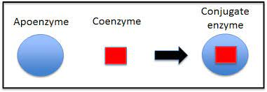

* Enzymatic activity only when both components (apoenzyme and cofactor) are present together.
* The cofactor may be a simple divalent metallic ion (e.g.,Ca, Mg, Zn, Co, etc), and/ or a nonprotein organic com­pound.
* However, some enzymes require both kinds of cofactors.
* If the cofactor is firmly bound to the apoenzyme, it is called prosthetic group.
* For example, cytochromes are the enzymes that possess porphyrins as their prosthetic groups. If, instead of being more or less permanently bound to the apoenzyme the cofactor attaches itself to the apoenzyme only at the time of reaction, it is called a coenzyme.

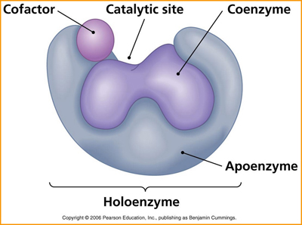

**(iii) Metallo-enzymes:**

* The metal cofactors involved in enzymic reactions are both monovalent (K+) and divalent cations (Mg++, Mn++, Cu++).
* These may be loosely held by the enzyme, or as in some cases, go into the composition of the molecule itself.
* If the metal forms part of the molecule, as iron of haemoglobin or cytochrome is, the enzymes are called metallo-enzymes.

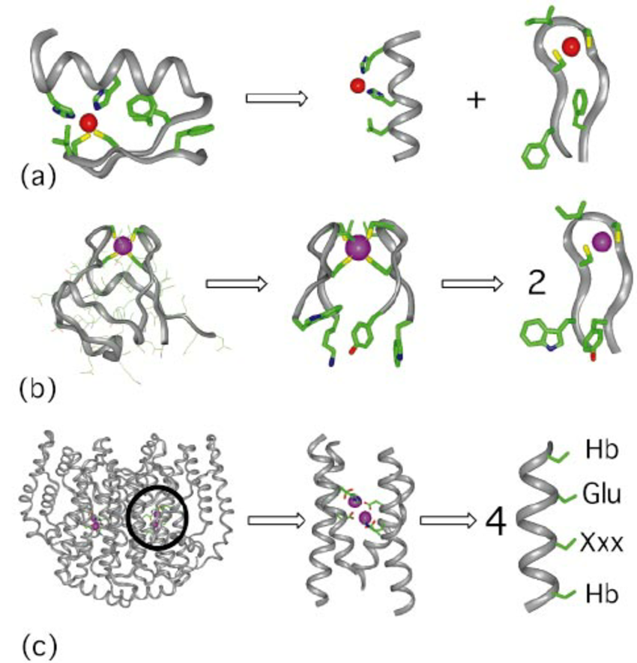

* **(iv) Isoenzymes (Isozymes):**
* The substrate may be acted upon by a number of variants of an enzyme producing the same product.
* The multiple molecular forms of an enzyme occurring in the same organism and having a similar substrate activity are called isoenzymes or isozymes.

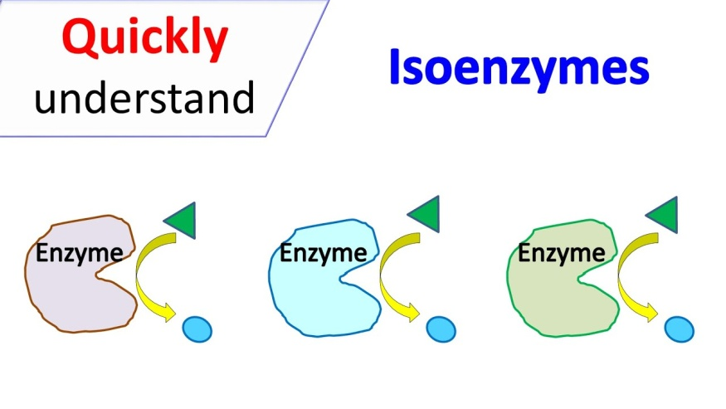

* Over 100 enzymes are known to have isoenzymes.
* E.g. lactic dehydrogenase (LDH) which occurs in five possible forms in organs of most vertebrates.

### Cofactors

* Cofactors are non-proteinous substances that associate with enzymes.
* A cofactor is essential for the functioning of an enzyme.
* An enzyme without a cofactor is called an apoenzyme.
* An enzyme and its cofactor together constitute the holoenzyme.

There are three kinds of cofactors present in enzymes:

* **Prosthetic groups**: These are cofactors tightly bound to an enzyme at all times. E.g. FAD
* **Coenzyme**: A coenzyme binds to an enzyme only during catalysis. At all other times, it is detached from the enzyme. E.g.NAD+
* **Metal ions**: For the catalysis of certain enzymes, a metal ion is required at the active site to form coordinate bonds. e.g Zn2+

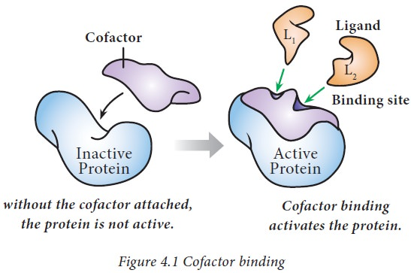

**Physical properties of soil**

* Enzymes are [colloidal](https://www.vedantu.com/chemistry/colloids) , high-molecular-weight compounds.
* At high temperature, (below the boiling point of the [water](https://www.vedantu.com/chemistry/water)) enzymes are killed or inactivated.
* Most enzymes in the liquid medium are inactivated at 60 degrees Celsius.
* Extracting dried enzymes can withstand temperatures of 100 degrees Celsius to 120 degrees Celsius or even higher. Enzymes are, therefore, thermos-labile.
* The optimum activity of each enzyme is always at a particular temperature, which typically varies from 25 degrees Celsius to 45 degrees Celsius. At 37 degrees Celsius, enzyme action is strongest and as temperatures rise above 60 degrees Celsius, enzymes become inactive.
* **Chemical Properties of Enzymes**

1. **Catalytic Properties:**

* Biological catalysts are enzymes.
* The greater amounts of compounds are catalyzed by a small number of enzymes.
* Enzymes improve the reaction rate and remain unaffected by the reaction they catalyze.

1. **Enzyme Specificity:**

Enzymes are extremely variable in nature, which means that a specific enzyme can catalyze a specific reaction. For example, only [sucrose](https://www.vedantu.com/chemistry/sucrose) hydrolysis can be catalyzed by Enzyme sucrase.

**General Properties of Enzymes**

* Enzymes can initiate and accelerate the biochemical reaction rate.
* The activity of enzymes depends on the pH. At a particular pH, each catalyst is most active. E.g pH 2 for pepsin, pH 8.5 for trypsin, for example. At near neutral pH, most intracellular enzymes act.
* The reaction can accelerated in either direction by enzymes.
* All enzymes have active sites involved in biochemical reactions.
* Enzymes are very unstable compounds, soluble in water, dilute glycerol, NaCl, and dilute alcohol.
* Enzymes work at the optimum temperature.
* All enzymes are proteins in nature, but all proteins may not be enzymes.
* Enzymes lower the molecule's activation energy so that the biochemical reaction can take place at the normal temperature of the body, which is 37 degrees Celsius.

**Active site**

* Active site –a groove/ pocket of the enzyme, located in a deep tunnel within enzyme.
* It is the region of an enzyme where substrate molecules bind and undergo a chemical reaction.
* Occupies 10 to 20% of the volume of an enzyme.
* It consists of 3 to 4 amino acids, other form/ maintains tertiary structure.

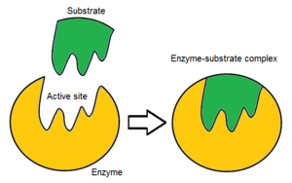

* It consist of amino acid residues that form temporary bonds with the substrate(binding site) & residues that catalyze the chemical reaction of that substrate(catalytic site).
* Active site – highly specific to substrate and catalyse a particular reaction.
* Enzymes also need to bind with some cofactors to catalyse a particular reaction.
* Active site- catalyse reaction repeatedly as residues are not altered (regenerated)
* Achieved by lowering activation energy.

**Classification Based upon the Reaction Catalyzed:**

Enzymes are broadly divided into six groups based on the type of reaction catalyzed.

**They are:**

(1) Oxidoreductases

(2) Transferases

(3) Hydrolases

(4) Lyases

(5) Isomerases and

(6) Ligases.

**(a) Oxidoreductases:**

Enzymes which bring about oxidation and reduction reactions.

Ex. Pyruvate + NADH—lactate dehydrogenase → Lactate + NAD +

**(b) Transferases:**

Enzymes which catalyze transfer of groups from one substrate to another, other than hydrogen. Ex. Transaminase catalyses transfer of amino group from amino acid to a keto acid to form a new keto acid and a new amino acid.

Ex. (α-Ketoglutarate + Alanine—alanine aminotransferase → Glutamate + Pyruvate

**(c) Hydrolases:**

Those enzymes which catalyse the breakage of bonds with addition of water (hydrolysis). All the digestive enzymes are hydrolases.

Ex. Pepsin, trypsin, amylase, maltase.

**(d) Lyases:**

Those enzymes which catalyse the breakage of a compound into two substances by mechanism other than addition of water. The resulting product always has a double bond.

Ex. Fructose-1-6-diphosphate—ALDOLASE → Glyceraldehyde-3-phosphate + DHAP

**(e) Isomerases:**

Those enzymes which catalyse the inter-conversion of optical and geometric isomers.

Ex. Glyceraldehyde-3-phosphate—ISOMERASE → Dihydroxyacetone phosphate

**(f) Ligases:**

These enzymes catalyse union of two compounds. This is always an energy requiring process (active process).

Ex. Pyruvate + CO2 + ATP—pyruvate carboxylase Oxaloacetate + ADP + Pi

#### Mechanism of Enzyme Action:

* Enzyme catalyzed a biochemical reaction.
* They possess active site, where substrate binds.
* Results into formation of enzyme-substrate complex(intermediate, unstable)
* The substrate interacts with enzyme through either ionic bonds and hydrogen bonds or Van der Waal forces.
* The active sites of enzyme have some special groups such as NH2 COOH, -SH etc. which bind the substrate though above bonds to form a transitional (intermediate) compound called enzyme-substrate complex (ES).
* This reaction is exergonic and releases some energy which raises energy level of the substrate molecule. **Thus, activating the substrate molecule and the phenomenon is known as activation energy or energy of activation.**

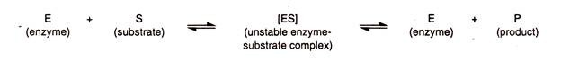

* The binding causes transformation of the substrate molecule to the product through opening of the bonds and formation of new bonds.
* The product is released, because it no longer fits into the active site and the enzyme molecule returns to its original form.
* It can now bind another substrate molecule at its active centre.

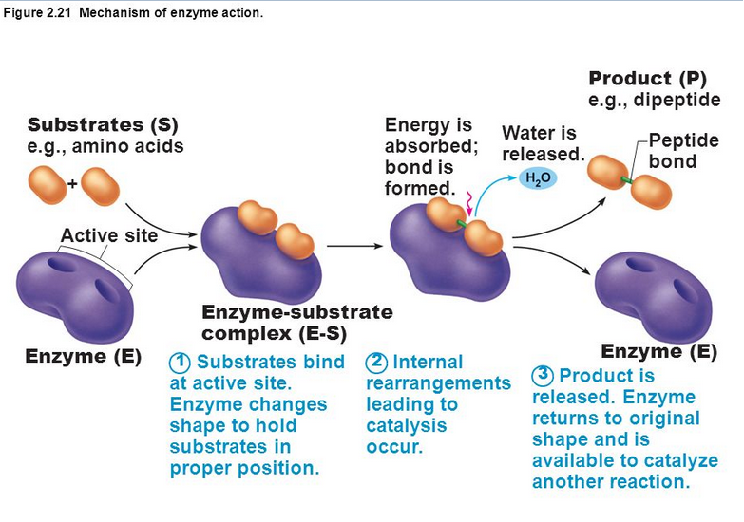

**Types of Mechanisms of Enzymes:**

There are two types: lock and key theory (template model), and induced-fit theory.

**(i) Lock and Key Theory:**

* Lock and Key Theory proposed by Emil Fischer (1894).
* According to this theory, reaction of subsrtate and enzyme is analogous to lock and key.
* Enzyme is analogous to key, where the geometrical configuration of socket is fixed.
* Similarly substrate has also got fixed geo­metrical configuration like that of key.
* A particular lock can be opened or closed by a particular key.
* According to the particular substrate can be found at active site of particular enzyme forming substrate-enzyme complex.
* Enzyme-substrate complex remains in tight fitting and active sites of enzymes are complementary to substrate molecules.
* Subsequently, enzyme-substrate complexes result in the transformation of substrate into the product formation due to activity of reaction sites.
* Since product has lower free energy, it is released.
* Enzymes are fixed to receive another molecule of substrate and thus enzyme activity continues.
* In this analogy, the lock is the substrate and the key is the enzyme. Only the correctly sized key (substrate) fits into the key hole (active site) of the lock (enzyme).
* Smaller keys, larger keys, or incorrectly positioned teeth on keys (incorrectly shaped or sized substrate molecules) do not fit into the lock (enzyme).

**Only the correctly shaped key opens a particular lock as shown in Fig. 12.11:**

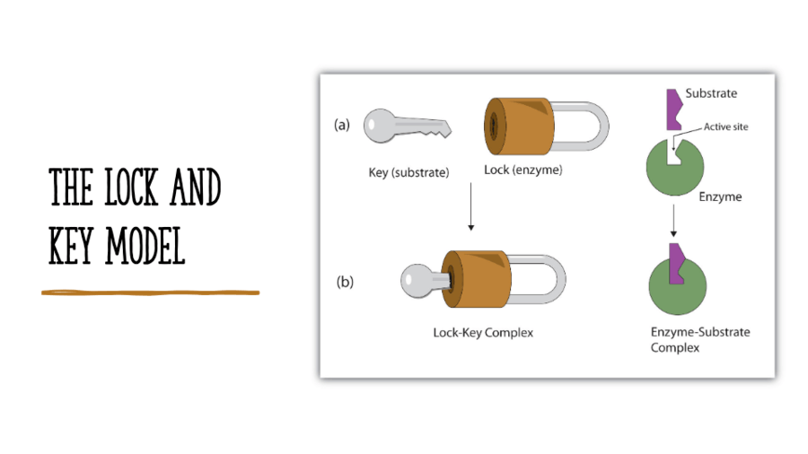

**(ii) Induced Fit Theory:**

Induced Fit Theory was given by Koshland in 1958.

It explains the enzyme property more efficiently.

According the Fischer’s model the nature of the active site of enzyme is rigid, but it is able to be pre-shaped to fit the substrate.

Koshland explains that the enzyme molecule does not retain its original shape and structure, but the contact of the substrate induces some geometrical changes in the active site of the enzyme molecule. The substrate molecule is made to fit completely the configuration and active centers of the enzyme. At the same time, other amino acid residues may become buried in the interior of the molecule.

It is more accepted theory.

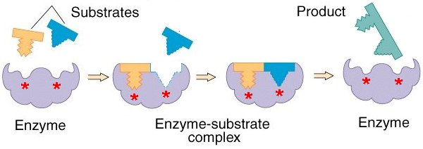

### Factors Affecting Enzyme Action:

**The factors influencing the rate of the enzyme catalysed reaction are:**

1. Temperature

2. pH

3. Substrate concentration

4. Enzyme concentration

#### 1. Effect of Temperature:

#### Raising temperature generally speeds up a reaction, and lowering temperature slows down a reaction.

#### Extreme high temperature enzyme denatures.

The temperature, at which the enzyme activity is maximum, is termed as the optimum temperature. Most of the enzymes are totally inactive at 0° C to 4° C, their activity starts at 10° C and slowly increases reaching its maximum capacity at its optimum temperature. Majority of the enzymes in the human body have their optimum temperatures between 37° C and 40° C.

**2. Effect of pH:**

Each enzyme has optimum pH range. Changing pH will slows down enzyme activity.The activity is maximum for most of the enzymes at the biological pH of 7.4. Optimum pH for pepsin is 1.5, acid phosphatase is 4.5 and for alkaline phosphatase it is 9.8.

**3. Effect of Substrate Concentration:**

Increasing substrate concentration increases the rate of reaction steadily, till the enzyme is saturated with the substrate. At this stage the reaction rate does not increase and remains constant. ( Enzyme is saturated with substrate).

**4. Effect of Enzyme Concentration:**

As the enzyme concentration increases, the rate of reaction increases steadily in presence of an excess amount of substrate, the other factors being kept constant.

### Enzyme Inhibition:

Alteration in the enzyme activity by specific substances other than non-specific substances like pH, temperature etc. is called enzyme inhibition.

**There are two types of enzyme inhibitions:**

(a) Irreversible and

(b) Reversible.

**1. Irreversible Enzyme Inhibition:**

The activity of the enzyme is inhibited by covalent binding of the inhibitor at the active site. The enzyme inhibitor bond cannot be dissociated, so it is permanent and irreversible i.e. it cannot be reversed. Even if increasing substrate concentration, enzyme inhibitor bond cannot be dissociated.

i. Aldolase is inhibited permanently by iodoacetate.

ii. Di-isopropylflurophosphate (DFP), a component of nerve gas, inhibits most of the digestive enzymes permanently in human beings. Hence it is very poisonous.

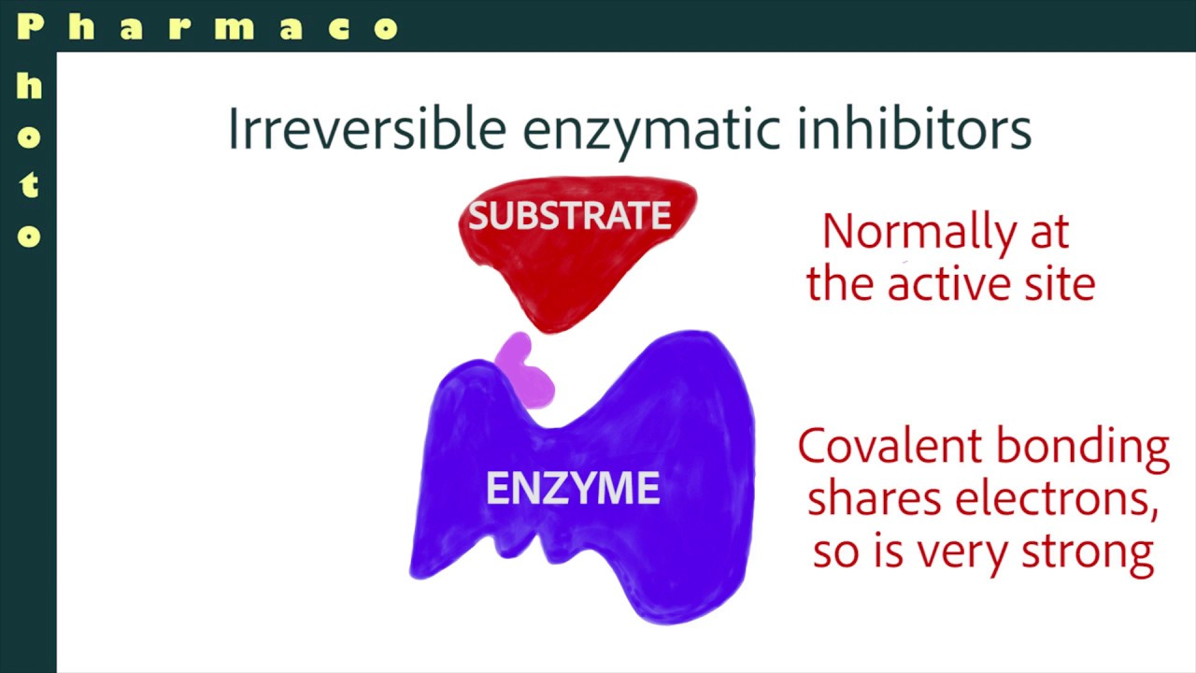

**2. Reversible Enzyme Inhibition:**

The inhibitors bind reversibly to the enzyme and so it is not permanent. The inhibition can be reversed by various mechanisms.

**(a) Competitive enzyme inhibition:**

* It is a type of reversible inhibition.
* The inhibitor and substrate have structural similarity.
* So there is competition between substrate and inhibitor for the active site of an enzyme.
* Competitive inhibitor blocks the active site and prevents binding of substrate molecule.
* This can be reduced by increasing the substrate concentration.
* The enzyme succinate dehydrogenase’s (SDH) substrate is succinic acid and the competitive inhibitors are oxalic acid, mallonic acid and glutaric acid. Among these, mallonic acid is the most potent competitive inhibitor of SDH.

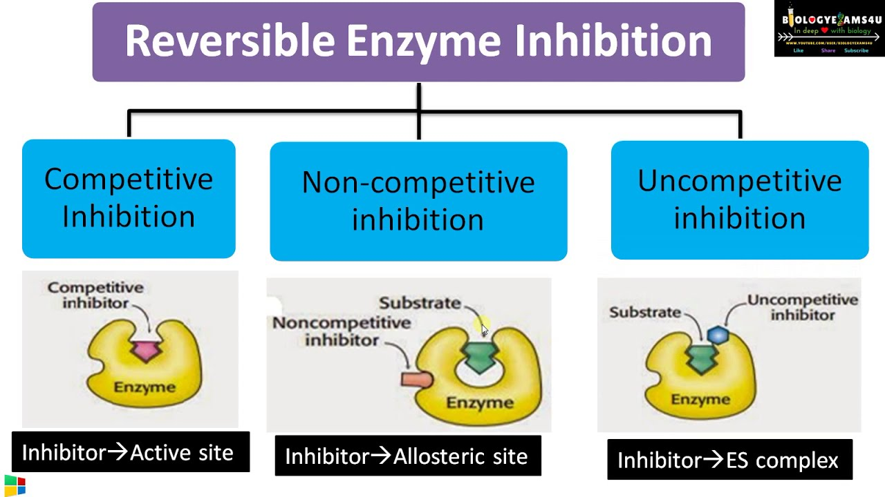

**(b) Non-competitive enzyme inhibition:**

* Non-competitive inhibition involves a molecule binding to a site other than the active site (an *allosteric site*)
* The binding of the inhibitor to the allosteric site causes a conformational change to the enzyme’s active site
* As a result of this change, the active site and substrate no longer share specificity, meaning the substrate cannot bind
* As the inhibitor is **not** in direct competition with the substrate, increasing substrate levels cannot mitigate the inhibitor’s effect

**(c) UnCompetitive enzyme inhibition:**

* Also known as anticompetitive inhibition.
* In this type, inhibitor binds only to the complex formed between the enzyme and substrate (ES complex).
* Examples: inhibition of aryl sulphatase by hydrazine
* inhibition of enzyme alkaline phosphatases by phenyl alanine.

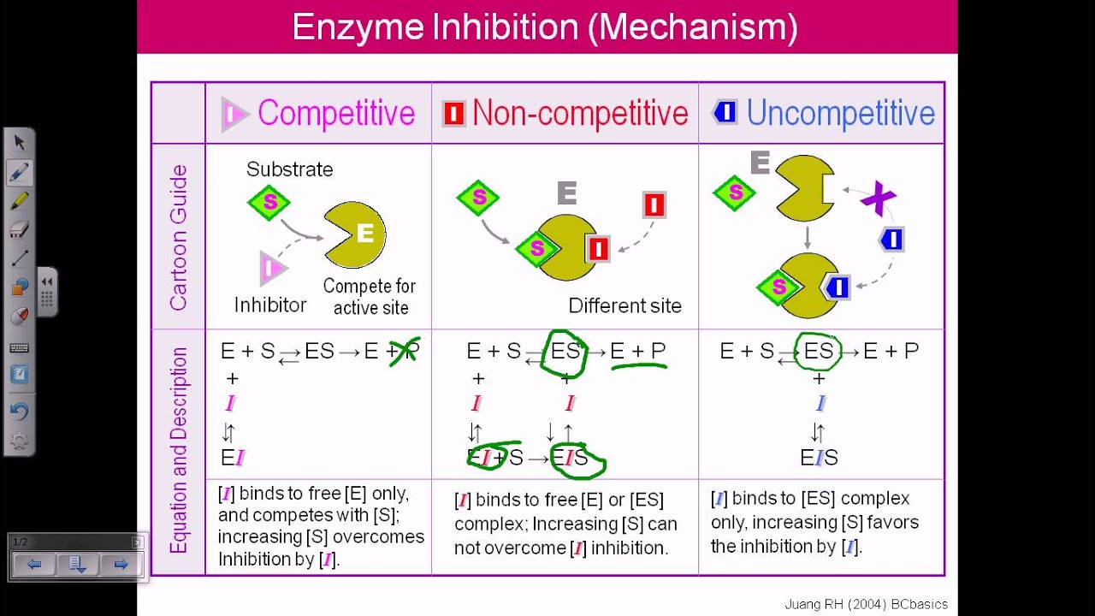 **Feedback Inhibition**

Feedback inhibition is a cellular control mechanism in which an enzyme’s activity is inhibited by the enzyme’s end product.

This mechanism allows cells to regulate how much of an enzyme’s end product is produced.

Most biochemical processes are complex and multi-step, requiring multiple enzymes to get from the starting [substrate](https://biologydictionary.net/substrate/) to the desired end product.

Typically, feedback inhibition acts on the first enzyme unique to a given pathway.

For example, in the case of amino acid production, an amino acid may act as an inhibitor for the first enzyme in the pathway whose purpose is making more of that amino acid.

The graphic below illustrates this process:

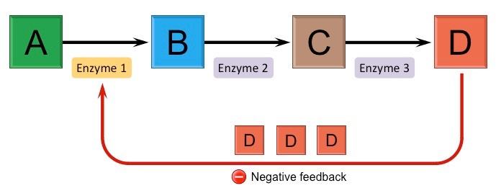

Feedback inhibition is usually accomplished through something called an “allosteric site” – a site on an enzyme that changes the shape of an enzyme, and subsequently the behavior of the [active site](https://biologydictionary.net/active-site/).

**Free Energy:**

* Free energy or Gibbs free energy (G) is the energy available in a system to do useful work and is different from the total energy change of a chemical reaction.
* Gibbs free energy (G) is used to describe the useful energy in a reaction or the energy capable of doing work.
* Enzymes do affect the activation energy.
* The activation energy is the difference in free energy between the substrate and the transition state.

**Activation energy:**

* All chemical reactions require some energy input to begin.
* The amount of energy needed before a reaction will proceed on its own is called activation energy.
* Energy is needed to break existing bonds before new bonds can be formed.
* The formation of new bonds may release more energy than was needed to break the original bonds.
* Even though there may be a net release of energy, the need for activation energy can act as a barrier to the chemical reaction occurring.

**Binding energy:**

* The binding energy is the free energy that is released by the formation of weak interactions between a complementary substrate and enzyme.
* The binding energy is maximized since only the correct substrate can interact with an enzyme and is released when the enzyme facilitates formation of the transition state.

**Transition state**

The transition state is the transitory of molecular structure in which the molecule is no longer a substrate but not yet a product.

All chemical reactions must go through the transition state to form a product from a substrate molecule.

In enzyme reactions, the enzyme-substrate complex represents the transition state.

The transition state is the state corresponding to the highest energy along the reaction coordinate.

It has more free energy in comparison to the substrate or product; thus, it is the least stable state. The specific form of the transition state depends on the mechanisms of the particular reaction.

In the equation S → X → P, X is the transition state, which is located at the peak of the curve on the Gibbs free energy graph.

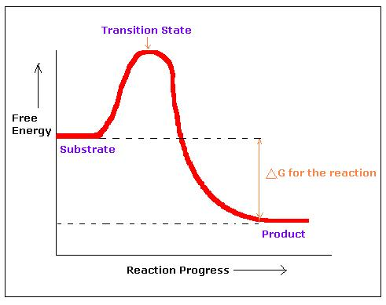

************************

References

* T.Y.B. Sc Textbook Nirali Prakashan
* www.biologydiscussion.com