**K.T.S.P. Mandal’s**

**Hutatma Rajguru Mahavidyalaya,**

**Rajgurunagar.**

**T.Y.B.Sc. Botany**

**Semester – V (CBCS pattern)**

**Subject – Cryptogamic Botany**

**(Paper I: BO. 351)**

**Chapter 6**

**Topic – Study of life cycle of *Puccinia* with reference to taxonomic position, Thallus structure & Reproduction**

**Prof.P.D.Kad**

**(Assistant Professor, Department of Botany)**

[poojakad92@gmail.com](mailto:poojakad92@gmail.com)

**Life cycle of *Puccinia* *graminis tritici (*Black stem rust of Wheat)**

**Habit and Habitat**

It belongs to Basidiomycotina division.

P. graminis is an obligate parasite, polymorphic, macro cyclic and heteroecious rust. It affects wide range of hosts including wheat, barley, oats and rye. Grass hosts include Agrostis, Dactylis and Agrophyron. P. graminis tritici involves in its life cycle two distinct alternate host plants i.e., wheat (Triticum vulgare fam. Poacae) and Barberry (Berberis vulgaris fam. Berberidaceae). Puccinia name is given in memory of T. Puccini.

* **Many species autocious: complete entire life cycle on single plant.**
* ***P. graminis-tritici* : heterocious - Wheat (Pri. Host), Barberry: *Berberis vulgaris***

**(Sec. host).*P. graminis-tritici*** requires two host.The wheat plant is called the primary host and the barberry plant is secondary or alternate host.

**Taxonomic position:**

**Kingdom: Fungi** (Eukaryotic, heterotrophic, Thallus filamentous, mycelia, cell wall is of chitin)

**Phylum: Basidiomycota**( sexual reproduction results in the formation of 2/ 4 basidiospores, true sex organs absent. Basidiocarps are formed)

**Class: Basidiomycetes** ( Same as above)

**Order: Uridinales** ( obligate parasites, septate mycelium)

**Family: Pucciniaceae** (polymorphic, macrocyclic, heteroceious rust, telutospores stalked)

**Genus: *Puccinia***( bicelled, spindle shaped, black telutospores)

**Species: *graminis* (**Biotroph on graminaceous host showing dikaryophase.)

**Variety: tritici (**wheat as one of the host)

### Symptoms of *Puccinia* g*raminis*:

#### On Wheat:

The symptoms of the disease appear as large, elongated and brown pustules (uredosori) on the stem, leaf, sheath and leaf (Fig. 1 A). Later on these brown pustules change into black coloured large pustules (teleutosori, Fig. 1 B). Grains of the infected plants are shriveled, much lighter in weight and thus reducing the yield.

**[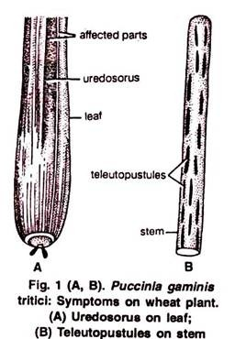](https://www.biologydiscussion.com/wp-content/uploads/2016/02/clip_image004-188.jpg)[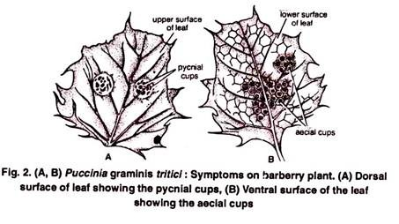](https://www.biologydiscussion.com/wp-content/uploads/2016/02/clip_image006-155.jpg)**

#### On Barberry:

Infection first starts on the dorsal surface of the leaf in the form of minute, dark coloured and flask shaped pycnia which appear as yellow spots (Fig. 2 A). Beneath Pycnia, on the ventral surface, appear cup like projections of aecia (Fig. 2 B) or aecidia.

**Thallus Structure of *Puccinia* g*raminis*:**

On Primary host (wheat) =mycelium is dikaryotic (each cell of the mycelium bears two nuclei)

On alternate host (Barberry) = mycelium is monokaryotic (each cell of the mycelium bears only one nucleus)

The Dikaryotic mycelium is well developed, branched, septate, colourless & intercellular. Produces intracellular haustoria which may be knob or finger like. Each cell in the mycelium is rectangular, dikaryotic and with septa having central pore.

Reserve food material remains in the form of glycogen bodies and oil globules.

#### Different Type of Spores Found in Puccinia graminis:

**[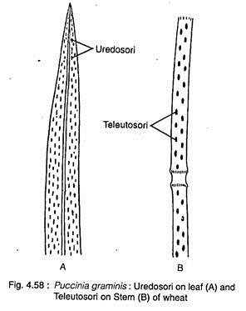](https://www.biologydiscussion.com/wp-content/uploads/2016/08/clip_image010-54.jpg)**

* *Puccinia* *graminis* *tritici* produces five different types of spores in its life cycle. These are uredospore, teleutospore, basidiospore, pycniopore and aeciospore.
* Uredospores and teleutospores grow on wheat, the primary host; basidiospores on soil or on dead plants upon soil that developed from teleutospore; and the pycniospores and aeciospores on barberry plant, the alternate host of the pathogen.

**4. Life Cycle of *Puccinia* *graminis*:**

Puccinia graminis is long cycled rust (macro cyclic). At the time of reproduction it produces five distinct stages in a regular sequence.

**These are as follows:**

On alternate host Barberry plant

**Stage 0:**Spermogonia bearing spermatia and receptive hyphae.

**Stage I:**Aecia bearing aeciospores.

**Stage II:**Uredia bearing uredospores.

On primary host wheat plant

**Stage III:**Telia bearing teleutospores.

**Stage IV:**Promycelia bearing basidiospores.

on soil or on dead plants upon soil

#### Stages on Primary Host (Wheat):

**Stage II :Uredospore’s or Uredinial stage:**

Aeciospores brought from the infected barberry plants through wind. The aeciospore after reaching the wheat plant may attack leaf, stem or glumes. Binucleate aeciospores are germinated to form dikaryotic mycelium. Dikaryotic mycelium which enters through stomata and grows intercellularly. The mycelium of the subepidermal region develops erect hyphae, those produce binucleate uredo­spores at their tips.

The uredospores develop in groups under the epidermis, called uredosorus, which appear in the form of reddish-brown pus­tules. With maturity, the host epidermal wall bursts by pressure of developed spore and uredo­spores become exposed.

Uredospores are stalked, oval, unicellular, brown, thick walled with 4-round equatorial germ pores.The spore wall is thick with echinulate outer layer. The uredospores in favourable condition (i.e., in winter season) again germinate, thus infect the wheat plant and deve­lop next crop of uredospore. The procedure may repeat several times in a single season.

**[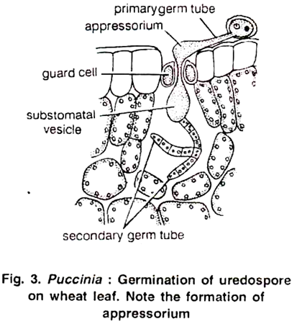](https://www.biologydiscussion.com/wp-content/uploads/2016/02/image-201.png)** [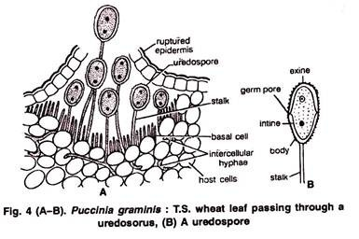](https://www.biologydiscussion.com/wp-content/uploads/2016/02/clip_image009-61.jpg)

**Telial Stage:**

Towards the end of the growing season of wheat crop, the environmental conditions become unfavorable (hot and dry) for the growth of the uredospore’s. Now uredosori produce another kind of spores called teleutospores. First, they develop among the uredospore’s within the same sorus, but later they develop in separate sori known as teleutosori or teleutopustule. As the crop matures, the number of uredospore’s is reduced and the sori contain only teleutospores. This stage is known as the black stage and hence the name black rust is given to the disease. The teleutospores are dark brown or black in colour. They are bi-celled and spindle shaped structures with a pointed apex and thick smooth wall.

Each cell of a teleutospore has a single germ pore and two nuclei (one of plus strain and the other of minus strain, Fig. 5 C). As the teleutospores reach towards maturity, karyogamy takes place and the two nuclei fuse to form a diploid nucleus (Fig. 5 C).

At this stage the teleutospores undergo a period of rest. During resting period they lie on the ground or still attached to the host. These are the dormant cells and are capable of tiding over unfavorable period.

**[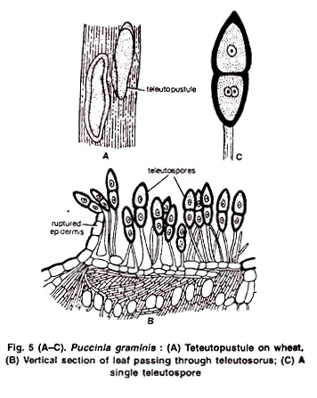](https://www.biologydiscussion.com/wp-content/uploads/2016/02/clip_image011-60.jpg)** [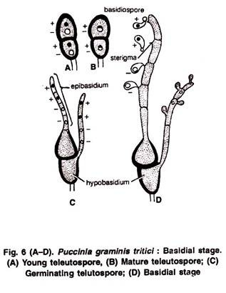](https://www.biologydiscussion.com/wp-content/uploads/2016/02/clip_image013-44.jpg)

#### Basidial Stage:

After the renting period, the teleutospores germinate during the early part of spring. They germinate in situ and either one or both of its cells give rise to a germ tube, known as promycelium. The promycelium together with the teleutospore cell is called basidium. However, many authors prefer to call the teleutospore cell as the hypo-basidium and the promycelium as the epibasidium (Fig 6 A-C).

The diploid nucleus of the teleutospore migrates into the promycelium and divides meiotically into four haploid nuclei (Fig. 6 C). The septa appear between the nuclei and divide the promycelium into four haploid cells. Each haploid cell of the promycelium produces a slender, short, lateral, tube-like structure known as sterigma (Fig. 6 D). The sterigma swells up at the end to form a spore like cell.

The haploid nucleus from each promycelium cell migrates into this developing spore cell through its respective sterigma. Thus, at the tip of each sterigma, a minute spore is formed.

This spore is called basidiospore (Fig. 6 D). Each cell of promycelium produces a single basidiospore. Thus, from a single cell of teleutospore four haploid, unicellular, uninucleate basidiospores are formed. Two, out of the four telutospore basidiospores are of ‘+’ strain and the other two of strain.

Soon after the basidiospore formation they are forcibly ejected by the ‘water droplet method’. (In this method a liquid begins to collect in the form of a droplet at the base of the basidiospore.

This droplet gradually attains a bigger size and suddenly pushes off the basidiospore forcibly into the air to a short distance.) The basidiospores are carried away by wind. They are capable of germinating only on Barberry plants (Berberis vulgaris) available on hills. They perish soon if the alternate host is not available.

#### Stages on Barberry Plant:

During favourable condition, the basidiospore germinates on contact with barberry leaflet towards the upper surface by producing germ tube. The germ tube penetrates the epidermis and grows there intercellularly.

The nature of the mycelium depends on the nature of basidiospore, either of + or – type. Within few days, the growing monokaryotic mycelium becomes aggregated under the epidermis and forms a yellowish flask-shaped structure, called Pycnium or Spermogonium.

#### The Pycnium has small sterile mycelium at the neck, called periphyses, which intermingle with much larger thin-walled simple and branched receptive or flexuous hyphae.

The bottom of the inner side of pycnium is lined by many uninucleate tape­ring cells, the pycniophores or spermatiophores, which develop many small oval to spherical uninucleate cells, called pycniospores (spermatia).

Depending on the nature of basidiospore, the pycnium and pycniospore may be of + or – type. Numerous pycnia of different types (+ and -) can grow in cluster on the upper surface of the leaf. The pycniospore or spermatium does not infect any host.

The mature pycnium (+ and – type) secretes nector drops during release of mature pycniospores which get intermixed.

The insects get attracted by nector and help in the transfer of pycniospore or spermatium to the flexous hyphae of opposite mating type. The wall at the point of contact dissolves and the nucleus of pycniospore (spermatium) passes to the flexuous hyphae, thus dikaryotic condition is established. This process is known as spermatisation.

**Aeciospore:**

During development of Pycnia, some hyphae of + and – type goes downward towards the lower side of the leaf and forms respective immature aecia (Protoaecium or aecial primodium). Further growth is initiated within few days of spermatisation.

The spermatial nuclei pass downward through the hyphae and after crossing the inner tissue they reach and dikaryotise the basal cells of the aecial primordium. The aecial primordium then stimulates to further growth and within few days, on the lower surface of the leaf, aecium (PI. aecia) or cluster cup (n + n) is formed.

The young aecium is buried inside the tissue below the lower epidermis, but with maturity it pushes and ruptures the epidermis, thereby spores are exposed. The aecium is inverted cup-shaped structure with outer margin composed of short cells, called peridium.

The stalk cell after becomes dikaryotised, divided mitotically into chain of alternately arranged large and small cells (Fig. 4.62A, C). The large cells form the aeciospores (n + n) and the small one becomes sterile, called disjunctor cell. The disjunctor cell helps in spore dispersal.

The aeciospores are unicellular, binucleate (n + n), thin-walled and orange in colour. The young aeciospores are polyhedral in shape, but becomes globose with maturity. They are dispersed by air current and can infect only the graminaceous host i.e., wheat plant. After falling on wheat plant (stem and/or leaf), they germi­nate by producing germ tubes (n + n), or primary hyphae.

The further development of the germ tube is similar as described in the uredinal stage and ultimately the dikaryotic mycelium is produced. This is the mycelium which produces the uredospore’s and later the teleutospores on wheat. In this way, the life cycle of Puccinia graminis is completed.

**[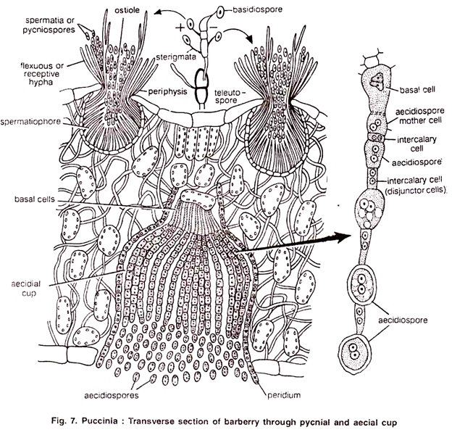](https://www.biologydiscussion.com/wp-content/uploads/2016/02/image-203.png) [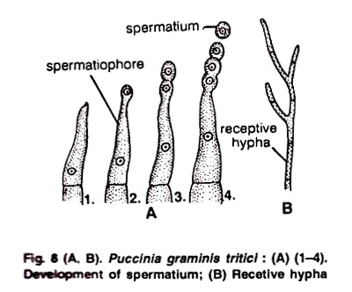](https://www.biologydiscussion.com/wp-content/uploads/2016/02/clip_image017-26.jpg)**

[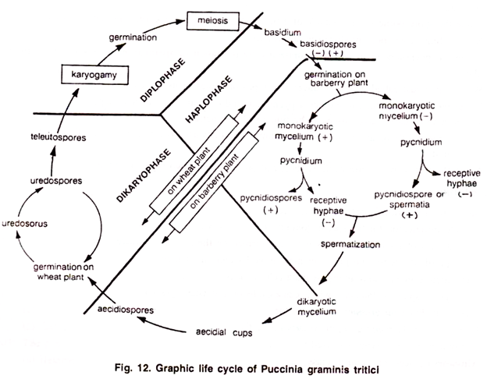](https://www.biologydiscussion.com/wp-content/uploads/2016/02/image-205.png)

#### References:

1. <https://www.biologydiscussion.com/>

2. Cryptogamic Botany textbook, Nirali prakashan.

3. Images from internet.