K.T.S.P.Mandal’s
Hutatma Rajgurunagar Mahavidyalaya
Rajgurunagar 410 505

Department of Zoology

SPPU T.Y.B.Sc (Zoology)
(CBCS 2021-22)

ZO- 351 PEST MANAGEMENT

By
Prof. Dr. Theurkar S.V.

ZO- 351 PEST MANAGEMENT
Chapter II Pest Management using Regulatory Control
INTRODUCTION
Preventing the entry and establishment of the foreign and animal pest is a country of area and eradication established in a limited area.
Preventing pests while also providing for equitable and orderly domestic and international trade is a major challenge. The goal of a pest prevention program is to prevent the introduction, colonization, and establishment of pests that would cause significant agricultural, environmental, and/or societal harm in an area where the pest does not already occur.
The program must efficiently and effectively:
- Identify pest harm.
- Assess pest risk.
- Manage pest risk.
Successful plant and animal pest control depends on the successful blending of many skills. Regulatory pest management programs use several different control strategies which may include:
- Identification of risk
- Quarantine
- Eradication
- “Crop free” period

IDENTIFICATION OF RISK
Before prevention strategies are initiated, pest prevention agencies must be able to:
- See the possibility for harm.
- Determine the probability for harm.
- Take appropriate avoidance measures.
A pest risk analysis is used to determine the probability for harm. Regulatory agencies look at the pests already present in the area; the life cycles and host ranges of quarantine pests of concern; when, where, why and how harm could occur and to what degree; how the pest could be introduced; and the likelihood of colonization and establishment. The pest risk analysis may identify a quarantine pest.
An organism may become a quarantine pest if:
- It is a pest.
- It could cause significant harm.
- It is likely to be moved artificially into or already
- Exists in the endangered area and is being or would be officially controlled.
- It could survive in the endangered area.
- The risk could not be reduced to an acceptable
- Level by means other than regulation.

QUARANTINE
Quarantine not only helps to ward off the threats of exotic pests, but also aim to eliminate and prevent further spread of pests/pathogens (both indigenous and introduced) with restricted distribution within the country (domestic quarantine).

ERADICATION
If prevention is not successful and an introduction occurs, the immediate objective of the control program is to eradicate the pest. Eradication generally means using all available viable options, which often includes the application of pesticides. Other pest control measures may include elimination of the pest’s food source in the limited area where the outbreak has occurred, or changing the pest’s habitat so that the pest cannot survive. Mass trapping can be a useful tool in helping reduce populations. Use of mating disruption techniques such as spreading flakes impregnated with pheromones can be another useful tool.

CROP FREE PERIOD
Pest, fungus, viruses and bacteria epidemics in vegetables were avoided by enforcing a crop-free period during one month especially in summer. It was found that the cultivated crops are the major reservoir of fungus and viruses, and that during these months the insect vector population and the natural virus sources are low.

CROP ROTATION
Crop rotation is the practice of growing a series of different types of crops in the same area across a sequence of growing seasons. It reduces reliance on one set of nutrients, pest and weed pressure, and the probability of developing resistant pests and weeds.
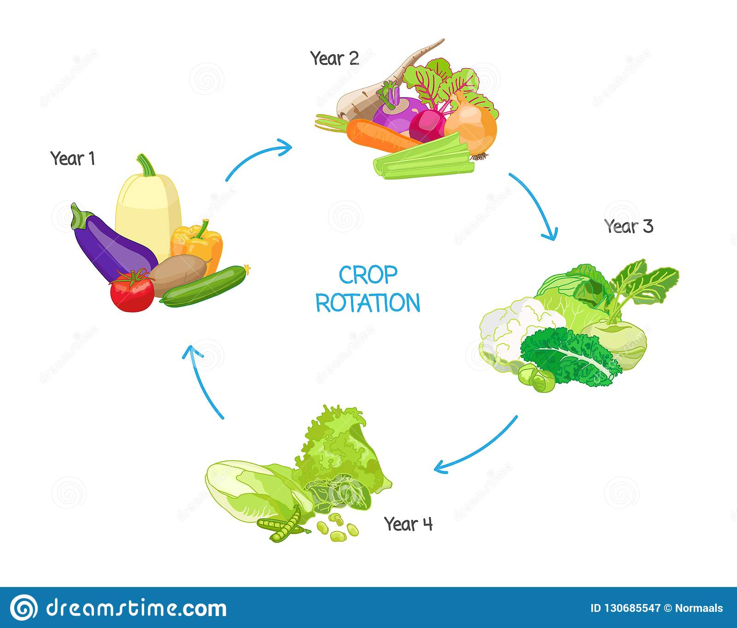

REFERENCE BOOKS -
1. Handbook of Pest Management in Agriculture by Pimentel.
2. Principles of Insect Pest Management by Dhaliewal and Arora.
3. Agricultural Pest of India & South East Asia by A. Satwal.
4. Pathological Problems of Economics Crop Plants & their Management by Paul Khurana, S. M., 1998.
5. Integrated Diseases Management and Plant Health by Gupta V. K. & Sharma R. C.
6. Diseases of Millets by Ramkrishnan T. S., I. C. A. R. Publ. New Delhi.
7. Fungal diseases of Rice in India by Padmanabhan S. Y., I. C. A. R. Publ., New Delhi.
8. Analysis of Pesticides Residues by H. A. Moye (JW)
9. Advance in Pest Control Research by R. L. Methcalf (JW)
10. Chemistry of pesticides by K. H. Buchel (JW).
11. Progress in Pesticides Biochemistry and Toxicology Vol. I, II & III by D. H. Hutsonand T. R. Robert.
12. Evaluation of Pesticides in Ground Water by W. Y. Garnett, R. C. Honeycatt and others.
13. Chemistry of Pesticides by Edward
14. Insecticide Biochemistry and Physiology by C. F. Wilkinson.

