K.T.S.P.Mandal’s
Hutatma Rajgurunagar Mahavidyalaya
Rajgurunagar 410 505

Department of Zoology

SPPU T.Y.B.Sc (Zoology)
(CBCS 2021-22)

ZO- 351 PEST MANAGEMENT

By
Prof. Dr. Theurkar S.V.

ZO- 351 PEST MANAGEMENT
Chapter III Pest Management using Cultural control
3.1. SANITATION
Sanitation used to be called "housekeeping," a term many experienced pest management professionals (PMPs) still prefer because it implies reducing clutter; picking up messes; sweeping, cleaning, and polishing surfaces; and keeping everything in good repair.
Sanitation is a prevention strategy to help safeguard your site against pest infestations and subsequent threats. Your sanitation schedule should factor in type of pest(s), different areas of your site and other factors that make it unique. Developing and implementing a comprehensive and consistent sanitation schedule as a part of your Integrated Pest Management (IPM) plan can help prevent pest activity, product contamination and lost profits.

3.2. TILLAGE
Tillage is a technique of manipulating the soil in preparation for crop production. The aim is to manage various characteristics of the soil, such as water retention, temperature, infiltration, and evapotranspiration.
Tillage to a depth of 15–20 cm is widely used in weed control. In addition, tillage is used to break up compacted soil, incorporate organic and inorganic fertilizers, prepare the soil for sowing cover crops, and bury diseased and infested plant remains for pest and disease control. However, awareness of its disadvantages has combined with other factors to curtail its use. Disruption of soil aggregate structure is among its major drawbacks. This can lead to “puddling” under heavy rain and the progressive formation of a hardpan under the tilled layer. The latter results from the transport, and subsequent accumulation, of clay particles deeper in the soil. Hardpans delay water infiltration, increase soil erosion, reduce water conservation, limit root penetration and tend to restrict root development to near the soil surface. Soil cultivation destroys infiltration and aeration channels produced by cracks in the soil and drastically reduces earthworm activity. This effect is most marked when the soil is cultivated when wet. In addition, by facilitating oxygen infiltration, tillage increases the rate of soil microbial action. This favors mineralization of organic material, disrupting soil crumb structure and elevating soil nutrient loss.
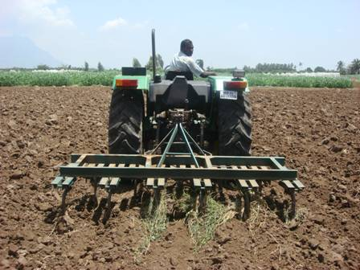

3.3. CROP ROTATION
What is crop rotation?
Crop rotation is the practice of planting different crops sequentially on the same plot of land to improve soil health, optimize nutrients in the soil, and combat pest and weed pressure.
Crop rotation is the practice of growing a series of different types of crops in the same area across a sequence of growing seasons. It reduces reliance on one set of nutrients, pest and weed pressure, and the probability of developing resistant pests and weeds.
For example, a farmer has planted a field of corn. When the corn harvest is finished, he might plant beans, since corn consumes a lot of nitrogen and beans return nitrogen to the soil.
A simple rotation might involve two or three crops, and complex rotations might incorporate a dozen or more.
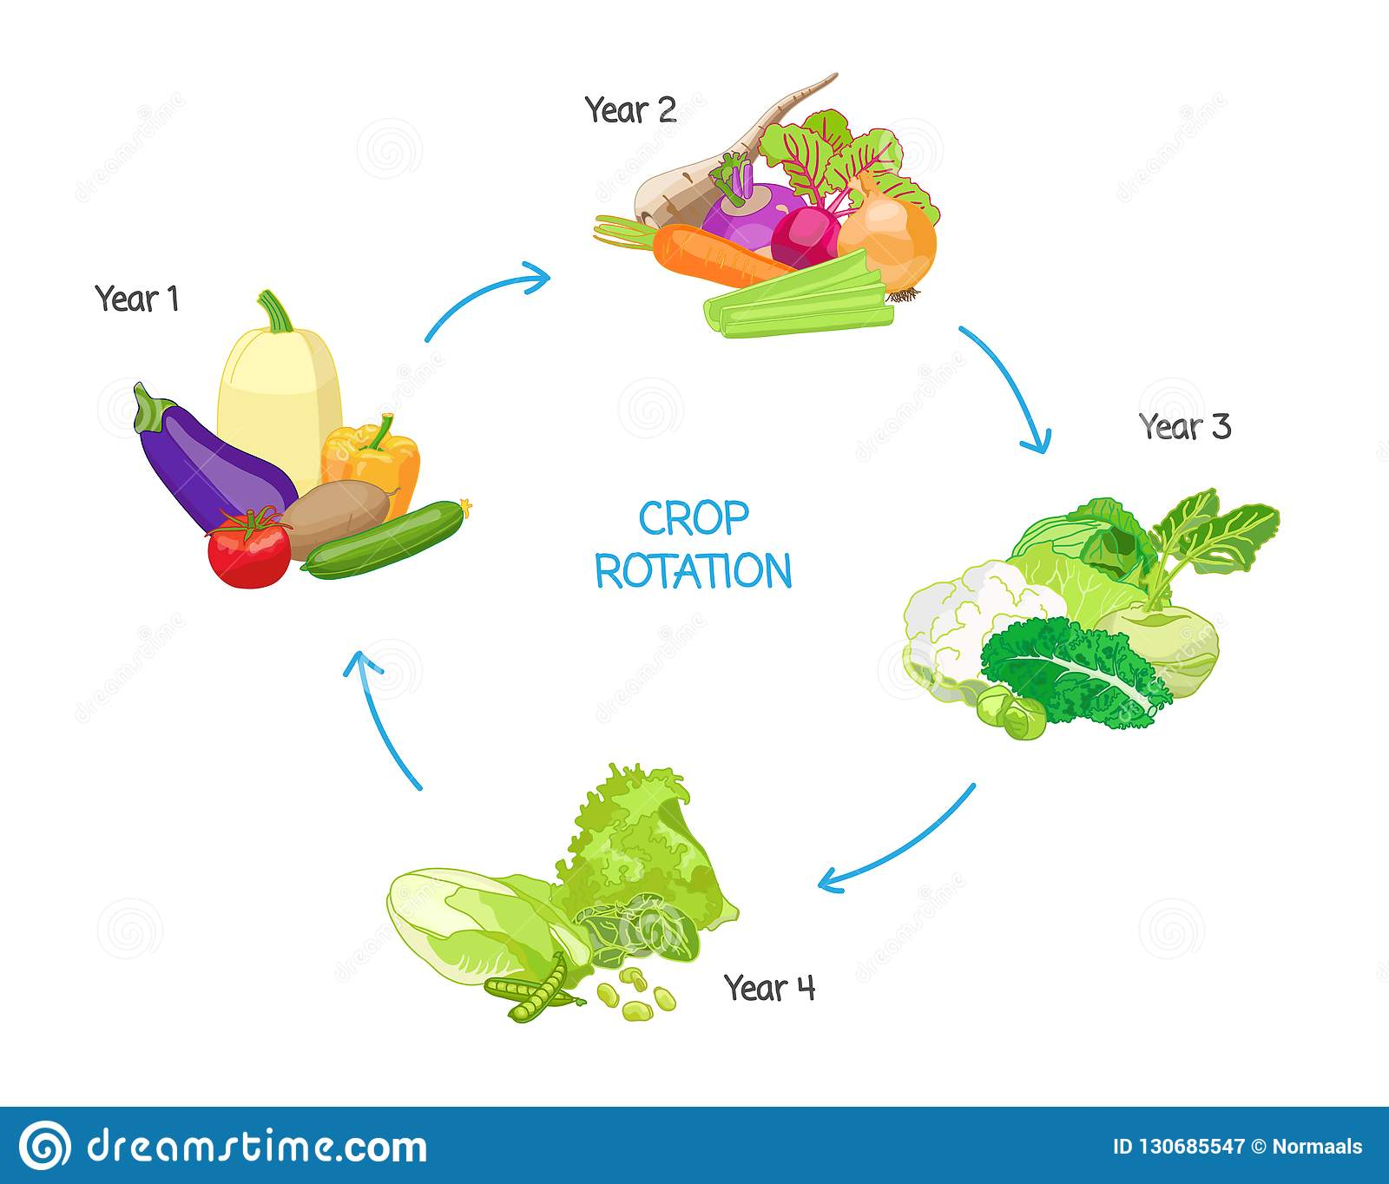

3.4. CROPPING SYSTEMS
A cropping system is defined as the cropping pattern and its management to derive benefits from a given resource base under a specific environmental condition. The productive base of cropping system is plant growth, which is influenced by management and environment. Management here includes all those components associated with crop production. These include, crop area, crop biomass, economic yield, crop rotation, crop calendar, time and spread of sowing and harvest. Environment is the invariant resource of soil, physiography and climate.
Cropping pattern is the yearly sequence and spatial arrangement of crops and fallow on a given area. Cropping system comprises all cropping patterns grown on the farm and their interaction with farm resources, other household enterprises and the physical, biological, technological and sociological factors or environments".
Sequential cropping
A form of multiple cropping in which paddy is grown in sequence on the same field, with the succeeding crop planted after the harvest of the preceding crop.
Mixed cropping
Growing of two or more varieties of paddy simultaneously and intermingled without row arrangements, where there is significant amount of intercrop competition.
Mono-cropping system
A system of cultivation in which a paddy is grown over a large area of land often for several years.
Ratooning
One of the important methods of intensive cropping, allowing the stubbles of paddy crop to strike again after harvesting and to raise another crop.
Relay planting
The second crop is planted into an established stand of a main crop. The second crop develops fully after the main crop is harvested.

Reference Books -
1. Handbook of Pest Management in Agriculture by Pimentel.
2. Principles of Insect Pest Management by Dhaliewal and Arora.
3. Agricultural Pest of India & South East Asia by A. Satwal.
4. Pathological Problems of Economics Crop Plants & their Management by Paul Khurana, S. M., 1998.
5. Integrated Diseases Management and Plant Health by Gupta V. K. & Sharma R. C.
6. Diseases of Millets by Ramkrishnan T. S., I. C. A. R. Publ. New Delhi.
7. Fungal diseases of Rice in India by Padmanabhan S. Y., I. C. A. R. Publ., New Delhi.
8. Analysis of Pesticides Residues by H. A. Moye (JW)
9. Advance in Pest Control Research by R. L. Methcalf (JW)
10. Chemistry of pesticides by K. H. Buchel (JW).
11. Progress in Pesticides Biochemistry and Toxicology Vol. I, II & III by D. H. Hutsonand T. R. Robert.
12. Evaluation of Pesticides in Ground Water by W. Y. Garnett, R. C. Honeycatt and others.
13. Chemistry of Pesticides by Edward
14. Insecticide Biochemistry and Physiology by C. F. Wilkinson.

